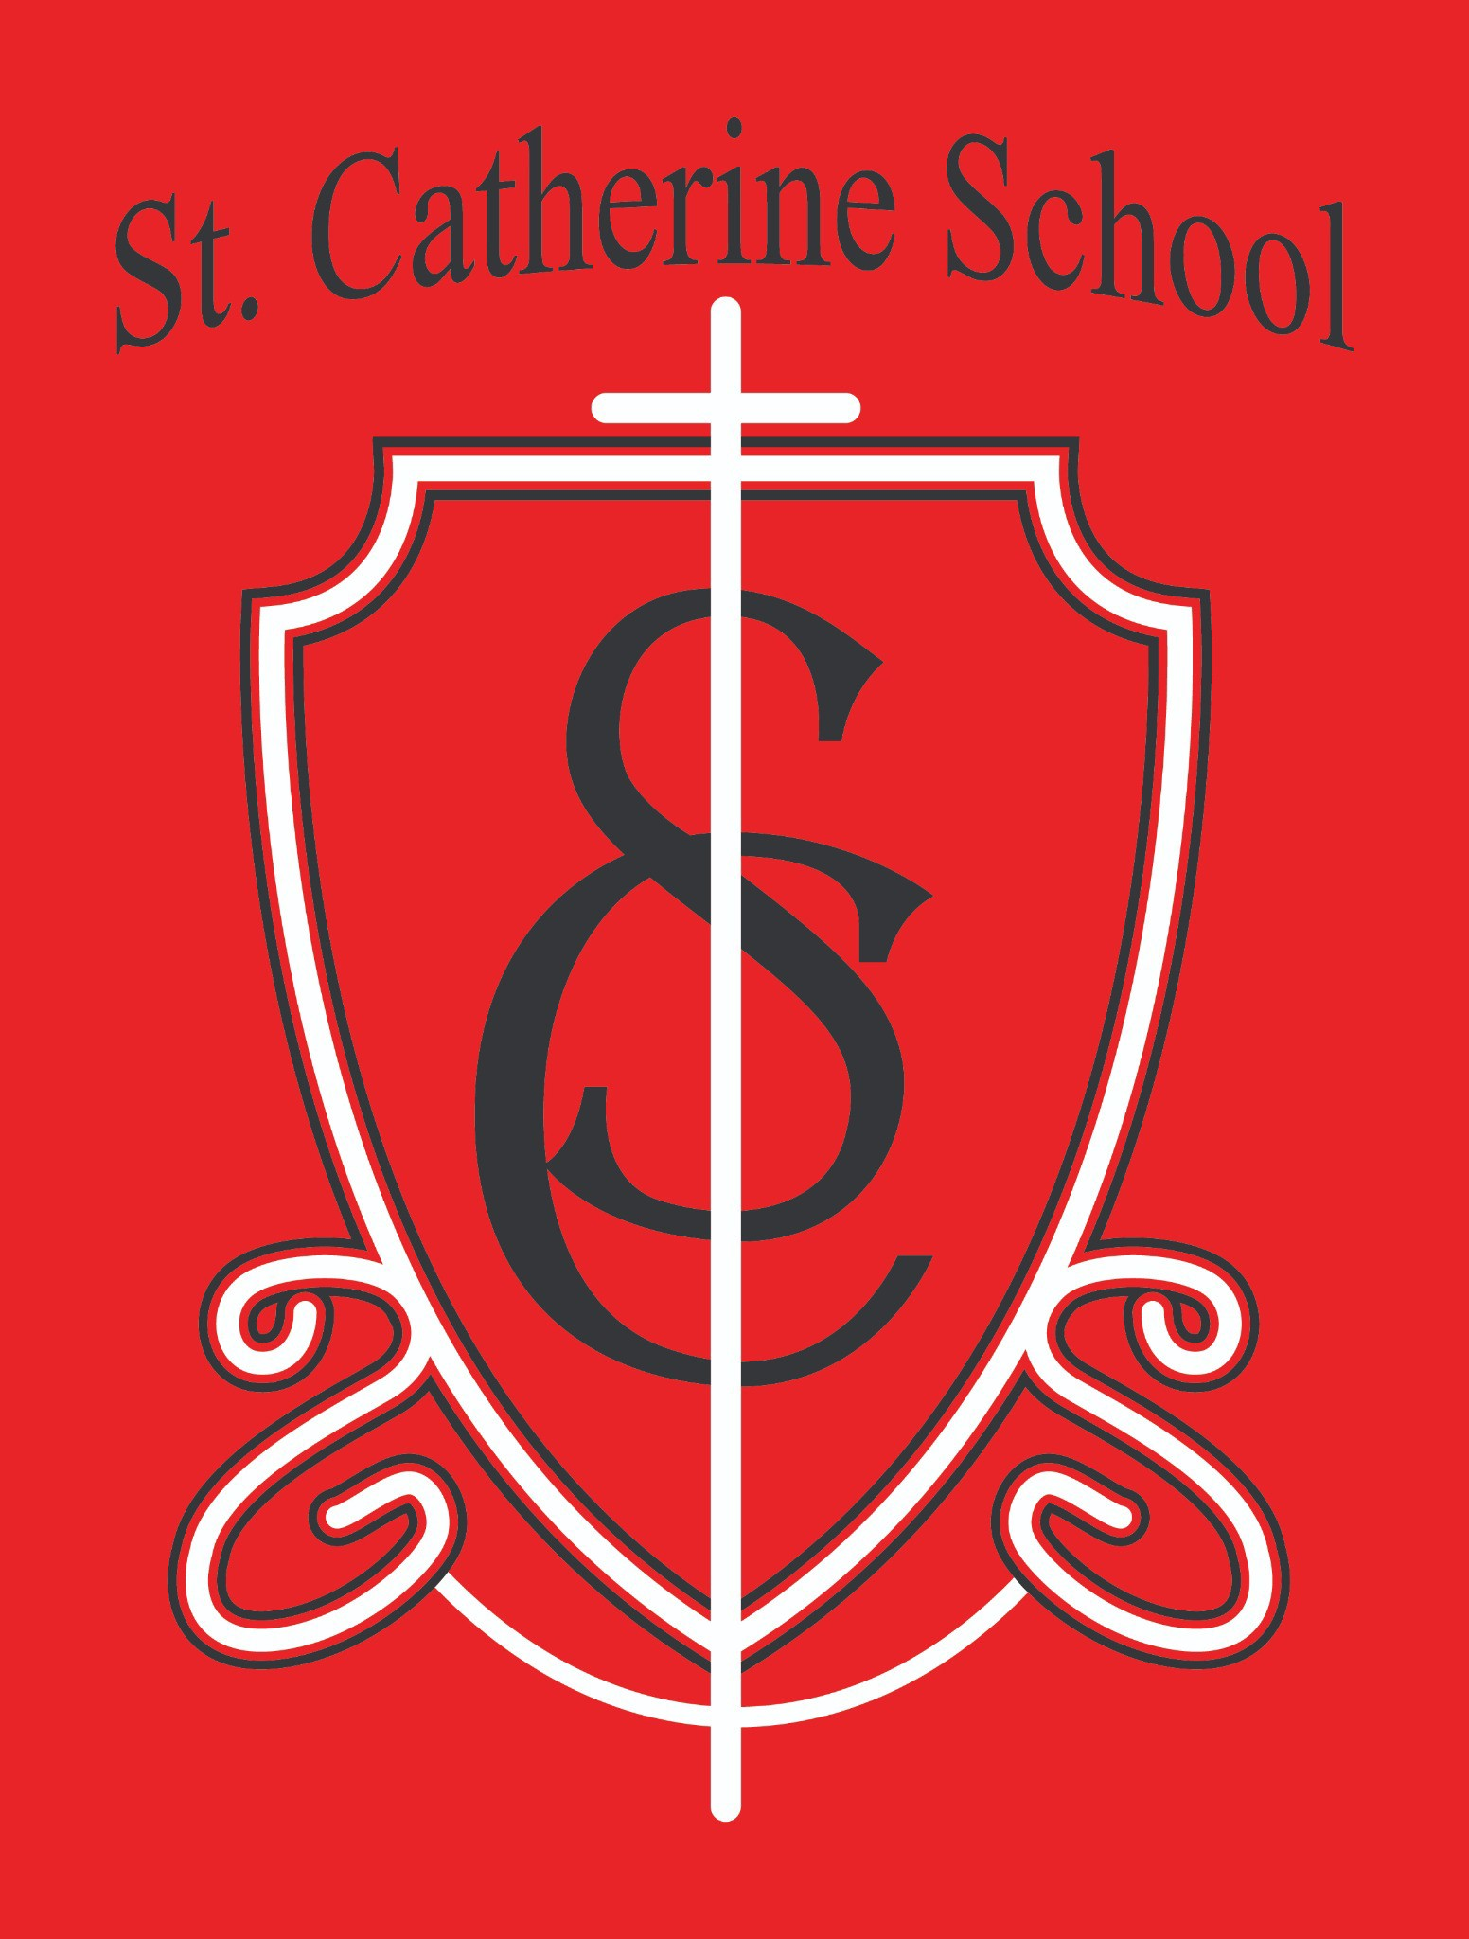

**St. Catherine School Weekly Newsletter**

[**https://www.stcatherine.k12.nd.us/parents**](https://nam02.safelinks.protection.outlook.com/?url=https%3A%2F%2Fwww.stcatherine.k12.nd.us%2Fparents&amp;data=05%7C02%7CTerra.Giesen%40k12.nd.us%7C18c214c4c2a843397fe408dd47cc99cf%7Cdbbf782acef14af186c81f9201061db6%7C0%7C0%7C638745666295972770%7CUnknown%7CTWFpbGZsb3d8eyJFbXB0eU1hcGkiOnRydWUsIlYiOiIwLjAuMDAwMCIsIlAiOiJXaW4zMiIsIkFOIjoiTWFpbCIsIldUIjoyfQ%3D%3D%7C0%7C%7C%7C&amp;sdata=kCw1F5XQhEwlGqGPANddh7uM%2FLB5358FxzKDNYegjtY%3D&amp;reserved=0)

# Principal's Message

## School Choice

The state’s school choice legislation presents a pivotal opportunity for us to rethink education so that it truly meets the unique needs of every child. Our children are diverse—

each one learns differently, brings unique gifts, and faces distinct challenges. Whether your family chooses public school, private school, or homeschooling, every child deserves an environment that fits their strengths and needs.

This legislation is not about casting any one type of schooling in a negative light—indeed, for many kids, public schools offer the best setting. Instead, it’s about embracing the power of choice and ensuring that all families can select what works best for them. In the coming weeks I will be asking for your written testimony, coordinated contact efforts, and participation in other legislative activities. These efforts come from a place of love and support for our parents, empowering us all to shape the future of education while honoring the diverse needs of our children.

# Reminders

#### International Music Camp (Ms. Busch):

Discover a fun, inclusive music camp offering activities such as band, orchestra, art, theater, garage band, drumline, jazz, guitar, and more! Sessions are organized by grade level, and the camp maintains high standards for safety and cleanliness. Visit the [International Music Camp website](https://nam02.safelinks.protection.outlook.com/?url=https%3A%2F%2Finternationalmusiccamp.com%2F&amp;data=05%7C02%7CTerra.Giesen%40k12.nd.us%7C18c214c4c2a843397fe408dd47cc99cf%7Cdbbf782acef14af186c81f9201061db6%7C0%7C0%7C638745666295992765%7CUnknown%7CTWFpbGZsb3d8eyJFbXB0eU1hcGkiOnRydWUsIlYiOiIwLjAuMDAwMCIsIlAiOiJXaW4zMiIsIkFOIjoiTWFpbCIsIldUIjoyfQ%3D%3D%7C0%7C%7C%7C&amp;sdata=ymxJfu8fkiN5fJA8ycbVP2%2BoJM7AFwQNwVTNHDamj2A%3D&amp;reserved=0) for details, and let me know if your child would like a registration form.

#### Kids Heart Challenge (Mrs. Johnston):

We’re already halfway to our $1500 goal! Running until the 19th, this challenge even offers the chance for a lucky donor to pie the principal and some teachers. Thank you to everyone who has donated so far!

#### Book Fair Success (Mrs. Gulka):

A huge thank you to all who supported the book fair and helped purchase books for our students, classrooms, and school.

#### Health & Safety:

With sickness going around, please keep your child home if they have a fever or feel unwell. Mr. Benner is ensuring extra disinfection of high-touch surfaces, and we’re hopeful the long weekend gives those pesky germs a break.

#### Reading at Home:

Please continue to support our reading sheets and pizza wheels activities. I confess I’ve been a bit lax with my own reading time lately, so I encourage you to carve out a few moments each day to read together.

#### Intent-to-Attend Forms:

Thank you for returning these forms promptly; your input is essential for planning next year’s instructional spots.

#### Kindergarten Round Up:

Save the date—February 28th at 8:45 AM. This event is a great opportunity for families interested in enrollment. Please spread the word!

**St. Catherine Spotlight**

#### Legislative Testimony:

A special thank you to Mrs. Tina Sackett for her impactful testimony in Bismarck before the House Education

Committee. It was a privilege to spend the day with such a dedicated school parent. I also had the opportunity to testify and am assisting Mrs. Sara Dudley, principal at St. Michael School in Grand Forks, in coordinating legislative efforts for our Catholic schools.



#### Catholic Schools Week:

We had a wonderful week celebrating what makes our small Catholic schools so special. The events truly highlighted our commitment to a personalized and nurturing educational environment.

#### Engaged Conversations:

At recent conferences, I was inspired by how our parents are open to having tough conversations and by the evident care our staff shows for your children. These discussions reinforce our shared dedication to student well-being and growth.

# St. Catherine Spotlight

## Virtues Program: Celebrating Generosity

Our current virtues theme is **Generosity**, running from February 3–14. Here are the key details:

#### Introduction:

The theme of Generosity was introduced by our Counselor on February 5.

#### Definition:

Generosity is defined as the cheerful giving of oneself for the good of others—a value beautifully exemplified by St. Giuseppe Moscati.

#### Scriptural Inspiration:

Reflecting on Mark 12:41–44—“She, from her poverty,

has offered her whole livelihood”—reminds us of the profound impact even small acts of giving can have. **Classroom Integration:**



Teachers will reinforce the importance of generosity in class during the week following the introduction.

#### Service Projects:

In line with our virtues program, we are launching service projects that celebrate kindness and encourage generous actions among our students.

Let’s use this time to inspire one another and make generous choices that uplift our entire community.

## Daycare Update: New Initiative Progress

I am excited to announce progress on our new daycare initiative! Our daycare advisory group has begun meeting and is actively working through several key areas:

#### Budget & Facility:

We are reviewing preliminary budget items and addressing facility issues to ensure a safe, welcoming environment.

#### Identity & Leadership:

Creative ideas for naming the daycare are being drafted, and we are developing a comprehensive position description for the director. This will help us identify a leader who embodies the qualities needed to guide our daycare.

#### Faith-Based Vision:

Unlike any other in town, this daycare will be a Catholic, faith-based facility welcoming all denominations. We aim for our youngest community members and their families to experience the light of Jesus, reflecting the

same high standards of excellence our school has maintained for over 100 years.



We’re enthusiastic about the potential of this initiative and will keep you updated on further developments.

Stay Connected with St. Catherine School

📍 **Address:** 540 3rd Ave. NE, Valley City, ND 58072

**Email:** [nicholas.lee1@k12.nd.us](mailto:nicholas.lee1@k12.nd.us)

📧

**Phone:** 1-701-845-1453

📞

**Website:** [www.stcatherine.k12.nd.us](https://nam02.safelinks.protection.outlook.com/?url=https%3A%2F%2Fwww.stcatherine.k12.nd.us%2F&amp;data=05%7C02%7CTerra.Giesen%40k12.nd.us%7C18c214c4c2a843397fe408dd47cc99cf%7Cdbbf782acef14af186c81f9201061db6%7C0%7C0%7C638745666296008380%7CUnknown%7CTWFpbGZsb3d8eyJFbXB0eU1hcGkiOnRydWUsIlYiOiIwLjAuMDAwMCIsIlAiOiJXaW4zMiIsIkFOIjoiTWFpbCIsIldUIjoyfQ%3D%3D%7C0%7C%7C%7C&amp;sdata=dAYPwNyvUZyp5ttVLj9xFXoafGtGG6KvWp%2FJp0oDGr8%3D&amp;reserved=0)

### 🌐

📘 **Follow Us on Facebook:** [St. Catherine School on Facebook](https://nam02.safelinks.protection.outlook.com/?url=https%3A%2F%2Fwww.facebook.com%2Fst.catherineschoolvc%2F&amp;data=05%7C02%7CTerra.Giesen%40k12.nd.us%7C18c214c4c2a843397fe408dd47cc99cf%7Cdbbf782acef14af186c81f9201061db6%7C0%7C0%7C638745666296024189%7CUnknown%7CTWFpbGZsb3d8eyJFbXB0eU1hcGkiOnRydWUsIlYiOiIwLjAuMDAwMCIsIlAiOiJXaW4zMiIsIkFOIjoiTWFpbCIsIldUIjoyfQ%3D%3D%7C0%7C%7C%7C&amp;sdata=ZrjMQuStmsoxS2bRvXFwrTymnFmziMbFb%2Fa47MKu5mw%3D&amp;reserved=0)

*“Inspiring excellence through faith, learning, and service.”*