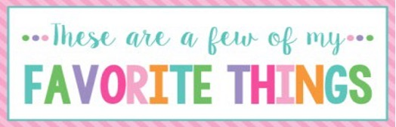

Name: | Kristy Williams | T-Shirt Size: | XL
Birthday: | March 31 | Monogram: | kWs
Favorite Color: | blue | Favorite Flower: | any
Favorite Scent: | fall | Favorite Candy: | Peanut m & m’s
Favorite Drink: | Dr. Pepper | Favorite Food: | Mexican
Favorite Snack: | Lays chips, pretzels | Favorite Fruit: | Watermelon, grapes
Favorite Restaurant: | Blue Agave, SONIC, Jason’s deli | Favorite Fast Food: | Sonic
Favorite Places to Shop: |  | Local stores, Kohl’s, Target
Favorite Bath & Body Works Scent: |  | Beach/ thousand wishes
Things I Collect: |  | Garden items, MSU items
Favorite Author/Book Series for Personal Reading: |  | mystery
Wish List for Classroom: |  | Card stock, colored paper, toy treats for rewards

