
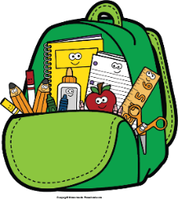
Mr. Marks’ Messages
August 11-15, 2024
Assessments
Friday Assessments: Math Quiz
Reminders
- If you haven’t joined Parent Square, please do so. This is my main source of communication.
- Please check your child’s binder daily for important information, homework, and their behavior chart.
- Monday-wear red, Tuesday-blue, Wednesday-yellow, Thursday-green, Friday- wear orange.
- Homework will be sent home Monday and is due Friday. Please send math homework to school each day. We will go over it in class.
Reading  This week the Open Court Getting Started Lessons will begin. These lessons will prepare the students for the unit lessons to come. We will work on reading fluency and comprehension. We will also take a few diagnostic/baseline tests that will help determine small group instruction. |  |  | Vocabulary Words  There will be no vocabulary words this week.
Math  Topic 1- Fluently Add and Subtract within 20  Lesson 1-5  Students will learn addition and subtraction strategies. Also, practice math homework to prepare for the math quiz on Friday. The quiz is a reflection of the homework. |  |  |  | Social Studies/Science  Science:  We will continue through a unit on matter and its attributes. Students will explain basic properties of matter, as well as explore changes in matter.
Spelling Words:
 |  | No spelling words this week.

