Mrs. Cannon’s Newsletter
November 4-8, 2024

New

Reading:
- Review R Controlled vowels
- Character, Setting, Plot
- 5 W Questions (Who, What, When, Where, Why)
- Main Idea and Details
- Character Point of View
- Unit 3 Test

Word Study Words:
Review R Controlled Vowels
(ar, er, ir, ur)

High Frequency Words:
Review Unit 3 words

Math:
- Addition strategies

Language:
- Informational Writing

Social Science:
- Lady Liberty
- Scholastic News

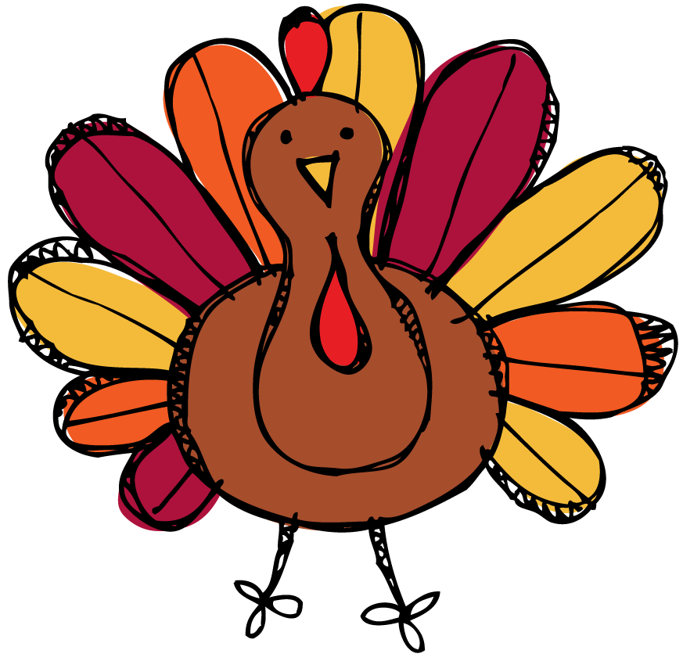
this week’s focus



Upcoming Events & Important Info

Student of the Week
Adilson
(If your child is student of the week and you would like to send in treats for the class, please send them in on Friday.
- PLEASE SEND EXACT CHANGE FOR SNACK. ($0.75 or $1.50) I do not have change to give back.
- PE: 11:20-112:05
- Lunch: 12:26-12:51
- Please label any money sent in (ex. -snack, field trip, etc.)
- Your child must wear tennis shoes or closed toe shoes to PE EVERYDAY!

- Wonderful Wednesday (special snack)- Wednesday for $2.00 (only send money on this day)
- Veteran’s Day program- Nov. 7th
- STEM Day- Nov. 8th
- Veteran’s Day- No School Nov. 11th
- Math Night- Nov. 12th
- Progress Reports- Nov. 14th
- Thanksgiving Lunch- Nov. 20th

Reminders

