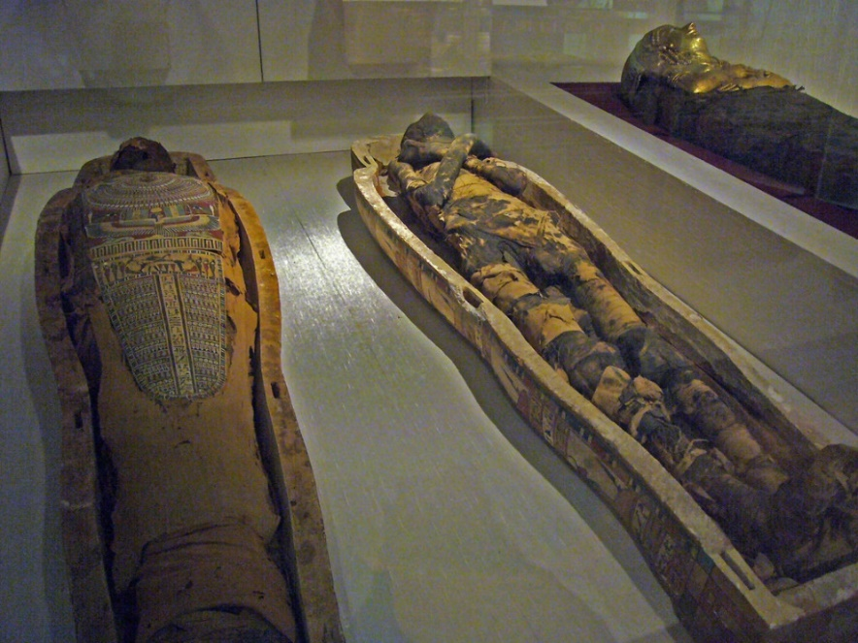
Reading News
Mrs. Williams
Date: April 6, 2026

Story: Mummies

Word Study:
-review words

Vocabulary:
mummies – a dead body that has been carefully prepared so that it will last a very long time
pharaoh – an Egyptian king
afterlife – life after death
god(s) – a god or gods that people worshipped long ago
x-ray – a special picture doctors/scientists use to see what is inside a body
deceased – no longer living

