Pay Check Deductions

Using the paycheck information below; calculate what percent each of the following

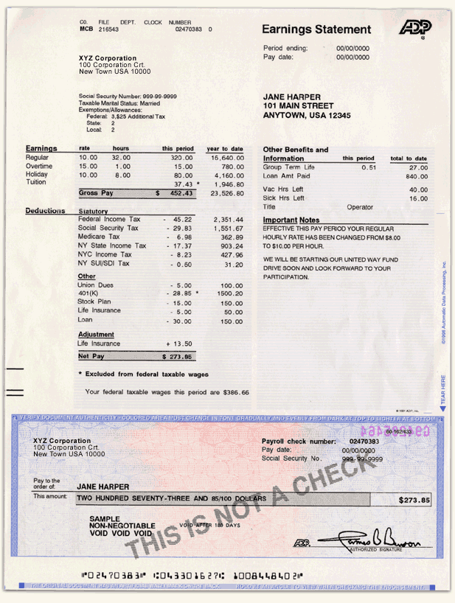is of the gross (pretax) income and write it on the lines after the questions:

Use paycheck information to answer questions below.

1. Federal Income Tax

2. State Income Tax

3. FICA

4. Medicare Tax

5. Total Deductions

**True or False Paycheck Quiz**

Check your understanding of taxes by answering the following questions.

1. Net pay is the total amount of income you receive during a pay period before taxes.

True  False

1. FICA Federal Insurance Contributions Act

True  False

Looking at it from the employer’s math



An employer has one employee, Bob Jones, who is paid $1800.00

per month before deductions. Bob is married and claims two

exemptions. His net paycheck is $1478.10. The details of his paycheck are:

⚫ Gross pay $1800.00

⚫ Federal income tax -145.00

⚫ State tax -39.20

⚫ FICA tax -111.60

⚫ Medicare tax -26.10

**Net pay $1478.10:** In addition, the employer must pay $111.60 for FICA and $26.10 for Medicare.

**Question**: What is the employer’s total labor expense for this month?

Solutions:

1. Federal Income Tax $45.22

2. State Income Tax $17.37

3. FICA $45.22

4. Medicare Tax $6.96

5. Total Deductions $273.06

1. False
2. True

The employer’s total labor expense for this

month is $1800.00 + $111.60 + $26.10 = $1937.70.