**District Social Studies Lesson Plan**

Teacher: Robinson/Hall Date: FEBRUARY 10-14, 2025 Subject: Social Studies Period:

|  |
| --- |
| Alabama CCRS/COS Standards:   * **E-G-H-CG-14**   Analyze the modern Civil Rights Movement to determine the social, political, and economic impact on Alabama. • Recognizing important persons of the modern Civil Rights Movement, including Martin Luther King, Jr.; George C. Wallace; Rosa Parks; Fred Shuttlesworth; John Lewis; Malcolm X; Thurgood Marshall; Hugo Black; and Ralph David Abernathy • Describing events of the modern Civil Rights Movement, including the Montgomery Bus Boycott, the Sixteenth Street Baptist Church bombing in Birmingham, the Freedom Riders bus bombing, and the Selma-to-Montgomery March • Explaining benefits of the Civil Rights Act of 1964, the Voting Rights Act of 1965, and Brown versus Board of Education Supreme Court case of 1954 • Using vocabulary associated with the modern Civil Rights Movement, including discrimination, prejudice, segregation, integration, suffrage, and rights |

|  |
| --- |
| Outcome(s)/Objective(s)/I can statement:  • I can recognize important persons of the modern Civil Rights Movement, including Martin Luther King, Jr.; George C. Wallace; Rosa Parks; Fred Shuttlesworth; John Lewis; Malcolm X; Thurgood Marshall; Hugo Black; and Ralph David Abernathy •   * I can describe events of the modern Civil Rights Movement, including the Montgomery Bus Boycott, the Sixteenth Street Baptist Church bombing in Birmingham, the Freedom Riders bus bombing, and the Selma-to-Montgomery March |

**ACTIVATING LEARNING STRATEGY/STRATEGIC TEACHING STRATEGIES:**

|  |  |  |  |  |  |  |  |  |  |  |  |  |
| --- | --- | --- | --- | --- | --- | --- | --- | --- | --- | --- | --- | --- |
|  |  |  |  |  |  |  |  |  |  | |  |  |
|  | KWL |  | Word Splash |  | Anticipation Guide |  | Lecture |  | Graphic Organizer/VLT | |  | Poem, Rhymes, etc. |
|  | Survey |  | Possible Sentence |  | Think-Pair-Share |  | Reading |  | Pictograph | |  | Acronyms/Word |
|  | First Word |  | Concept Map |  | Vocabulary Overview |  | Model |  | Diagram | |  | Other: ____________ |
|  | Word Map |  | Frayer Model |  | Daily Language Practice (DLP)___________________ |  | Hands-on |  | Mind Map/Visual Guide |  | |  |
|  |  |  |  |  |  |  |  |  |  | |  |  |
| **Engagement Strategies:**  - Collaborative Group Work  - Writing to Learn  - Literacy Groups  Other:_____________________  - Questioning Techniques  - Scaffolding Text  -Classroom Talk  - T.W.I.R.L. | | | | | | | | | | | | |
| **Technology Integration:**  Smart board  Document Camera  IPADS  Mac Books  Computers  Kindles  Interactive Tablets  Digital/ Video Camera  Clickers  ACCESS  Computer Program: www.studiesweekly.com__________________  Other:______________________________________ | | | | | | | | | | | | |

**This Week’s Vocabulary:**

Civil Rights Movement discrimination prejudice segregation integration suffrage rights

**AL 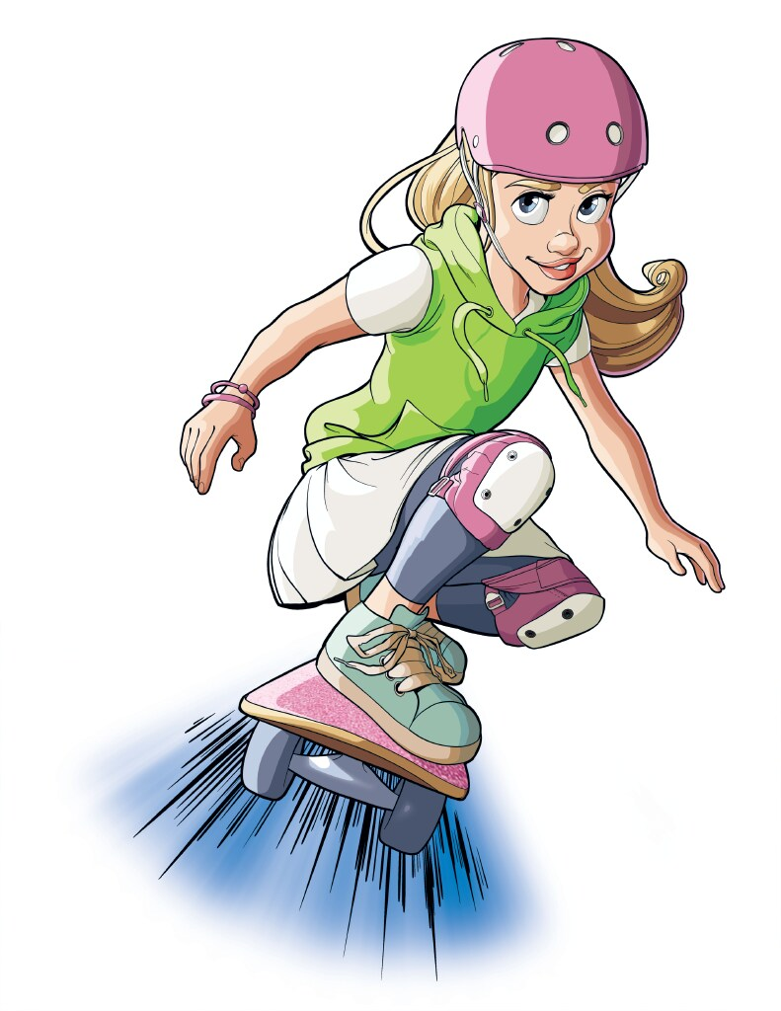ABAMA LEGISLATIVE JUDICIAL CONSTITUTION**

**EXECUTIVE**

**PROCEDURAL CONTENT (application)**

|  |  |  |  |  |  |  |  |
| --- | --- | --- | --- | --- | --- | --- | --- |
|  | | **Monday** | **Tuesday** | **Wednesday** | **Thursday** | **Friday** | |
| ***Essential Question*** | | WHAT WAS THE CIVIL RIGHTS MOVEMENT? | WHY WAS THERE A NEED FOR THE CIVIL RIGHTS MOVEMENT? | WHAT WERE THE GOALS OF THE CIVIL RIGHTS MOVEMENT? | HOW DID THE CIVIL RIGHTS MOVEMENT CHANGE AMERICA? | HOW DID THE CIVIL RIGHTS MOVEMENT CHANGE AMERICA? | |
| ***Daily Objective(s)***  ***I Can Statement*** | | **I CAN EXPLAIN** WHAT STATEHOOD MEANS. | **I CAN EXPLAIN** HOW ALABAMA MODELS ITS GOVERNMENT AFTER THE U.S. GOVERNMENT. | **I CAN EXPLAIN** WHAT A CONSTITUTION IS. | **I CAN EXPLAIN** THE SIGNIFICANCE OF ALABAMA BEING A STATE CAPITOL. | **I CAN EXPLAIN** IMPORTANT LEADERS IN EARLY ALABAMA. | |
| *Preview*  *(Before)*  *Warm-up- Hook* | | REAL WORLD INTRODUCTION  SAY SOMETHING  VIDEO | KWL/VIDEO | SAY SOMETHING  RECAP LESSON | SAY SOMETHING  RECAP LESSON | REVIEW | |
| *Instruction*  *(During)*  I Do-  We Do-  Y’all Do-  You Do- | | VOCABULARY BUILDER  QUICK WRITE  INDEPENDENT PRACTICE | REVIEW LESSON  INDEPENDENT PRACTICE | SHARE AND TALK  INDEPENDENT PRACTICE | TIMELINE  QUICK WRITE  ONE PAGER/ART TALK  INDEPENDENT PRACTICE | CHECK | |
| Small Groups | | CENTERS/GROUPS | CENTERS/GROUPS | CENTERS/GROUPS | CENTERS/GROUPS | CENTERS/GROUPS | |
| *After/Homework* | | GRAND CONVERSATION  STUDY NOTES | GRAND CONVERSATION  STUDY NOTES | GRAND CONVERSATION  STUDY NOTES | GRAND CONVERSATION  STUDY NOTES | GRAND CONVERSATION  STUDY NOTES | |
| **Assessment (Formative):** Class work Notebook Homework Quizzes Tests Computer Activities Collaborative Work  Project/ Other: | | | | | |

**Assessment (Summative):** QuizzesTestsGroup Activities Project Based Other:

**Summarizing****:**  3-2-1  Ticket out the Door  The Important Thing  Cue Cards  Teacher Questions  Student Summary  Other: