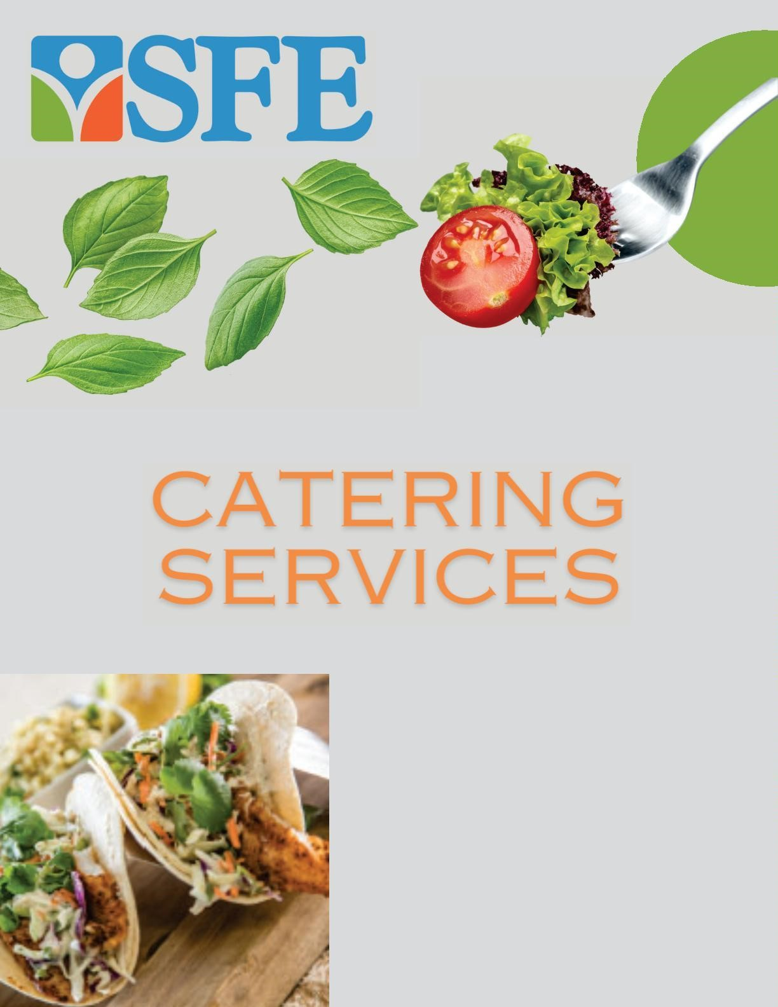

**TALK**

**TO**

**US:**

Chef Gary Johnson

314-

537-

4279

***gary.johnson***

***@sfellc.org***

***nicholsonl2@jenningsk12.us***

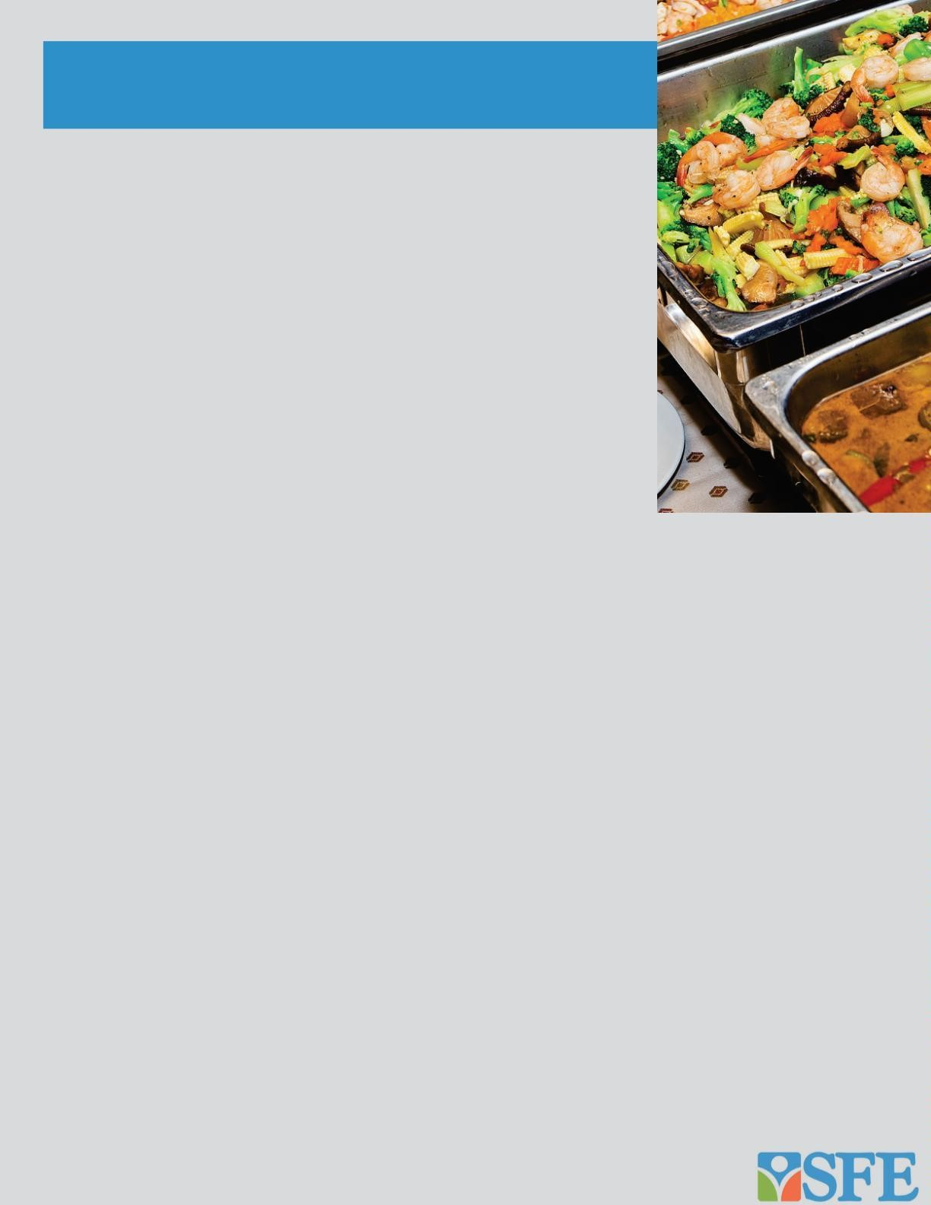Catering Request Information

**Thank you for choosing SFE’s Catering Services!**

Our Food and Nutrition Services Department offers a full range of catering expertise and knowledge. Our Catering Specialists are skilled in large-scale events such as business meetings, conferences, and receptions as well as small parties and coffee breaks. No matter what the event is, we will work closely with you to provide top-quality, professional services ensuring that your event is a success.

Although we have listed a variety of menu options, we welcome your ideas and suggestions. We can customize a menu that is uniquely yours. A customized menu may incur additional costs. Our goal is to make your occasion a pleasurable experience. On behalf of the SFE Food and Nutrition Services Staff, we look forward to catering your special events this upcoming year.

# Booking an Event

Please follow the catering guidelines below when placing an order. If you need additional information, contact Chef Gary Johnson, Southwest Foodservice Excellence (SFE) Catering Services Coordinator in the Food and Nutrition Services Department at gary.johnson@sfellc.org and (314) 537-4279.

1. Email and/or contact Chef Gary Johnson, SFE Catering Services Coordinator in Food and Nutrition Services

Department at gary.johnson@sfellc.org and (314) 537-4279, to submit your catering request. Please copy the General Manager of Foodservice on all catering requests. Catering requests must be submitted via email Monday-Friday by 4pm. ***Next day catering orders will not be accepted.***

1. **Complete the SFE Catering Request Form within SEVEN (7) days from the day of the event. All requests must be submitted via email to be considered valid. A confirmation will be sent within 24 hours via email when a catering order has been received. *THE MINIMUM AMOUNT REQUIREMENT TO RESERVE A CATERING IS***

***$150.00.***

1. SFE will forward the following attachments within 24 hours after booking the event via email. All three documents will be located at the lower left-hand corner of the attachment:

* **Catering Request Form**
* **Order Confirmation Form**
* **Invoice Form**

1. **Balances from prior caterings must be paid before any future caterings can be confirmed.**
2. It is the client’s responsibility to review all attachments.
3. The client should contact Chef Gary Johnson at gary.johnson@sfellc.org (314) 537-4279 immediately, if there are any questions and/or concerns about your catering event.

Catering Request Information

**Booking an Event, cont.**

1. After the event, it is the client’s responsibility to complete all required forms for payment (i.e., Checklist for invoice payments and reimbursements, voucher certification forms, etc. **Payments should be sent to:** Chef Gary Johnson at gary.johnson@sfellc.org.



# Enhance Your Event

Different serving styles are also available upon special request: wait staff, selfservice, buffet service, or pick-up service. We will discuss the type of service you need when you place your order with the Catering Services Coordinator. **The wait staff charge is $25 per hour.**

***We do provide tablecloths or linen for events.***

***Please be aware, there may be a charge associated with any unreturned or damaged items at the conclusion of your event.***

# Guarantees, Minimums and Deadlines

A minimum of 7 **days** is required for all new catering orders. Any balance from previous caterings must be paid prior to scheduling new catering. **No Exceptions**.

5 days prior to the event, the customer **must** provide the catering office with an estimate of the total guest guarantee. Any additional guests will be charged individually

# Cancellations

All cancellations must be emailed and submitted to Chef Gary Johnson at gary.johnson@sfellc.org (314) 537-4279 in the Food and Nutrition Services Department at **least 48 hours prior to the event. All cancellations shorter than 48 hours prior to event will be charged full cost.**

# Last-Minute Requests

We cannot guarantee modifications for booked events, including increased customer counts or changes and adds to menu selections unless a 5-day notice is provided.

# School Closings

In the event of school closings, the catering function will be considered void unless other arrangements are made. All preestablished prices in the catering guide will reflect the food, labor, paper products and overhead. They do not cover rentals or decorating fees.

**ALLERGEN WARNING:**

**Our food may contain traces of peanuts, tree nuts, soy and dairy products**.

# Great Beginnings

**All entrees are priced per person unless otherwise noted.**

**All breakfast entrees come with freshly brewed coffee and hot tea service.**

## Classic Continental Continental Express

Bakery Fresh Assorted Danishes, Freshly Baked assorted Danishes and an Freshly cut seasonal fruit, assorted Assortment of Fruit Juice. **$8.00 per person**

juices, and hot coffee + tea service

**$9.00 per person**

## Morning Sunshine

An assortment of layered Freshly Cut Seasonal Fruit and yogurt Parfaits topped with Granola.

**$7.50 per person**

## Yogurt Parfait Bar

Fresh seasonal berries and cut fruit, lowfat strawberry yogurt, granola and honey.

Juices and hot coffee + tea service

**$7.95 per person**

## Sunrise Breakfast

Light and fluffy scrambled eggs, your choice of savory pork or turkey sausage patties warm baked biscuits and freshly cut seasonal fruit tray.

**$9.70 per person**

## All American Breakfast

Light and fluffy scrambled eggs, seasoned breakfast potatoes, your choice of savory pork or turkey sausage patties, and assorted breakfast breads. **$10.00 per person**

## Coffee House Special

Assorted fresh bagels with a variety of cream cheese and assorted jams, freshly cut seasonal fruit tray and an assortment of fruit juice. Toaster not provided.

**$8.70 per person**

## French Toast Special

Hand dipped brioche, with whipped butter, scrambled eggs and your choice of savory pork or turkey sausage, bacon or cured pork ham. Sprinkled powdered sugar provided on the side. **$8.95 per person**

## Country Style Breakfast

Warm biscuits served with country style gravy, southern style breakfast potatoes, and your choice of savory pork or turkey sausage, bacon. Accompanied by fresh breakfast breads. **$9.70 per person**

|  |
| --- |
| **Great Beginnings**  **All entrees are priced per person unless otherwise noted.**  **All breakfast entrees come with freshly brewed coffee and hot tea service.**  **ALLERGEN WARNING:**  **Our food may contain traces of peanuts, tree nuts, soy and dairy products.** |

## Fresh Baked Quiche

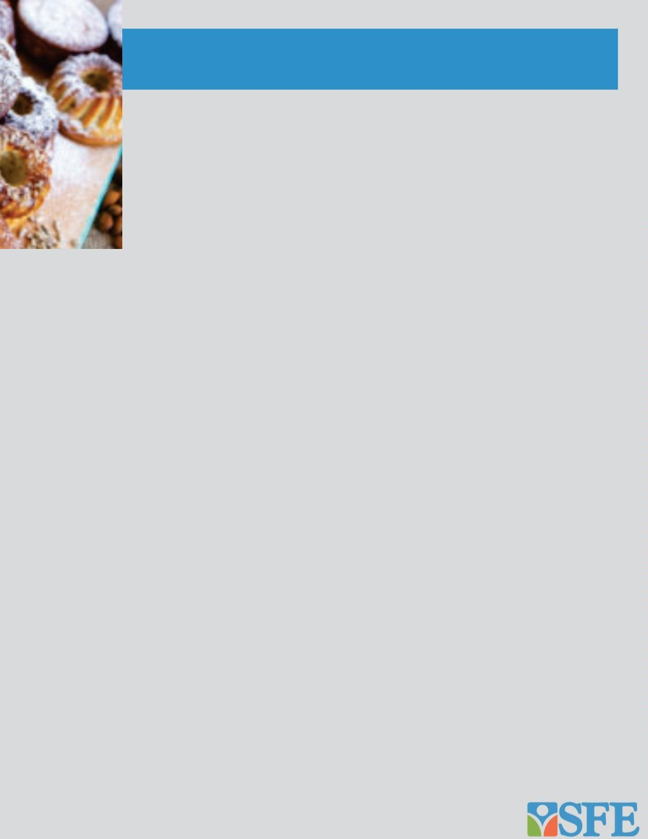

Flaky pie crust baked with fluffy egg custard customized with a variety of toppings.

Juices and hot coffee + tea service **$7.95 per person**

## Action Stations

**Made to order Omelets**:

Assorted breakfast meats and veggies

Freshly baked biscuits

Southwest potatoes

Fresh cut seasonal fruit

Juices and hot coffee + tea service $**11.50 per person**

## Buenos Dias Breakfast Bar

Fluffy scrambled eggs with one filling

(Sausage, ham, bacon, or vegetable)

Refried Beans & Southwest potatoes

Warm flour or corn tortilla House made salsa, shredded cheese, guacamole, and sour cream. Juices and hot coffee + tea service

**$8.95 per person**

## A La Carte

*All A La Carte Items are priced per person unless otherwise noted*

Selection of Fruit Juice $1.85

Seasonal Fruit Tray $4.50

Veggie Sausage $2.75

Scrambled Eggs $2.25

Hard Boiled Eggs (Per Dozen)

$7.50

Seasoned Cubed Potatoes $1.75

Southern Style Breakfast Potatoes

(cubed w/ peppers & onions) $1.95

Home Style Grits $1.50

Sausage or Bacon

(pork or turkey) $3.50

Coffee & Hot Tea Service $2.75

Assorted Muffins

(per dozen) $40.80

Bagels with cream cheese and jelly

(per dozen) $19.80

Assorted Danish (per dozen) $19.00

|  |
| --- |
| The Lunch Box  **All Lunch Specials, Boxed Lunches and Garden Fresh Salads are**  **priced per person unless otherwise noted.**  **Lunch Specials**  ***All lunch specials come with fruit punch, pink lemonade, lemonade or iced tea.***  **Pizza Special**:  Veggie, Cheese or Meat Topping, accompanied by a side salad. **$8.60**  **Wing Special:**  Hot, BBQ or Plain Chicken Wingettes (5-6), accompanied by a side salad.  Sauce is provided on the side. **$9.40**  **Grill Special:**  Grilled Hamburger or Hot Dog on a Bun, with Potato Chips**. $9.80** |

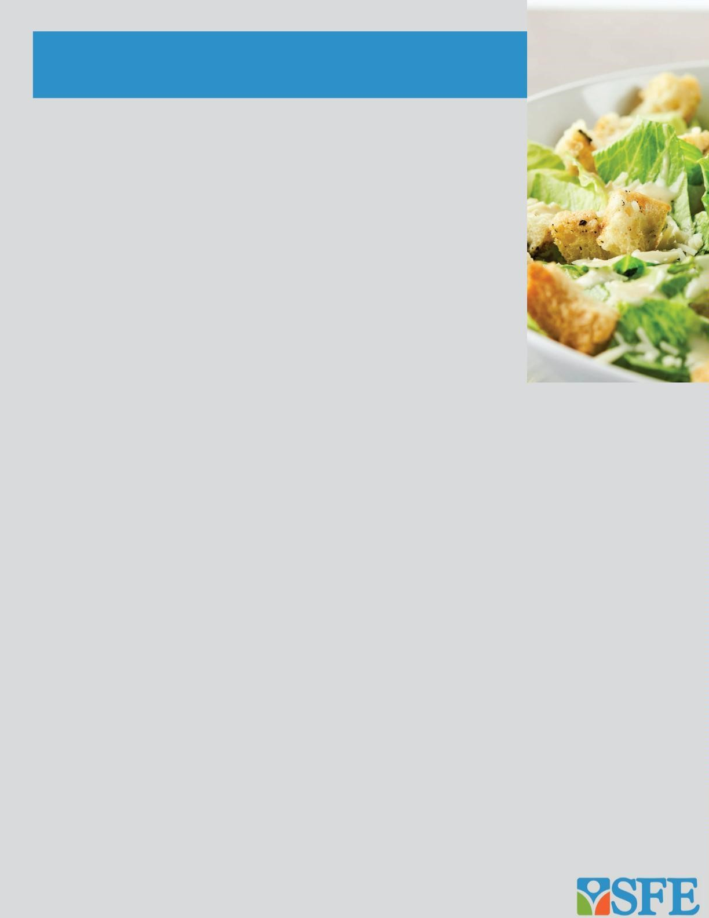**Deluxe Box Lunches**

**Boxed lunches include a cookie or**

**Brownie, bag of chips and fresh Fruit.**

***Add Soup to Any Sandwich, Wrap or Salad for an additional $3 per person!***

**Harvest Turkey**: Deli sliced roast turkey, Swiss, fresh leaf lettuce and sliced tomato on a hoagie roll. **$10.00**

**Chicken or Tuna Salad**: Creamy tuna or tender chicken salad with fresh lettuce & sliced tomato on a buttery croissant. **$10.70**

**Roast Beef and Cheddar**: Sliced roast beef, cheddar cheese, mayo, fresh lettuce and sliced tomato on a hoagie roll. **$9.80 Oven Roasted Veggie Wrap**:

Marinated grilled squash, peppers, red onion and zucchini with parmesan cheese, romaine lettuce and Italian dressing, rolled in a fresh wrap. **$9.80**

**Grilled Chicken Wrap**: Seasoned grilled chicken with mixed peppers, chipotle mayo,

tomatoes, shredded cheese, romaine lettuce, rolled in a fresh wrap. **$9.80**

,

### Garden Fresh Salads

**All salads are hand-prepared and served buffet style.**

**SFE’s House Salad:** Fresh mixed greens, grape tomatoes, sliced cucumber and shredded carrots. Served with oil and vinegar and Creamy Ranch Dressing. **$4.50**

**Greek Salad:** Chopped fresh romaine, artichokes, sliced black olives, feta cheese,

and sliced red onions. Served with a House Greek Dressing. **$4.45**

**Caesar Salad:** Chopped fresh romaine, shredded parmesan cheese and crispy garlic croutons. Served with a Creamy Caesar Dressing. **$4.60**

**Vinaigrette Pasta Salad:** Farfalle pasta, mixed peppers, onions, artichokes, black olives, and spinach. Served with Vinaigrette Dressing. **$5.25**

|  |
| --- |
| Small Bites Selections  All selections are priced per person unless otherwise noted.. |

**Dollar Sandwiches (2 each):**



Ham & Cheese, Roast Beef & Cheddar, Chicken Salad or Tuna Salad on a freshly baked dollar

roll. **$2.80**

**Chicken Wingettes:**

Choose from BBQ, Hot & Spicy or Plain. Served with assorted dipping sauce. Approximately 4 per person. **$6.75**

**Wrapped Pinwheels (2 Each):**

Roast Beef, Cheddar & Chipotle Mayo

Turkey, Swiss & Herb Ranch

Ham, Cheese & Sweet Chili Mayo

Veggie, Parmesan & Remoulade Mayo

**$2.95**

**Spinach Artichoke Dip: (Two Quarts)**

Served with Tortilla Chips **$72.00**

**Chef Gary’s Deluxe Trail Mix Bar:**

Assorted snack mix including plain M&M’s, Peanut M&M’s, cranberries, mixed nuts, chocolate morsels and pretzels. **$6.25/cup Individual Bagged Chips**

Your Choice of assorted varieties including

Plain, BBQ or Jalapeno **$1.50**

**Grilled Quesadillas:**

Zesty cheese mixture and your choice of chicken, beef or veggies. **$22.00/dozen**

*Guacamole, Sour Cream or additional toppings $1.40 per person*

**Teriyaki Meatballs:**

Homemade meatballs smothered in special teriyaki sauce**. $5.80**

**Vegetable and Cheese Tray:**

Fresh broccoli, tomatoes, carrots, cucumber and cauliflower with a creamy dipping sauce with assorted cubed cheeses and gourmet crackers.

**$8.95**

**Sweet & Salty Trail Mix (packets):**

Assorted snack mix including Peanut M&Ms

and Pretzels. **$1.30/bag**

**Vegetable (Crudité) Tray:**

Fresh broccoli, tomatoes, carrots, cucumber and cauliflower with a creamy dipping sauce**.**

**$6.40**

**Gourmet Fruit & Cheese Tray:**

Fresh cut seasonal fruit, assorted cubed cheeses and gourmet crackers. **$8.75**

**ALLERGEN WARNING:**

**Our food may contain traces of peanuts, tree nuts, soy and dairy products**.

|  |
| --- |
| Buffets  All Buffet selections include linen and service ware.  **Little Italy Pasta Bar**  Your choice of Linguini or Penne pasta, served with your choice of Marinara or Alfredo Cream Sauce. Accompanied by garlic bread and grated parmesan cheese.  **$8.00 per person**  *With Meatballs* **Additional $3.00 per person**  *With Italian Sausage OR Seared Chicken Breast* |

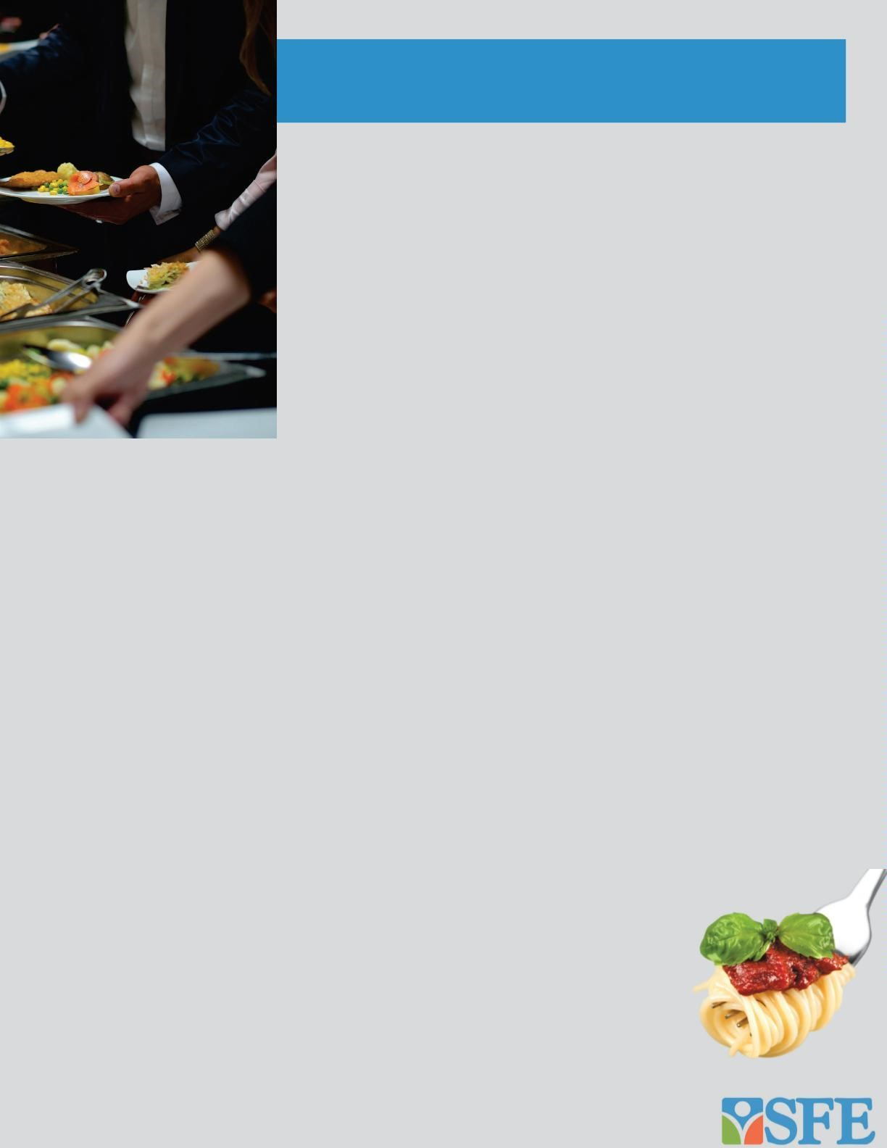

*Additional Pasta or Sauce*

*Bolognese Sauce*

### Fiesta Mexicana Taco Bar

Soft & crispy shells and seasoned ground beef, accompanied by assorted toppings and chips with fire roasted salsa.

**$8.00 per person**

*With Seasoned Chicken* **Additional $3.85 per person** *With Seasoned Ground Turkey*

**Additional $2.50 per person**

*With Mexican Rice (Vegetarian option)*

**Additional $2.25 per person**

*With Refried Beans (Vegetarian option)*

**Additional $2.50 per person**

*With Warm Cheese Sauce*

**Additional $2.75 per person**

*With guacamole, sour cream or extra toppings*

**Additional $2.00 per person**

### Backyard BBQ

Includes BBQ Baked beans, buttered corn cobettes, coleslaw, relish tray, dinner rolls and freshly baked cookies.

*With Smoked Beef Brisket* **$15.75 per person**

*With Smoked Chicken* **$13.25 per person**

*With St. Louis Style Ribs* **$15.50 per person Additional $3.85 per person**

**Additional $2.25 per person**

**Additional $3.25 per person**

### Pizza, Pizza, Pizza

Your choice of up to 3 pizzas:

Pepperoni, Cheese, Hawaiian,

BBQ

Chicken, Buffalo Chicken, Meat

Lover’s. Veggie, Taco.

Accompanied by Caesar Salad, Cookies or Brownies and Assorted Beverages.

**$9.95 per person**

### Homestyle Meatloaf

Homestyle Meatloaf with mashed potatoes and gravy and grilled seasonal vegetables. **$9.50 per person**

|  |
| --- |
| Buffets, cont.  All Buffet selections include linen and service ware.  **Build A Sandwich Buffet**  Assorted deli-fresh sliced meats, cheeses, and freshly baked breads and rolls. Accompanied by potato chips, lettuce, tomatoes, onions,  pickles and assorted condiments. **$10.75 per person**  *Add a cup of soup* **Additional $3.85 per person**  **Lemon Chicken Piccata**  Sautéed chicken in a lemon butter cream sauce, accented with capers and parsley. Accompanied by buttered penne pasta.  **$7.95 per person**  *Add a side salad* **Additional $1.50 per person** |

### Big Easy Buffet



Includes Cajun rice pilaf, roasted red pepper sauce, side salad and dinner rolls.

**$10.00 per person**

*With Blackened Chicken Breast*

**Additional $4.05 per person**

*With Blackened Tilapia*

**Additional****$5.60 per person**

### Baked Potato Bar

Baked potatoes with assorted sides including sour cream, butter, green onions, bacon bits, cheddar cheese and steamed broccoli.

**$7.75 per person**

*With Shredded Chicken or Chili*

**Additional $3.85 per person**

### Homestyle Favorites

Your choice of tender baked chicken or baked tilapia with a lemon butter sauce. Served with dinner rolls and your choice of two sides *(listed on next page*).

**$10.95 per person**

### Salmon Teriyaki

Salmon Teriyaki served with basmati rice and mixed vegetables **$10.00 per person**

### Basil Rosemary Chicken

Served with chicken au jus with fresh spinach

risotto. **$9.00 per person**

#### Mama’s Chicken Dinner

Breaded oven fried chicken with country-style green beans, garlic smashed potatoes and a corn muffin.

**$8.75 per person**

*Substitute Baked Chicken*

**Additional $2.00 per person**

**ALLERGEN WARNING:**

**Our food may contain traces of peanuts, tree nuts, soy and dairy products**.



Buffets, cont.

**Lasagna**

**Dinner**

House made tomato beef or creamy

vegetable getable lasagna

vegetable lasagna served with

Freshly baked garlic bread, Caesar or Garden Salad, cookies or

brownies and assorted beverages.

**$9.95 per person**

All Buffet selections include linen and service ware.

Yukon Potato Salad

$1.85

Southwest Coleslaw

$3.35

Classic Coleslaw

$3.35

Seasoned Green Beans

$3.35

BBQ Baked Beans (vegan)

$2.75

Mexican Rice

$2.75

Roasted Yukon Potatoes

$3.50

Rice Pilaf

$2.75

Steamed Broccoli

$2.50

Warm Breadsticks, Rolls or Corn Muffins

$2.50



Side Dishes

All Side Dishes are priced per person unless otherwise noted.

Classic Macaroni Salad

$2.85

Saffron Rice

$2.90

Confetti Pasta Salad

$4.05

Corn Cobettes

$2.50

Macaroni & Cheese

$3.50

Refried Beans

$2.50

Garlic Smashed Potatoes

$3.50

Seasonal Vegetables

$3.00



**ALLERGEN WARNING:**

**Our food may contain traces of peanuts, tree nuts, soy and dairy products**

.



Refreshments

**Service includes table set**

**-**

**up, cups, straws, napkins and service containers**

**All drinks are priced per person unless otherwise noted.**



Coffee & Hot Tea

$2.85

L Lemonade, Pink Lemonade, or Fruit Punch Dispenser Service

$1.75

Sweet or Unsweetened Iced Tea Dispenser Service

$1.75

Individual Bottled Water

$1.00

Assorted Fruit Juice

$1.85

Case of Individual Bottled Water

$24.00

Pure Leaf Sweetened or Unsweetened Bottled Tea

$3.00

Sweet Saint Louis

**All dessert selections are priced per person unless otherwise noted.**

Turtle Brownies with Caramel

$26.00 per dozen

Chocolate Fudge Brownies

$20.00 per dozen

Caramel Cake

$2.25 per person

Yellow Cake with Chocolate Icing

$2.25 per person

Homemade Apple Pie

$2.00 per person

Cheesecake

$2.25 per person

Carrot Cake

$2.50 per person

Freshly Baked Assorted Cookies

$11.00 per dozen

Homemade Peach Cobbler

*Half Pan (Feeds 15*

*-*

*20)*

$70.00 each

*Full Pan (Feeds 25*

*-*

*30)*

$105.00 each

Decorated Sheet Cake

*Half (Feeds approx. 48)*

$95.00 each

*Full (Feeds approx. 96)*

$145.00 each



**ALLERGEN WARNING:**

**Our food may contain**

**traces of peanuts, tree nuts,**

**soy and dairy products**

.