**Health Services**

in the

**Perry County School District**

**Health Requirements**

Meeting health requirements for school attendance is an important part of making sure your child is ready for school.  These requirements provide the assurance that your child is not only up to date on necessary immunizations, but also that he/she is healthy to attend school.  Keep your child “on track” by making sure that he/she meets the health requirements every school year.

**Virtual School-Based Health Programs (EduHealth)**

**Partnering with Primary Care Centers of Eastern Kentucky**

Virtual School-Based Health Programs can be used to provide high-quality healthcare using video technology.  PCSD Health Office staff will be the liaison with PCCEK to schedule and lead the video visits with PCCEK medical staff.  If needed, the virtual visits will be enhanced using a USB otoscope and stethoscope for the provider to hear and see in real time. School health office staff can test for flu, strep, and COVID if ordered by the provider at the time of the virtual visit. Medications can be prescribed at the time of the visit. Documents for consent and new-patient need to be completed for the initial visit annually. These are sent home at the beginning of the year or can be printed from this website under the health services tab.

**Your child doesn't have to miss school. You don't have to miss work.**

• With your consent, your child will have the opportunity to be seen by a Primary Care licensed healthcare provider, right from the school nurse's office

• You will be notified by the school nurse prior to initiating a video visit for their child.

• You do not need to be present for your child to be seen.

• Neither you nor your child are required to be a Primary Care patient to join the program.

**VACCINATIONS**

* It is important to check your child's immunization records and ensure they are up to date on all vaccines.
* Vaccination throughout childhood helps prevent potentially life-threatening, but vaccine- preventable diseases​​​​

**Visit this webpage to learn more about the importance of immunizations**

<http://www.publichealth.org/public-awareness/understanding-vaccines/>

**The Centers for Disease Control and Prevention Immunization Schedules**

[https://www.cdc.gov/vaccines/?CDC_AAref_Val=https://www.cdc.gov/vaccines/schedules/](http://www.cdc.gov/vaccines/schedules/)

**Immunization compliance is required for all students in the PCSD**

**Kentucky Immunization Registry (KYIR) Public Portal**

KYIR has launched a public facing portal that allows individuals to log in and access their child’s immunization records. Individuals can access their/their child’s full immunization record, COVID-19 vaccine specific record with a SMART Health Card QR code, and Kentucky’s official school certificate. Please see the attached one-pager with information and QR code to access [Getting Vaccination Records- English](https://drive.google.com/file/d/1CQxOwhTsSL30NfLpEeZQ14HyI1tTVxeW/view?usp=share_link)  [Getting Vaccination Records- Spanish](https://drive.google.com/file/d/1vWLAHFeL6EUJEEDB40EfugXsWaKmFjF6/view?usp=share_link)

In order for individuals to use the portal, there must be a matching email or phone number in their/their child’s KYIR record. For individuals attempting to access their own records, the portal pulls this information from the demographic page in KYIR, see [this guide](https://nam04.safelinks.protection.outlook.com/?url=http%3A%2F%2Flistserv.ky.gov%2Ft%2F2505346%2F13019482%2F1035%2F2%2F&data=05%7C01%7CKYHC%40LSV.UKY.EDU%7C67ec8c40ccdf46e71f1808dac0daee4a%7C2b30530b69b64457b818481cb53d42ae%7C0%7C0%7C638034344420031440%7CUnknown%7CTWFpbGZsb3d8eyJWIjoiMC4wLjAwMDAiLCJQIjoiV2luMzIiLCJBTiI6Ik1haWwiLCJXVCI6Mn0%3D%7C3000%7C%7C%7C&sdata=FgPkmmughsZeyOUezMTGsdoFqc5anBxXzR4iTqJGA9s%3D&reserved=0) for instructions. For parents and guardians attempting to access records for individuals under 18, it pulls this information from the primary contact. Please see [this guide](https://nam04.safelinks.protection.outlook.com/?url=http%3A%2F%2Flistserv.ky.gov%2Ft%2F2505346%2F13019482%2F1036%2F3%2F&data=05%7C01%7CKYHC%40LSV.UKY.EDU%7C67ec8c40ccdf46e71f1808dac0daee4a%7C2b30530b69b64457b818481cb53d42ae%7C0%7C0%7C638034344420031440%7CUnknown%7CTWFpbGZsb3d8eyJWIjoiMC4wLjAwMDAiLCJQIjoiV2luMzIiLCJBTiI6Ik1haWwiLCJXVCI6Mn0%3D%7C3000%7C%7C%7C&sdata=PP0IJeb0FfNW507FFYD5JS1RfAJglm3JSofzezEikCw%3D&reserved=0) on how to update that information.

Please email [KYIRHelpdesk@ky.gov](mailto:KYIRHelpdesk@ky.gov) with any questions you may have.

**VAPING**

The CDC is currently investigating over 450 cases of severe lung illness in at least 33 states, including five deaths that are potentially linked to the use of e-cigarettes. Recently, health care providers in Kentucky were asked to begin reporting cases.

The most common symptoms of this severe lung illness include cough, shortness of breath and chest pain.  Based on reports from several states, patients have also experienced fatigue, nausea, vomiting, diarrhea, fever, or weight loss. Although some of these symptoms may be common at this time of year, those who use e-cigarettes and experience any of the above symptoms should contact their health care provider immediately.

Use of e-cigarettes by youth in Kentucky is higher than the national average, and the rate of use has more than doubled from 2016 to 2018, as measured by the Kentucky Incentives for Prevention (KIP) Survey.  To help prevent more cases, NKY Health recommends the following actions:

● Talk with your students about e-cigarette use and warn them of the potential hazards of using these devices.  
● Advise parents to contact their child’s doctor immediately if the child has any of the above symptoms, especially if they are having serious breathing problems for no known reason

There are potential dangers of vaping, especially with THC, but also with nicotine. Many people think that e-cigarette liquid just contains water and flavorings; however, most e-cigarettes contain nicotine and/or other chemicals. They do not realize the very serious impact on their lungs and the rest of their body. If you are not using e-cigarettes or vaping, do not start. If you are currently using e-cigarettes or vaping, get help to quit.

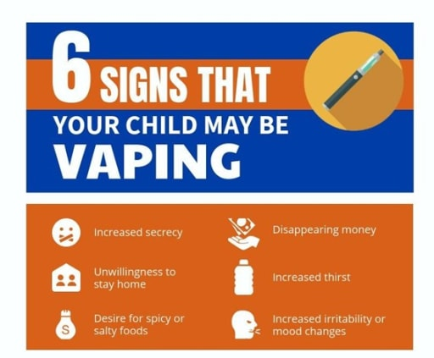

**Please take a minute to show your teens these public service announcements from other teens in our state.**

[http://www.ijustdidntknow.org](http://www.ijustdidntknow.org/)

**Communicable Illnesses:**

Per Kentucky Regulatory Statue (KRS) 158.160 parents and guardians are obligated to notify the student's school if the student has a medical condition that threatens the safety of the student or others in the school. The notification should be given as soon as the medical condition becomes known and upon each subsequent enrollment by the student in a school.

If any student is known or suspected to have or be infected with a communicable disease or condition for which a reasonable probability for transmission exists in the school setting, the district may order the student excluded from school. This KRS has been in effect since 2005.

[Reportable Diseases and Conditions in Kentucky](https://drive.google.com/file/d/18pCRyh_OVrYjBofn2jskLgPpeNMryqTC/view?usp=sharing)

**National Association of School Nurses**

**"School nursing, a specialized practice of public health nursing, protects and promotes student health, facilitates normal development, and advances academic success. School nurses, grounded in ethical and evidence-based practice, are the leaders that bridge health care and education, provide care coordination, advocate for quality student-centered care, and collaborate to design systems that allow individuals and communities to develop their full potentials."**

**The Importance of Sleep**

Many of the common complaints seen in the nurse's office (headache, stomachache, etc.) are the result of sleep deprivation.  The following article from the Center for Disease Control and Prevention discusses the importance of sleep and the recommended hours of sleep needed.

<https://www.cdc.gov/sleep/index.html>

**“… Sufficient sleep is not a luxury—it is a necessity—and should be thought of as a vital sign of good health.”**

Wayne H. Giles, MD, MS, Director,  
Division of Adult and Community Health,  
National Center for Chronic Disease Prevention and Health Promotion

**To help reduce the risk of virus transmission, students and staff should:**

* Wash hands often with soap and water for 20 seconds, especially after changing diapers if soap and water are not available use an alcohol-based hand sanitizer.
* Avoid touching eyes, nose, and mouth with unwashed hands.
* Cover your mouth and nose with a tissue when you cough or sneeze and put your used tissue in the waste basket. If you don't have a tissue, cough or sneeze into your upper sleeve or elbow, not your hands.
* Avoid kissing, hugging, and sharing cups or eating utensils with people who are sick.
* Stay home when feeling sick and consult their health care provider as needed. Children with cold-like symptoms that have trouble breathing should consult their health care provider for further evaluation.
* Disinfect frequently touched surfaces, such as handrails and doorknobs, especially if someone is sick.
* **In addition, we encourage staff and students, especially those with chronic respiratory diseases such as asthma, to be vaccinated against influenza as soon as the vaccine becomes available. Getting the flu along with an upper respiratory virus could be very serious for someone with chronic respiratory diseases.**
* **Do not come to school if you are sick.**

**Information and resources available to help guard against the spread of flu**

**Each flu season, flu causes millions of illnesses, hundreds of thousands of hospitalizations and thousands or sometimes tens of thousands of deaths. Vaccination can reduce flu illnesses, doctors' visits, and missed work and school due to flu, as well as prevent flu-related hospitalizations. Flu most commonly peaks during the month of February. If you have not gotten vaccinated yet this season, you should get vaccinated now— It's Not Too Late!**

Healthy people can get very sick from the flu and spread it to friends and loved ones.  
Following are the most important steps to help protect your family against the flu this season.

**Tips to prevent flu**

* Try to avoid close contact with sick people
* While sick, limit contact with others as much as possible to keep from infecting them.
* If you are sick with flu-like illness, CDC recommends that you stay home for at least 24 hours after your fever is gone except to get medical care or for other necessities. (Your fever should be gone for 24 hours without the use of a fever-reducing medicine.)
* Cover your nose and mouth with a tissue when you cough or sneeze.  After using a tissue, throw it in the trash and wash your hands.
* Wash your hands often with soap and water, If soap and water are not available, use an alcohol-based hand rub.
* Avoid touching your eyes, nose and mouth, Germs spread this way.
* Clean and disinfect surfaces and objects that may be contaminated with germs like flu.

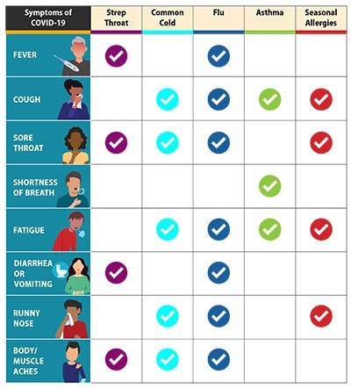

**Use the following guidelines to determine when students should stay home**

**Please keep your child home if any of the following are present:**

* a fever of 100º F (37.8º C) in the past 24 hours
* Tylenol or Ibuprofen used to control fever in the past 24 hours
* an undiagnosed rash
* sore throat
* new cough (for students with chronic cough due to allergies or asthma, a change in their cough from baseline)
* difficulty breathing (for students with asthma, a change from their baseline breathing)
* vomiting or diarrhea
* suspected conjunctivitis (pink eye) or yellow eye drainage
* new onset of severe headache, especially with fever
* sore throat/strep throat- if awaiting culture results or less than 24 hours of antibiotic treatment
* New loss of taste or smell
* Muscle aches or body aches
* Respiratory virus: COVID, Influenza, Respiratory Syncytial Virus (RSV)
  + Return to normal activities when symptoms are improving overall for at least 24 hours
  + If a fever was present, it must be gone without the use of fever-reducing medication for 24 hours

It's often difficult to tell how sick your child is in the morning.  Remember if they stay home and improve, you can always bring them to school. We appreciate your help as we work to prevent the spread of viruses and other communicable diseases throughout our communities. If you have any questions, contact the school nurse.

We look forward to a happy and healthy school year!

**Ashley Combs, District Health Coordinator**