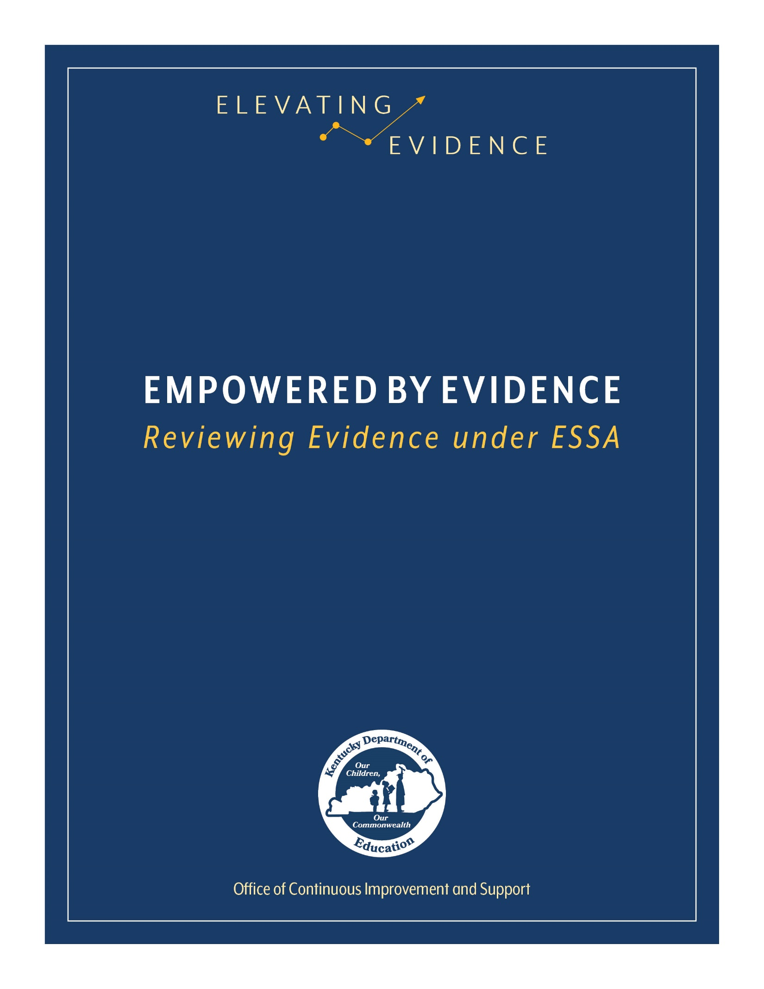

## Introduction

In 2015, the U.S. Congress reauthorized the Elementary and Secondary Education Act through a bill known as the Every Student Succeeds Act (ESSA). One of the requirements of ESSA is that school improvement initiatives be rooted in “evidence-based activities, strategies, or interventions.” While many clearinghouses and databases exist to assist schools in identifying and selecting appropriate evidence-based practices, it is important that education leaders and shareholders have the skills necessary to evaluate evidence on their own allowing for more informed decisions. This instrument provides a framework to guide education leaders and shareholders through the process of evaluating evidence.

While completing this instrument, consider the following:

* Examples are provided throughout the instrument; however, these are not comprehensive. There are other possible answers to a question outside of those that have been included. For consistency, each set of examples is limited to only three choices. The Kentucky Department of Education (KDE) encourages shareholders to fully examine a piece of evidence and answer the questions to the best of their abilities, even if the answer is not provided in the exemplar.
* This instrument is for individual use. No two evaluations will look exactly the same. While it is not required, if this instrument will be used as supporting documentation for a grant application or school improvement plan, please be as specific as possible by including exact quotations and American Psychological Association (APA) citations from the source.
* KDE recommends reading and annotating a study in its entirety before attempting to complete this instrument.
* Responses must be typed in the grey boxes, which will expand as information is entered.
* While completing the instrument, a district/school may find it beneficial to consult other resources. Relevant resources may include:
  + [Non-Regulatory Guidance: Using Evidence to Strengthen Education Investments](https://ed.gov/policy/elsec/leg/essa/guidanceuseseinvestment.pdf)
  + [ESSA Evidence Levels](https://education.ky.gov/school/evidence/Documents/ESSA%20Evidence%20Levels.pdf)
  + [Evidence-based Practices Glossary of Terms](https://education.ky.gov/school/evidence/Documents/Evidence%20Based%20Practices%20Glossary.pdf)
  + Webinar: [Evidence-based Interventions: An Overview](https://youtu.be/QAuwQX0cjVA)
  + Webinar: [Evidence for ESSA – An Introduction to Study Design](https://youtu.be/yGAmapMnjrk)

## Study Overview

Reason for Evaluation: TSI School Improvement Plan If other, describe: Click here to enter text.

Study Citation (APA preferred): Miller, C., & Oh, K. (2013). The Effects of Professional Development on Co-Teaching for Special and General Education Teachers and Students. Journal of Special Education Apprenticeship, 2(1).

Identify the Intervention Studied: Co-Teaching

Identify the relevant outcome(s) of the study. A relevant outcome is the student outcome(s) (or the ultimate outcome if not related to students) that the proposed process, product, strategy or practice is designed to improve, consistent with the specific goals of a program (i.e., reading comprehension).

This study suggests that professionaldevelopment on co-teaching has minimaleffects for students and teachers. However,the trends in the data support the theory thatco-teaching is a valid instructional tool forsome educators, and it could benefit somestudents. When looking at the teachers’ preand post surveys as a whole, it is apparentthat special education and general educationteachers see themselves differently. Bothgroups claim to bring different skills to theworkplace. After a semester of co-teaching,special education teachers report a slightincrease of scores in the areas that theirgeneral education counter-parts claim to bestrong in. The same trends are seen withinthe general education teachers, as they claimto be slightly more capable on the postsurvey in the areas that their specialTHE JOURNAL OF SPECIAL EDUCATION APPRENTICESHIP 16education teachers report as strengths. Whilestrong evidence for the benefits of coteaching are not presented in this study, it ispossible that the development of co-teachingpartnerships help foster an environment ofcollaboration among school staff

## Study Design

The study design provides a framework for the development and implementation of a study. A study is a detailed investigation and analysis of a subject or situation. The study design framework guides researchers as they collect and analyze data to test solutions and solve problems. Different study designs provide different levels of rigor and reliability. Education leaders and shareholders should carefully consider the study design used to evaluate an intervention.

In this section, you will evaluate the key features of study design. If you are unsure how to identify a study design, KDE encourages you to reference either the [Evidence-based Practices Glossary of Terms](https://education.ky.gov/school/evidence/Documents/Evidence%20Based%20Practices%20Glossary.pdf) or the [Evidence for ESSA: An Introduction to Study Design](https://youtu.be/yGAmapMnjrk) webinar.

1. Identify the study design: Correlational
2. If participants were assigned to groups, describe the method used to assign them to groups. Common group assignment methods include, but are not limited to, random assignment, matched pairs or class assignment. If participants were not assigned to groups, record N/A.

N/A

1. Describe any statistical controls used to control for study bias. Statistical controls are more common in correlational studies than experimental/quasi-experimental studies, but they can be found in both. Common statistical controls include, but are not limited to, analysis of covariance, difference-in-difference adjustments and correlation. If no statistical controls were used, record N/A.

N/A

## Analytic Sample

The analytic sample is the sample on which an analysis is based. It is important for education leaders and shareholders to take time to review the analytic sample used in a study. The [Non-Regulatory Guidance: Using Evidence to Strengthen Education Investments](https://ed.gov/policy/elsec/leg/essa/guidanceuseseinvestment.pdf) describes the importance of aligning the analytic sample with the population of your school. The highest quality evidence will align to a school in both setting and population and will include a large and multi-site sample.

1. Briefly describe the demographics of the analytic sample. Be sure to include any relevant information, including, but not limited to, grade levels, race/ethnicity, gender, socio-economic status, special education status or English language status.

The research site was a large, public middle school in California. The school is part of a school district housed in a very populous urban city. Students were enrolled in grades seventh and eighth and were between 12 and 14 years of age. The population fluctuates around 1,000 students. Approximately 50% receive free or reduced lunch, 40% are ELL, 13% are receiving special education services, 35% are Asian,30% are Latino, 20% are White, and 5% report other ethnicities.

1. How many people or groups of people participated in this study? 35 students and 22 teachers
2. How many study participants were assigned to the intervention group? If the study design did not include an intervention group, record N/A. N/A
3. How many study participants were assigned to the control group? If the study design did not include a control group, record N/A. N/A
4. Were any additional comparison groups used in this study? If so, describe the demographic makeup of the groups.

No

1. Describe the method used to select study participants.

The participants of this study were teachers who participated in a professional development on co-teaching and students at the middle school. Teachers were a convenience sample, as they were self selected to attend professional development. Students were selected from these teachers’classes. The students selected were in one of two categories: (a) general education students who received “below basic” on at least one of the standardized tests from the prior year, and (b) students who are receiving special education services.

1. How many sites were included in this study? One
2. Which descriptor best describes the setting of the study? Urban
3. Are there any special circumstances for the sample? Special circumstances may include, but are not limited to, the reporting of additional subgroups, alignment with common academic labels (such as “at risk” or “gifted”) or the exclusion of certain groups from the analytic sample.

The analytic sample did not include students who were not receiving Special Education services and did not include students who scored above the “below basic” level on the previous year’s standardized tests.

## Intervention Delivery

When evaluating evidence, it is important for education leaders and shareholders to consider the specific methods used by the researchers to implement an intervention. Schools should seek to replicate the conditions used in a study in order to achieve similar results. If an evidence-based practice is not implemented in a way that accurately replicates the conditions used in a study, the intervention may not work as reported.

1. Describe the way the intervention was implemented in this study. Be sure to include relevant details you may need to replicate the results, such as the intervention delivery method, materials used and other protocols unique to this study.

The intervention was a professional development focus group for teachers. The objective was to learn the basics of coteaching. They discovered strategies to coassess, co-plan, and co-instruct. Teams of co-teaching teachers decided on a standing co-planning appointment with their teams.They received direct instruction on how to co-teach yet were allowed the creative space to design their schedules and lessons with their partners as they see fit.

## Results

The [Non-Regulatory Guidance: Using Evidence to Strengthen Education Investments](https://ed.gov/policy/elsec/leg/essa/guidanceuseseinvestment.pdf) suggests that quality evidence “shows a statistically significant and positive (i.e. favorable) effect of the intervention on a student outcome or other relevant outcome.” Education leaders should pay careful attention to the results of a study and how those results were collected.

1. Describe the procedures used to collect data for this study. This information may be found in the Methods or Results section of the study. Be sure to include all relevant information such as the names of any standardized assessments, the conditions under which an assessment was given or archival data sets used.

The data were collected in two phases. When teachers participated in the professional development in August of 2011, they completed the survey about coteaching experience, expectations, and philosophy. These teachers took a postsurvey in December of that same year. Thes urveys were distributed through the internal email service and on paper. The data were collected through printed or handwritten responses. Students selected from these coteaching teachers’ classes took a survey about their experiences with co-teaching, academic success, and perception of special education services. After being potentially co-taught for a semester, the students took the post-survey, measuring the same variables.

1. Describe the findings of this study. Be sure to include the findings for any reported subgroups and relevant outcomes and a discussion of the statistical significance of the results. It is generally accepted that study findings are statistically significant when *p* is less than 0.05 (p<.05). APA standards state that studies should include the *p* value when reporting on statistical significance either within the text or in a parenthetical. For example, the results of the statistical test Analysis of Variance should be reported [*F* (2, 145) = 3.24, *p* = .04]. In this example, *p* equals 0.04, which is less than 0.05. This would indicate that the results of this statistical test are significant.

The quantitative results of the surveys were analyzed. First, we report the analysis of the data for the student groups’surveys, and then data from the teachers’surveys. There were no statistically significant changes in the pre-surveys and the post-survey of either student group. Eighty percent of students receiving special education services responded affirmatively to the question posed in both the pre and post-surveys. Seventy-five percent of the students receiving general education answered affirmatively in the pre-survey, and in the post-survey 100% of general education students responded affirmatively. There were no statistically significant changes in the pre-surveys and the postsurvey of either group. Overall, special education teachers report having received more information about coteaching than general education teachers. All special education had received information about co-teaching through articles, books, observation, teaching, and talking with colleagues. Approximately half of both special and general education teachers had already had professional development on coteaching. Most general education teachers either received information about coteaching through talking to their colleagues or previous professional development.

## Implication

Once a piece of evidence has been evaluated, education leaders and shareholders should consider the implications of the study on their school’s potential implementation of an evidence-based practice. In this section, you are encouraged to look beyond the items discussed in the study to consider your local context and school’s capacity to implement an intervention with fidelity.

1. Describe the implications of this study for your school. Does the study support the use of this intervention in your building? What special considerations are necessary for implementing this intervention? Be sure to examine all relevant factors, including cost, time and manpower.

This study included teachers who had participated in Co-Teaching professional development and who were at the beginning of the implementation process in their classrooms. Our district had Co-Teaching professional learning right before the COVID shutdowns and is now back to an emphasis on implementation in our classrooms. Costs currently include training new teachers and also providing Special Education consultants who are in classrooms modeling and coaching veteran teachers in the Co-Teaching method. This study supports co-teaching as a whole; however, the authors warn that a more accurate and reliable study on Co-Teaching should be conducted over a much longer period of time.

1. Identify any additional pieces of evidence referenced in this study that you may want to review before implementing the intervention.

N/A

1. Using the [ESSA Evidence Levels](https://education.ky.gov/school/evidence/Documents/ESSA%20Evidence%20Levels.pdf) one-pager, consider all of the information collected here and provide an estimate of the level of evidence provided in this study. Demonstrates a Rationale (Level IV)