Neil Middleton

WYMT-TV

VP General Manager

August 20, 2021

Dear Guidance Counselor,

It is hard to believe another school year is upon us. And this one is drastically different than any other school year we have encountered. I want to thank you and all of our education professionals for the contributions you are making to our students and their future success.

WYMT-TV wants to honor your outstanding seniors again this year.

I have included the following Applications.
- WYMT Mountain Classic Scholarship – (October 1, 2021 Deadline)
- Ralph Gabbard Memorial Scholarship – (October 1, 2021 Deadline)
- Tony Turner Memorial Scholarship – (October 1, 2021 Deadline)
- Mountain Student Achiever (Two students announced weekly) *Please send immediately!

Here are the guidelines for the Mountain Student Achiever.

You may nominate any senior deserving of this honor. Make copies of the enclosed form for each additional student.

Students must have a 3.7 GPA or higher. A Photograph (no larger than wallet size) must accompany each form. Please do not staple photos. Please include the student’s extracurricular activities and community service. Winners are selected based on their GPA, extracurricular activities, and community service.

Please send Student Achiever nominations ASAP to:

WYMT-TV
Attn: Student Achiever
P.O. Box 1299
Hazard, KY 41702

Should you have any questions please feel free to call. (606) 436-5757

Best Wishes,

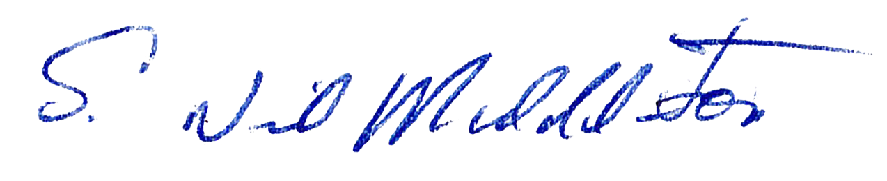

Neil Middleton

