Hatch Valley HIGH SCHOOL
(575)267-8230 | 170 E Herrera, HATCH, NM 87937

Hatch Valley High School
STUDENT HANDBOOK
2023-2024
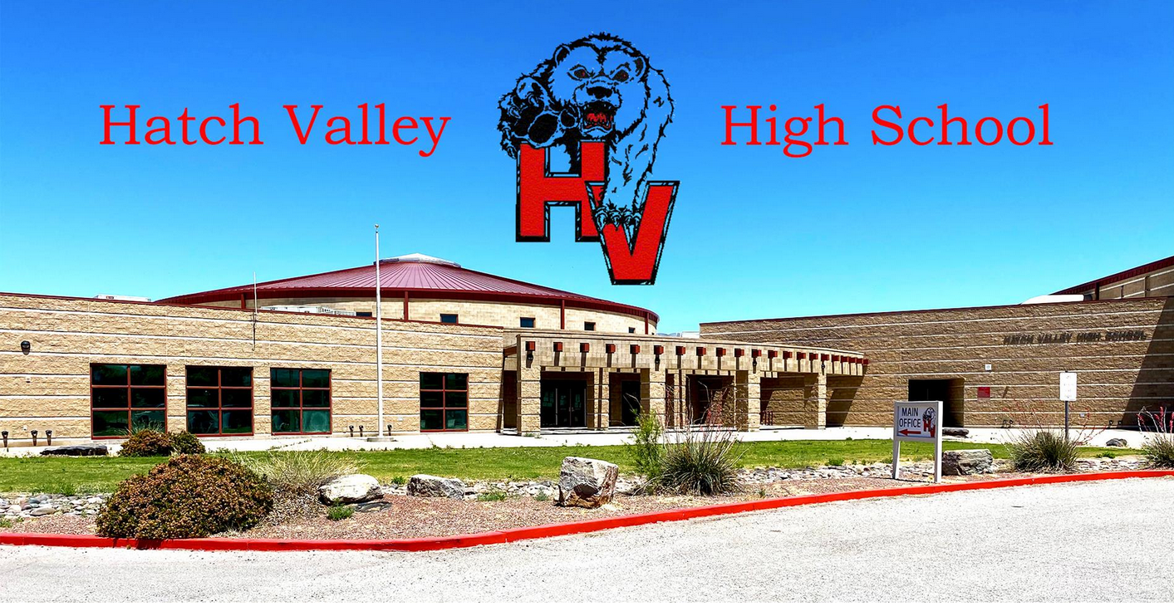

Table of Contents
General Information 4
HVHS Mission Statement 4
HVHS Vision 4
HVHS FIGHT SONG 4
FEDERAL PROGRAMS 4
FERPA 4
MEGAN’S LAW 4
NOTICE OF NONDISCRIMINATION 4
VIDEO SURVEILLANCE & ELECTRONIC MONITORING 5
REGISTRAR 5
ENROLLMENT REQUIREMENTS 5
OPEN ENROLLMENT/TRANSFER 5
WITHDRAWAL PROCESS 5
ATTENDANCE 6
ATTENDANCE POLICY 6
CHRONIC ABSENTEEISM 7
TARDIES 7
ASSESSMENTS-GRADES-GRADUATION 7
CREDIT RECOVERY 7
GRADES 8
GRADUATION & CEREMONY REQUIREMENTS 8
GRADUATION REQUIREMENTS 9
MAKE UP WORK 9
POWER SCHOOL PARENT PORTAL 10
PROMOTION/RETENTION 10
REPORTING STUDENT PROGRESS 10
TESTING REQUIREMENTS 10
VALEDICTORIAN, SALUTATORIAN AND TOP TEN SELECTION 10
GENERAL RULES 11
After School Pick up 11
ARRIVAL AT SCHOOL 11
BACKPACKS/BAGS 11
CUSTODIAL RIGHTS OF PARENTS 12
DELIVERIES FOR STUDENTS 12
EMERGENCY SAFETY DRILLS 12
EMERGENCY SITUATION 12
FIELD TRIPS 12
HALL PASSES 12
LEAVING SCHOOL EARLY 13
MONEY 13
Open/Closed Campus 13
PARENT INVOLVEMENT 14
PARENT TEACHER CONFERENCES 14
PERSONAL PROPERTY AT SCHOOL 14
PHYSICAL EDUCATION (PE) 15
SALE OF ITEMS BY STUDENTS 15
DRIVING REGULATIONS - STUDENT PARKING 15
Parking Permits 15
STUDENT PICK UP 16
SKATEBOARDS/BICYCLES 16
SNACKS 16
STUDENT VISITORS 16
SUPPLIES 16
TELEPHONE, OFFICE 16
TEXTBOOKS 16
VISITORS 16
VOLUNTEERS 17
WELLNESS 17
STUDENT SERVICES 17
ADMINISTERING MEDICATION TO STUDENTS 17
BILINGUAL PROGRAM 18
COMPUTERS/TECHNOLOGY 18
GUIDANCE AND COUNSELING 18
HEALTH SERVICES 18
INSURANCE 19
LIBRARY PROCEDURES 19
LOST AND FOUND 19
PARENT NOTIFICATION 20
SCHEDULE: 20
Bell Schedule 20
Days Schedule 21
SCHOOL CAFETERIA 22
STUDENT BASED HEALTH CENTER 22
BUS TRANSPORTATION 23
CODE OF CONDUCT 23
STUDENT HARASSMENT/BULLYING/CYBER BULLYING 23
CHEATING & PLAGIARISM 23
CELL PHONE POLICY 24
DANCE & PARTY RULES 25
DRESS CODE 25
DRESS CODE ENFORCEMENT 25
DRESS FOR PHYSICAL EDUCATION 26
Drug Detection Canine 26
PROHIBITED ITEMS 26
PUBLIC DISPLAY OF AFFECTION 26
RESPECT FOR AUTHORITY 26
RESPECT FOR PROPERTY 27
RESPECT FOR SELF AND OTHERS 27
SAFETY 27
SEARCHES 27
THREATS OF VIOLENCE 27
VAPES AND VAPE USE 27
WORK HABITS 28
DISCIPLINE CODE 28
STUDENT DISCIPLINE CODE 28
Discipline Matrix 29
ATHLETICS -EXTRA CURRICULAR ACTIVITIES 29
ATHLETICS 29
ACTIVITES 30
NATIONAL HONOR SOCIETY MEMBERSHIP 30
HVPS PROCEDURES FOR USE OF DRUG DETECTION DOGS 30

General Information

HVHS Mission Statement
HVHS strives to inspire a shared sense of community by developing, motivating, supporting, and emphasizing the relevance of learning in our changing society. Ultimately, to revitalize student pride, involvement and create opportunities for future success.

HVHS Vision
Motivate, Educate, Graduate ALL students at Hatch Valley High School

HVHS FIGHT SONG
Hatch Valley High School
Hatch Valley High School
The pride of every loyal bear!
Come on you old grads, come join us young lads!
Hatch Valley High School now we cheer, Rah, Rah, Rah
Now is the time boys to make a big noise!
No matter what the people say!
For there is none to fear, the gang’s all here! So, hail to ole Hatch Valley High!

FEDERAL PROGRAMS
Complaint Procedure for an alleged violation of a Federal Program has occurred: please follow procedures outlined in NMAC 6.10.3.8 FILING A COMPLAINT

FERPA
“The school maintains confidential student records for each student enrolled in the school. The school complies with the U.S. Family Educational Rights and Privacy Act (FERPA) to keep student records confidential and to provide procedures and establish responsibility for collecting, maintaining, and releasing information about students that is contained in student records. Parents who wish to have student directory information restricted need to complete and submit the FERPA Directory Information Sheet declaring their students not to participate in the district’s PERPA Directory to the front office of the school”

MEGAN’S LAW
Hatch Valley Public Schools Board of Education supports the purposes of the Sex Offender Registration and Notification Act
(New Mexico’s version of “Megan’s Law”) Chapter 29, Article 11A NMSA 1978. Registered offenders are listed on the state. Website: http://www.nmsexoffender.dps.state.nm.us/

NOTICE OF NONDISCRIMINATION
HVPS School Board Policy A-0250 AC the Board is committed to a policy of nondiscrimination in relation to race, color, religion, sex, sexual orientation, age, national origin, and disability. This policy will prevail in all matters concerning staff members, students, the public, educational programs and services, and individuals with whom the Board does business.

VIDEO SURVEILLANCE & ELECTRONIC MONITORING
In order to protect school property, promote security and protect the health, welfare and safety of students, staff and visitors, HVMS will use video surveillance and electronic monitoring equipment on school property, and in school buildings and school buses. Information obtained through video Surveillance/electronic monitoring may be used to identify intruders and persons breaking the law, school policy, or the Student Code of Conduct (i.e., it may be used as evidence in disciplinary actions and criminal proceedings).”

REGISTRAR

ENROLLMENT REQUIREMENTS
- Students must reach the age of five prior to September 1, the year of enrollment, to be eligible for entrance into the kindergarten program. Children must reach the age of six prior to September 1, the year of enrollment, to be eligible for entrance into the first grade.
- Complete new student registration packet
- Proof of student’s Date of Birth - birth certificate
- Current immunization record
- Evidence of physical address – utility, water, gas, or electric bill
- Official withdrawal papers from former school with complete list of current classes and withdrawal grades. (If Applicable)
After all papers are in order, the new student will be assigned classes based on his/her withdrawal form. Substitutions will be made for any classes not offered at Hatch Valley High School when possible. Evaluation of credits for graduation will be made from a completed, official transcript. HVHS will offer to temporarily register students with unofficial transcripts to ensure that your student has access to an education. In order to determine a student’s plan for graduation, along with a potential graduation date, our registrar must receive official transcripts. If HVHS does not receive official transcripts from your student’s previous institution, the parent and student understand and agree that we will only award credit towards graduation that the student has earned at Hatch Valley High School.

OPEN ENROLLMENT/TRANSFER
HVPS has an open enrollment policy. Students are required to attend the school within their residential boundaries unless approval of a transfer has been obtained. All open enrollment transfers must be submitted to and approved by the school’s principal office annually. Falsification of residence information may result in the withdrawal of a student.

WITHDRAWAL PROCESS
When students withdraw from HVHS, they must be accompanied by a parent. An administrator/counselor will authorize the withdrawal process. Students must fill out and complete a Withdrawal Form to present to the receiving school or district.
Students shall turn in all textbooks, musical instruments, library books, athletic equipment, all technology and all fines must be paid before their school records will be released.

ATTENDANCE

ATTENDANCE POLICY
The parent or guardian is charged by law with responsibility for the student's school attendance. The New Mexico statutes governing school attendance are very specific (Attendance for Success Act: NM House Bill 236/a) and leave little option for school authorities to excuse children from school. HVPS code classifies absence from school as excused or unexcused.
Excused Absences: The following conditions constitute reasons for excused absence from school: Absence from a class or school day for a death in the family, medical absence with written documentation, religious instruction or tribal obligations, interscholastic extracurricular activities or any other allowable excuse pursuant to the policies of the local school board.
Per semester, three written excuses from home will be accepted to excuse absences. After three notes from home, only a doctor’s note or an absence due to a death in the family will be excused.
Unexcused Absences: an absence from a class or school day for which the student does not have an allowable excuse pursuant to the Attendance for Success Act or policies of the local school board. i.e. Absences that are not followed by written documentation from the parent or doctor, hair appointments, oversleeping, and/or vacations.
All documentation must be submitted within 5 working days from the last day absent. All absences not verified by parental or administrative authorization will be considered unexcused.

Number of Absences | School Intervention
1-2 Absences | School will call parents to inform them of absence
3 Absences | School will call parents to inform them of absence.
5 Absences | NOTIFICATION LETTER WILL BE SENT HOME Attendance meeting notification will be sent home. Parents are required to attend. Implement intervention strategies to support keeping the student in an educational setting.
10 Absences | Attendance meeting notification will be sent home. Parents are required to attend. Students will lose electives, and will have to attend study hall. (remove for Elem) and students will sign an attendance contract. May meet with SRO
14 Absences | Attendance meeting notification will be sent home. Parents are required to attend. Potential CYFD referral.
20 Absences | Attendance meeting notification will be sent home. Parents are required to attend. Potential CYFD referral. Meet with Superintendent

CHRONIC ABSENTEEISM
The regular school attendance of a child of school age is required by state law. Regular school attendance is essential for success in school; therefore, absences shall be excused only for necessary and important reason. Absent means not in attendance for a class or school day for any reason, excused or not except for interscholastic extracurricular activities.
HVPS shall provide progressive interventions for absent, chronically absent and excessively absent students outlined in NM HB236/a section 11 and section 12

TARDIES
All students must be in their classrooms when the tardy bell rings. All parents and students should understand the importance of being on time. Written “excuse” from a medical doctor or dentist, or a late bus arrival is the only “excused” reason for being tardy.
Tardies will accumulate on a monthly basis. Students who receive two unexcused tardies within a month will be referred to the principal. If a student accumulates 3 or more tardies in a month, the student’s parents will be required to meet with the assistant principal.

ASSESSMENTS-GRADES-GRADUATION

CREDIT RECOVERY
HVHS uses E2020 for credit recovery, the following requirements must be met to use E2020:
- E2020 is a Senior course
- Seniors who have not met graduation requirements (AP, Honors, Dual Credit) are eligible for an E2020 Course
- Seniors who need a Health Credit (only 1 semester)
- Only Seniors may only enroll in Government if the face-to-face course is unavailable (either semesters) or they need a distance learning credit.
- E2020 Course may not be available at HVHS face-to-face
- IF a Senior has not passed a face-to-face course TWICE, they can be eligible for the E2020 course
- Any Senior pursuing the Bilingual and Biliteracy Graduation Seal needing a language E2020 course.
- As 11th graders students have an opportunity to enroll in AP and Dual Credit courses (which should be encouraged from previous interest AND to increase our Dual Credit enrollment so as to not lose it), only after these options will a senior be afforded the opportunity to enroll in a Distance Learning course E2020.
- Juniors must first exhaust summer school and face to face options before petitioning for a review for enrollment in E2020 (regardless of credit status and graduation status)
- Juniors are only allowed admittance into an E2020 course with approval after a review from advising team and have been determined ‘critical’ from counselors due to being behind in credits yet have potential to graduate on time with summer school credits
- Non-Seniors may enroll in E2020 Core Courses to pursue early graduation only after they have successfully completed the Early Graduation Application and have received approval
- If a student has previously failed an E2020 course, a one-on-one session with the E2020 coordinators and counselors must be conducted before they’re allowed to sign up again.
- A remedial E2020 course DOES NOT meet the online component of graduation requirements
In addition, students must pass Graduation Exams required by the New Mexico Public Education Department

GRADES

Progress Report Dates | Report Card Dates
August 18, 2023 | September 13, 2023
September 29, 2023 | November 1, 2023
November 17, 2023 | December 20, 2023
January 26, 2024 | February 15, 2024
March 8, 2024 | April 10, 2024
April 26, 2024 | May 23, 2024

GRADUATION & CEREMONY REQUIREMENTS
All requirements for graduation must be met completely before a student can participate in graduation exercises. This means students must have completed the required credits and have passed the all High School Graduation Exams before the end of the regular school year. Additionally, all fees and fines must be paid in full, credit appeals must be completed, the official check-out paperwork, before a student is allowed to participate in graduation ceremonies or have official transcripts mailed on their behalf. Please pay fees each year so they do not accumulate over the high school career.
Ultimately it is the responsibility of each parent/student to ensure that the student has fulfilled the required credits and test scores necessary to obtain a diploma from HVHS. Parents and students need to be familiar with the Next Step Plan to capitalize on opportunities that lead to post-high-school options. A diploma will be issued to those students meeting State and District credit requirements as well as State Testing Requirements. Students not meeting both credit/testing requirements may be issued a Certificate of Completion and be given the opportunity to retest after graduation to earn a diploma.
Participation in the high school commencement exercises is encouraged but is not compulsory. However, since these exercises require planning and rehearsals, the following rules shall apply:
- Students who wish to participate must be present at the rehearsals. Failure to do so, except for legitimate reasons, may because for excluding students from participating in the graduation exercises.
- Students must pay all fees, fines and charges prior to the ceremony.

GRADUATION REQUIREMENTS
Subject Area | Credits | Additional Information
English | 4.0 | English I, II, III* and IV or higher
Mathematics | 4.0 | One must be equivalent to Algebra II* or higher
Science | 3.0 | Two must earn lab science credit
Social Sciences | 3.5 | New Mexico History - .5, US History - 1, World History - 1
Physical Education | 1.0
Health | 1.0 | Taken in Middle School
Career Cluster, Workplace Readiness or a Language other than English | 1.0 | See your counselor to find out what classes fulfill this requirement.
Electives: | 12.0
TOTAL CREDITS: | 29.0

MAKE UP WORK
Students have a responsibility to make up work regardless of the reason for the absence. The teacher has an obligation to provide the student with resources in order to learn the material missed during an absence. This may include the actual class work assigned during the student’s absence or an alternate assignment to cover the same material. It is the student’s responsibility to learn the missed material, including completing alternate assignments deemed appropriate by the teacher.
The student has three days after the absence to complete and submit the assignments. A school activity (field trip, athletic event, etc.), in-school suspension, short-term suspension are all considered to be an excused absence; therefore, the material will be graded and included in the student’s overall grade average. If the absence is unexcused, the teacher may provide the student with the missed assignment. The teacher also has the option of grading the assignment and averaging it into the student’s overall average.
INCOMPLETES
- At the end of the semester, incompletes may be given at the discretion of the teacher for those students with excessive excused absences.
- The deadline for changing "incomplete" grades is two (2) calendar weeks from the final date in which grades are due to the school office.
- All work not completed by the deadline will be assigned zero points and averaged with other class work for the final term grade.

POWER SCHOOL PARENT PORTAL
Parents are able to monitor students' grades through the PowerSchool Parent Portal. Please create a parent power school account on the portal. The Portal can be found on the HVPS website under the Parents page or use the following url www.hatch.powerschool.com/public/home.html

PROMOTION/RETENTION
The promotion/retention of a student in any grade level should be in the best interest of the student. The first consideration for student retention is failure to meet minimum levels of knowledge and skills at this grade level. However, academics will not be the sole factor in the determination of retention. The student’s age, maturity level, emotional and social criteria must also be considered on an individual basis. Retention shall occur only if it presents the possibility of allowing the student to function successfully at grade level in these areas. It is viewed as an opportunity for growth. If deemed necessary, it should occur as early as possible in a student’s educational program.

REPORTING STUDENT PROGRESS
Reporting student progress is the result of daily evaluation of your child. We will be sending Mid-Progress Reports approximately every three weeks with your child. In addition to this, you will receive a report card every six weeks. If you wish to request a conference, please notify the school office.

TESTING REQUIREMENTS
Hatch Valley High School will follow all testing requirements provided by NMPED students are required to take the following Assessments:
Assessments Grade Administered
WIDA Screener Grades 9-12
Avant Stamp Grades 9-12
Dynamic Learning Maps (DLM) Grades 9-12
PSAT Grade 10
Advance Placement (AP) Grade 9-12
ACCESS Grades 9-12
Alternate ACCESS + Field Test Grade 9-12
NM Assessment of Science Readiness (NM-ASR) Grade 11
SAT School Day Grade 11
Optional College Bound Assessments: ACT, AP Exam, Accuplacer (DACC), ASVAB

VALEDICTORIAN, SALUTATORIAN AND TOP TEN SELECTION
In order to be considered for HVHS Valedictorian or Salutatorian Honors, a student must:
- have been enrolled for at least four (4) consecutive semesters immediately prior to completing graduation requirements in full-time (earn at least 8 Credits at the end of the Senior year) residence at Hatch Valley High School.
- The Valedictorian shall be the graduating senior(s) with the highest-grade point average (GPA) letter grade, exclusive of modified assignments on regular curriculum and having followed a natural progression (not having retaken courses for an improved grade or GPA).
- The Salutatorian shall be the graduating senior with the second highest (GPA) letter grade, exclusive of modified assignments on regular curriculum and have followed a natural progression (not having retaken courses for an improved grade or GPA).
- Students must be enrolled for a full class schedule (earn 8 credits at the end of their senior year) in order to be Valedictorian or Salutatorian. The final GPA will be calculated at the end of the second semester of the senior year. AP, Honors, and college courses may vary from year to year due to needs and/or requests of students. In the case of a tie, as many as per rank, or position will be honored.
Class Ranking for Top Ten Graduation Ceremony purposes (to wear a white gown) students must:
- Have been enrolled in the Hatch Valley Public Schools Diploma of Excellence Graduation Requirement Curriculum for 4 semesters prior to graduation to earn a top ten ranking position. (Also, see Valedictorian, Salutatorian).
- Any student who does not meet either of those requirements (either enrollment or curricular path) but does have a GPA within or above the range of the top 10 will be recognized with a white gown, but will not hold a ranking number. This may result in more than 10 students wearing white gowns at graduation. Class Ranking for post-secondary education or training purposes will be calculated per the institution requirements.

GENERAL RULES

After School Pick up
Students who are being picked up by vehicle must be picked up in the designated student pick up area. Students will be escorted out of the building by the duty teacher to the waiting vehicles. To ensure that traffic continues to move, we ask that all vehicles pull forward as far as possible and continue to pull forward as other vehicles move forward in the parking lot. Please be on time to pick up your child.
Students riding the bus will exit to the designated bus loading zone. Vehicles are strictly prohibited in the bus zones.

ARRIVAL AT SCHOOL
Students are not to be dropped off by parents before 7:30 A.M.

BACKPACKS/BAGS
Students may bring a book bag or backpack to school. If a student or grade level show they are not being responsible and bring inappropriate items in their backpack, they will lose the privilege of bringing a book bag to school. Administration may permit book bags and backpacks in classrooms and other academic areas when deemed appropriate or necessary.

CUSTODIAL RIGHTS OF PARENTS
Each parent or court-appointed guardian shall be assumed to have all legal rights pertaining to parenthood or guardianship unless otherwise court ordered. The requesting parent must provide the building administrator with a court order delineating the custodial rights of the parties involved. It is the responsibility of parents to update school records indicating names, addresses and contact information of custodial parents.

DELIVERIES FOR STUDENTS
Period Items delivered to the school for a student e.g., flowers, gift baskets, stuffed animals, balloons, will not be accepted before 2:00 P.M. Students will be picked up by the student in the office in the afternoon. Items will not be delivered to classrooms. Under no circumstances are balloons allowed on a school bus.

EMERGENCY SAFETY DRILLS
Emergency Safety drills at regular intervals are required by law and are an important safety precaution. Students will clear the building following their teacher's lead, as quickly as possible. Students are not permitted to talk during a fire drill and are to remain outside the building until a signal is given to return inside. Books and personal belongings are to be left in the room. Drills required by the state to be conducted are: Fire, Evacuation and Shelter in Place.

EMERGENCY SITUATION
Certain situations may require the early release/relocation or delay of students to and/or from school. The superintendent will authorize such actions only in times of extreme emergency. All possible attempts to notify parents will be made as soon as possible. If an emergency occurs and an early release/relocation is necessary, school safety procedures will be implemented.

FIELD TRIPS
Students will not be allowed to go on any type of field trip without a signed parent permission slip. Parents wishing to transport their child on the return trip must sign a release form indicating that the Hatch Valley Public Schools are no longer responsible for the child. Students' attendance for field Trips will be at the discretion of the school administrator after review of students' attendance and behavior.
Parents wishing to chaperone on a field trip must have completed a successful background check and prior approval from the building principal. It is recommended that background checks be completed during the fall semester. Parents wishing to pick their child up from the field trip must have the pickup form completed and submitted to the school administration prior to the field trip.

HALL PASSES
Hall passes are required for every student out of a classroom during instructional time. When a student finds it necessary to leave an assigned class, a hall pass must be obtained from the teacher. Leaving classrooms will be kept to a minimum. Students are not allowed to go to another classroom without a note from a teacher. Students found to be in the hallways without a pass from a teacher will be subject to the school discipline policy.

LEAVING SCHOOL EARLY
Students leaving school during the school day must be picked up in the office. There are times when emergencies arise and the student must leave school before dismissal time. When this occurs, please come to the office and request that your child be allowed to leave. You will be requested to sign out your child, with time and date noted. No student will be allowed to leave school during the day with anyone other than legal guardians, parents and emergency contacts will be allowed to pick-up students. If a person is not on the emergency contact list, they will not be allowed to pick up the student. This is for the safety and protection of our students. Emergency contacts need to be 18 years old or older and hold a valid driver’s license.

MONEY
Students should not carry extra money to school. They should carry snack money in a safe place. Helping children take care of money is very important. Please be concerned if your child “comes up” with extra money found at school, or if he/she comes with items bought from other students. The school will not be responsible for money that is lost or stolen. Students are not allowed to sell or trade items of any kind at school.

Open/Closed Campus
There may be specific reasons why it is necessary and appropriate for a high school student to leave campus during the school day. Students must always have their current student ID on their person at all times. If a student is granted off-campus privileges, he/she must have the appropriate documentation and class schedule to show to school authorities any time it is requested. High school students may be allowed to leave campus during the school day if they are in good standing at the school and only under the following conditions:
- The student is reporting to an off-campus location to participate in an in person dual credit class through Dona Ana County Branch
- The student has a scheduled appointment with a provider for health reasons, such as a dental, medical, or counseling appointment, as verified by the provider; and/or the student is signed out by his/her parent/guardian.
- The student is a sophomore, junior, or senior and has earned special privileges which allow him/her to leave campus during lunch period only. The student must have the proper ID and a signed Parent Permission Form to go off campus during lunch.
  - Freshman will not be allowed to leave the campus during the school day
  - Sophomores, Juniors, or Seniors shall be allowed to leave school campus during lunch period only if they are in good standing academically and met behavior expectations:
    - No Failing Grades,
    - Less than 7 Tardies
    - Less than 5 Absences
    - Met Behavior Expectations, Write Ups Follow HVHS Student Code of Conduct
  - HVHS will be issuing passes for the above-mentioned students every three weeks (grading period/progress report periods)

PARENT INVOLVEMENT
HVPS promotes a shared responsibility for high student performance by establishing partnerships with parents of our students. Parents will be afforded opportunities to volunteer (Background checks are required of volunteers in accordance with Section 22-10- 3.3 NMSA 1978) and participate in their child’s class throughout the year, unless the NM PED sets guidelines that prohibit it for the safety of students and staff.
To the extent possible, school information shared with parents verbally and/or written will be presented in English and/or Spanish. A most important parent responsibility is to make certain that children arrive at school on time each day and ready to learn. Parents are their children’s first teachers. We, as parents, have the responsibility to make sure our children learn as much as possible.

PARENT TEACHER CONFERENCES
There will be no parent teacher conferences scheduled this year, the expectation is that teachers will be in consistent communication with parents on student progress.
Parents are also encouraged to visit the school any time they feel the need arises, or request a conference.
In an effort to establish greater communication about student progress every three weeks a report will be sent home with the child and parents will be asked to review their child’s work, sign the report, and have it returned to the school promptly. We would like to stress however, that the evaluation of your child’s progress is a result of daily monitoring of his/her work.
The following is a checklist that may help you get ready for your conference:
Before the Conference
- Make a list of questions and concerns.
- Ask your child if he/she has questions for the teacher.
- Arrange for a babysitter for small children.
At the Conference:
- Please arrive on time.
- Discuss your questions and concerns.
- Share information that will help the teacher know your child better.
- Take notes if you wish.
After the Conference:
- If you have more questions, or if you run out of time, make another appointment with the teacher.
- Tell your child about the conference.
- Plan to keep in touch with the teacher.

PERSONAL PROPERTY AT SCHOOL
The school is not responsible for lost, damaged, or stolen items that are brought from home.

PHYSICAL EDUCATION (PE)
PE is an important part of the HVPS curriculum. All areas of the PE curriculum strive to enhance the development of a positive feeling toward life-long learning. Reminder: students need to wear appropriate footwear on P.E. days to prevent any injuries.

SALE OF ITEMS BY STUDENTS
The sale of any items by students at school is prohibited. The school administrator may make an exception for school activities/club fundraisers.

DRIVING REGULATIONS - STUDENT PARKING
Students driving or riding to school in automobiles or other motor vehicles do so at their own risk. For security purposes it is suggested that vehicle doors be locked and windows rolled up at all times.
The following driving regulations have been adopted for the Hatch Valley High School:
1. Once a driver enters the school drive in the morning, he/she must go directly to the student parking lot, park his/her car and go directly to the school building.
2. Students are not permitted to sit in parked vehicles on school grounds prior to, or during the school day.
3. The no smoking on school grounds regulation includes the driver and passengers while the vehicle is on school property.
4. A ten-mile-per-hour speed limit will be observed on school property.
5. All traffic signs must be obeyed. Do not drive against a one-way sign while entering or leaving school. Vehicles must be parked in designated parking spaces.
6. Accidents in the parking lot must be reported to the principal’s office.
7. No firearms are to be brought to school. This includes hunting rifles.
8. Students may only park in the student parking lot. Students may not park next to the building or in staff/visitor parking spots.
9. Any unsafe driving act such as speeding or driving recklessly will result in student losing driving privileges.
10. Violations of the above regulations would constitute grounds for a student to lose driving privileges to school.
11. Student vehicles are subject to search by school officials.
12. Any driving/parking violation is subject to SRO issuing a citation.
12. Students must obtain a form from the high school office in order to get a parking pass.
13. The parking pass must be displayed at all times while driving and parking on campus.

Parking Permits
All students who drive vehicles to school are required to complete a student vehicle registration form for each vehicle before a parking permit is issued. Ninth grade students are not allowed to drive to campus. Student parking on campus is a privilege and should be treated as such.
Students driving on campus and parking in the student parking lot are required to have a valid driver’s license, car insurance, and registration. A $10.00 parking permit must be purchased at the school front office within 2 days of bringing a car on campus. A parking sticker will be issued and must be placed on the driver’s side of the front windshield. If there is a special situation when a student does not have a parking sticker, they should report to the office after parking. Unauthorized vehicles will be towed at the owner's expense.

STUDENT PICK UP
Only legal guardians, parents and emergency contacts will be allowed to pick-up students. If a person is not on the emergency contact list, they will not be allowed to pick up the student. This is for the safety and protection of our students. Emergency contacts need to be 18 years old or older and hold a valid driver’s license.

SKATEBOARDS/BICYCLES
Skateboards and bicycles are not permitted in school buildings. Bicycles must be stored in bicycle racks.

SNACKS
Snacks are allowable for HVHS Students, effort should be made to bring healthy snacks for consumption. Limitation on food and beverage may be restricted by a staff member to protect school property (computers, lab chemicals, school supplies, books, etc.), to limit disruption to the learning of other students, or when it creates a classroom management issue. Classroom instructional staff and administration reserve the right to take away any food or drink privilege of a student for inappropriate use. Students will be responsible to throw away all food or beverage trash in the appropriate trash receptacles in the school. Staff or administration reserves the right to limit food and beverage availability if this is not followed. Consumption of food and beverage shall not be a reason for a student being late/tardy for class

STUDENT VISITORS
Student visitors are not permitted.

SUPPLIES
To do their best work, students must have the necessary supplies and materials for school.

TELEPHONE, OFFICE
Students who wish to call home during the day must do so from the office with the approval of school personnel.
TEXTBOOKS Our School provides students with textbooks or necessary resource materials. It is the student’s responsibility to care for the books according to the following school procedure:
- Textbooks are to be returned in the condition in which they were issued, subject to normal wear and tear.
- Textbooks are to be brought to class each day.
- Loss of a textbook is to be reported immediately to the teacher by the student.
- Payment for lost or damaged textbooks is to be made to the school.

VISITORS
All visitors must enter through the Main entrance “front doors” and sign-in at the office before visiting a classroom/school. To enter the building a visitor must use the video system located outside of the doors. Once a visitor has signed in they shall be given a school identification tag and directed to their corresponding classroom. Background checks are not required of parents/guardians or community members who only wish to visit and observe a classroom. During a classroom visit and observation, we ask that you please refrain from interacting with the teacher and students. Student visitors are not allowed during school hours.

VOLUNTEERS
Our parent and community volunteers do an excellent job of serving the needs of the staff and students. We would like to invite all parents or community members to become part of these groups. Parent and community volunteers play an important part in the opportunity to provide extra activities for our students. Therefore, parents/guardians and community members are encouraged to volunteer. All volunteers and visitors are required to sign in and out at the front office.
To protect students, volunteers must comply with Hatch Valley Public Schools’ Board of Education policy. The policy requires volunteers to complete all forms contained in the Volunteer Packet, which can be found in the Hatch Valley Public Schools Human Resource Department. Background checks are required of volunteers in accordance with Section 22-10-3.3 NMSA 1978. If you have any questions, please feel free to call the Hatch Valley Public Schools Administration Office at 267-8200.

WELLNESS
To ensure the health and wellbeing of all student’s foods such as; cake, cookies, ice cream, potato chips, candy, etc., and carbonated drinks from being served to students during the regular school day unless it is a school sanctioned party or celebration approved by the school administrator.

STUDENT SERVICES

ADMINISTERING MEDICATION TO STUDENTS
When it is medically necessary for a student to receive medications at school (prescription or over-the-counter):
- The parent/guardian, not the student, is responsible for delivering the medication to and from the Student Health Office. Paperwork will need to be completed allowing school health personnel or designee permission to administer the medication.
- The medication must be a bottle prepared by a pharmacy with the following information:
  - The name of student
  - Name of the healthcare provider prescribing the medication
  - Name of the medication
  - Frequency of administration
  - Dose of the medication to be administered
  - How it is to be administered
  - The date it was prepared. It must be within the 12 months.
  - This also applies to over-the-counter medications.
- Self-carrying and self-administration of medication:
  - Only grades 6th-12th are permitted to self-carry their medication with written approval from the student’s primary care provider and their parent/guardian. This written approval must be obtained on an annual basis.
  - Abuse of self-administration of medication will result in disciplinary action and lost of the privilege to self-carry.
- If a student is found to have medication in their possession without the proper documentation, disciplinary action will be taken.
- The parent/guardian will be responsible for picking up any unused medication by the end of the year or the medication will be disposed of.
- The parent/guardian may come to the school and administer medication to their child following visitor procedures.

BILINGUAL PROGRAM
HVPS Bilingual Program works in conjunction with normal classroom schedules, whereas this instruction can be accomplished during the regular instructional day in the regular classroom. If you have any questions concerning this program, please feel free to call 267-8280.

COMPUTERS/TECHNOLOGY
All students will have access to school computers and other technologies on a daily basis in order to help prepare them for future success in college or the workplace. Therefore, students are expected to value and take care of school computers and other technologies. Students/Parents will be financially responsible for any careless, malicious or intentional damage to school computers, mouse, headphones, keyboards, printers, SMART Boards, document cameras, etc.
Students Chromebook must remain free of any writing, drawing, stickers, or labels that are not the property of the District, Chromebooks should never be left unsupervised. Students are discouraged from lending their Chromebook or Charger to other students, since they are ultimately responsible for any damages.

GUIDANCE AND COUNSELING
School counseling is integral to the mission of schools and to the total educational program. School counseling programs assist in removing barriers to learning and promote knowledge and skills necessary for academic achievement and personal growth of all students through prevention and intervention services. Social and emotional learning delivered through a comprehensive, developmentally appropriate school counseling program has a positive impact on student academic performance. Please contact your school’s administrative offices for more information.

HEALTH SERVICES
The primary purpose of the school health services program is to promote optimal health for the school community to increase opportunities for learning
New Mexico Health Authorization Form
To enable the parents/guardians to AUTHORIZE emergency treatment for a child who becomes ill or injured while under school authority, when the parent/guardian cannot be reached Parents will need to fill out the New Mexico Health Authorization Form. This authorization also allows the Student Health Department to conduct health screenings, i.e., vision, hearing, height, weight, blood pressure, and BMI. This authorization must be completed at the beginning of each year and It is the parent/guardian’s responsibility to provide updated information when changes occur.
New Mexico Required Immunizations
An immunization record is required at the time of initial registration. If one is not available, the transferring school district will be contacted for a copy if one is available. If the student has not received the required immunizations and no record is available, the student will have 10 days to initiate the process. Once enrolled in Hatch Valley Public Schools, the student must be up-to-date with their immunizations in order to be able to remain in school.
Acute Illness
If your child has symptoms of respiratory or gastrointestinal infections, such as cough, fever, sore throat, vomiting, or diarrhea, they should stay home. If your child has symptoms of an acute illness, i.e., respiratory or gastrointestinal infections, unexplained rashes, green drainage from eyes, fever greater than 100.4 at school, your child will be sent home. The child may return to school provided they are no longer running fever without the use of Tylenol or Motrin for 24 hours and their symptoms are no longer present.
Should your child test positive for COVID, they will need to be out of school for 5 days beginning the day after the symptoms started or the child tested positive. They may return on day 6, provided they are no longer running a fever without the use of Tylenol or Motrin and their symptoms are improving. They must wear a mask for an additional 5 days.
With pink eye (conjunctivitis), the child is considered non-contagious after 24 hours of antibiotic therapy.
Should your child be absent 3 days or more due to illness, a note from the child’s primary care provider must accompany the student on the day they return to school.

INSURANCE
Student accident insurance may be purchased for students in grades PreK-12th Grade. Enrollment forms will be sent home on the first day of school. Hatch Valley Public Schools is not affiliated with the insurance company in any way. All claims will be handled directly with the insurance company.

LIBRARY PROCEDURES
Students may check out five books at a time from the HVHS Library. Library books are checked out for 3 weeks. Students with overdue books or charges for lost or damaged books may not check out library books. Fines are five cents for each school day per overdue item with a maximum fine of $5.00 per item. Each student is responsible for materials borrowed from the library. Library fines must be paid in full prior to graduation. Library computers are to be used for school research purposes only. Several on-line magazine and reference databases are available from the library homepage both in the library and remotely. To access these databases remotely, it is necessary to have the logins and passwords which can be obtained in the library.
Keep in mind that the library is intended as a quiet location for studying or reading. Please speak quietly and respect other students' right to work without interruption, follow the directions of library and school staff, and leave your food, gum, and drinks outside.

LOST AND FOUND
A lost and found location is provided at our school for coats, gloves, backpacks, etc. We recommend that you or your child check the lost and found container periodically for any lost items. Student clothing and other items should be clearly labeled.

PARENT NOTIFICATION
The district’s parent notification system will be used in emergency situations and to communicate events and important information. The system is voice activated and the recording will start when a phone is answered OR when the call is dropped into voice mail or a text message will be sent. Please answer all calls from the school, in case there is an emergency. It is up to each parent to make sure the front office of the school has their correct home/cell phone numbers, along with at least 3 emergency contacts with current and accurate phone numbers. Please call the front office to update phone numbers.

SCHEDULE:

Bell Schedule
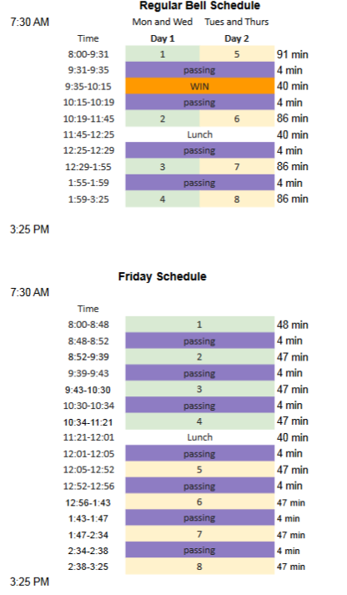

Days Schedule
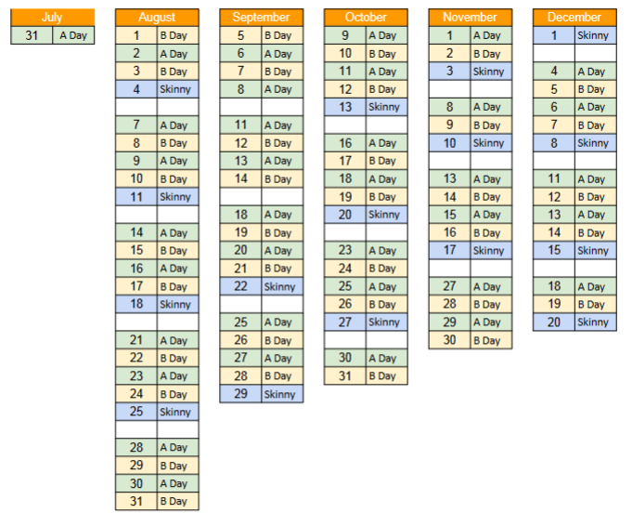
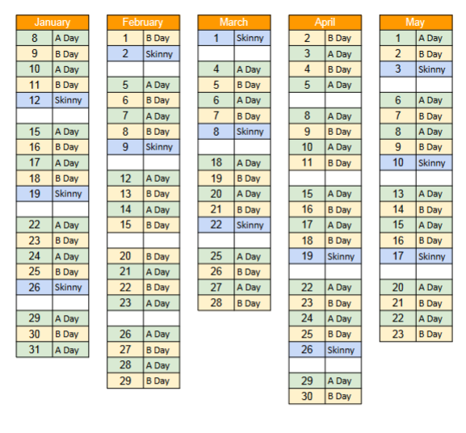

SCHOOL CAFETERIA
HVPS participates in the National School Lunch Program and makes a free balanced breakfast and lunch available to students. Eating should be designated to the tables, Students are responsible for picking up after themselves and adhering to our Student Code of Conduct. Parents should encourage their children to eat their breakfast and lunch at school
Students may pack a lunch, unless they are found to bring snacks, foods, or items that are illegal. At that point the child will not be allowed to bring his/her lunch from home.
Lunch deliveries to students will not be allowed.

STUDENT BASED HEALTH CENTER
A student-based health center is located at Hatch Valley High School to provide care for our student’s health and medical needs.

BUS TRANSPORTATION
Riding a school bus is a privilege extended to students in the Hatch Valley Public Schools. The driver is in full charge of students when they are riding the bus. All students must obey the driver promptly. All students must ride their assigned bus to and from school on a daily basis. Changing of assigned buses will not be allowed by the school unless there is a change of permanent residence and approved by the transportation director.

Students are expected to comply with school bus rules at all times. Student misconduct will be reported to the transportation director, parents and school administration. Discipline procedures range from verbal/written warnings to indefinite suspension of bus services. Students shall abide by all policies and regulations. HVPS Transportation 575-267-8221

CODE OF CONDUCT

STUDENT HARASSMENT/BULLYING/CYBER BULLYING
Harassment, Intimidation, or Bullying" means any intentional written, verbal, graphic, electronic, or physical act, gesture or pattern thereof, that a student or group of students exhibited toward another particular student (s) or school personnel that a.) causes mental or physical harm to the other student/school personnel; and b) is severe, persistent, or pervasive that it creates an intimidating, threatening, and/or abusive educational environment for the other student.
"Harassment, Intimidating, or Bullying" also includes violence within a dating relationship.

CHEATING & PLAGIARISM
Academic honesty and personal integrity are fundamental components of a student’s education and character development. Hatch Valley High School expects that principled students will not cheat, lie, plagiarize, or commit other acts of academic dishonesty.
Plagiarism is not tolerated at Hatch Valley High School. Plagiarism includes (but is not limited to) the following:
- Using someone else’s words or ideas without proper citation
- Copying someone else’s work and calling it your own
- Copying and citing a work that is longer than a paragraph (print or online sources)
Cheating is work that doesn’t reflect your own effort and understanding. This can take many forms and will not be tolerated.
Cheating includes (but is not limited to) the following: Looking at others’ answers on tests and homework, taking someone else’s paper and putting your name on it, copying someone else’s work, answer for answer, Rearranging words from someone else’s work, allowing someone to copy from your paper, telling someone else the answers on an assignment or test and having someone else do your work for you (Friends, Family, Tutors, etc.)

CELL PHONE POLICY
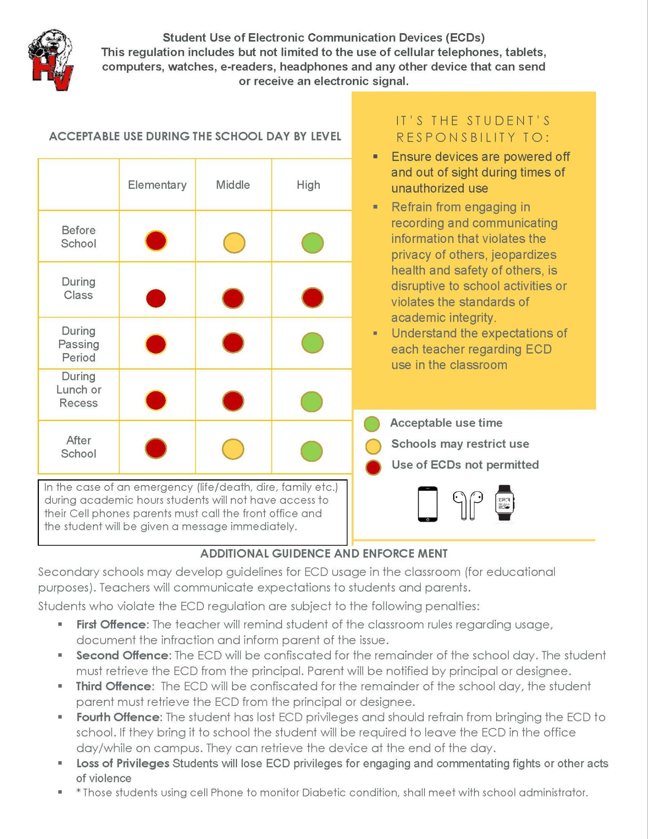

DANCE & PARTY RULES
For safety reasons, students will dance in a manner that enhances the safety of others. All food and drinks need to be kept in the commons area, and not in the gym. Students will promote safety by walking at all times during the dance. Students will be considerate of others at all times. Arrangements should be made with parents/guardians for student drop off and pick up no more than 15 minutes before the dance. Student behavior at the dance is governed by the Hatch Valley High Schools Code of Student Conduct.

DRESS CODE
The reason for the Hatch Valley High School dress code is to maintain a safe learning environment, where students are allowed to wear clothing of their choice that is safe and comfortable. Students are allowed to wear clothing that expresses their self-identity without fear of discipline or discrimination.

Students May Wear:
Clothing that does not violate any of the items listed in the do not wear section:
Does include:
- Hoodie Sweatshirts (Hoods must NOT be worn in the building)
- Fitted pants, including leggings, yoga pants, and “skinny jeans”
- Ripped jeans as long as there are no holes above the designated Short/Dress length
- Sleeveless blouses are ok (spaghetti straps and halter tops are not)
- Shorts (when arms are at the side, fingertips should reach the bottom of the shorts leg)
- All sweaters and jackets must be marked with the child’s name inside.
Students may NOT wear:
- Hoods must NOT be worn in the building
- Clothing with violent language or images
- Images depicting tobacco, drug, alcohol (or any illegal item or activity) or use of the same
- Shorts – Higher than an envelope length above the knee (standard mailing envelope)
- Hate speech, profanity, or sexually explicit images
- Images or language that creates a hostile or intimidating environment based on any protected class.
- Visible Underwear, Clothing that reveals any part of the student's underwear, or cleavage that becomes a distraction to the/their learning process.
- Headgear that covers the face and ears of a student (No Beanies in the building)
- No Sunglasses in the building

DRESS CODE ENFORCEMENT
When possible students should be allowed to use their own jackets, extra clothing (PE clothes), etc.. to resolve dress code issues or call parents to bring in appropriate clothing. Parents may be notified to bring their child an article of clothing and as a last resort, students will be given “school clothing”.

DRESS FOR PHYSICAL EDUCATION
All students are required to participate in physical education class. Failure to participate will result in a loss of points, and possible disciplinary action. A doctor's excuse is required if the student is unable to participate due to physical limitations or illness.
Students are required to wear proper footwear and are encouraged to wear appropriate clothing for physical activity.

Drug Detection Canine
To deter students from bringing illegal substances to campus, HVPS will utilize detection canines to detect the presence of contraband on campus, specifically, in communal areas, classrooms, lockers and vehicles. The detection canine searches will be random and the canine will not be used to search students. The detection canines are very friendly, non-aggressive retrieving breeds. They are trained to discriminate specific “scents” of contraband items and passively indicate the area where the scent is detected. If an illegal substance is detected and found, appropriate disciplinary action will be initiated. The goal of this program is to deter unwanted contraband on campus and provide a school atmosphere that is conducive to learning while minimizing the safety and security concerns associated with the presence of illegal narcotics, alcohol, weapons and prescription medications.

PROHIBITED ITEMS
The following items are not permitted on any HVPS school property or school event. The items will be confiscated and will not be returned. Use or possession of these items may result in one or more of the following disciplinary actions according to the school’s disciplinary policy:
- Aerosol Cans
- Alcoholic beverages, drugs, controlled substances, or paraphernalia
- Fire Arms
- Firecrackers, smoke bombs, or any flammable materials
- Gang related items
- Knives/weapons or any weapon facsimile
- Laser Pointers
- Lighters or other incendiary devices
- Noise Making Devices (i.e. whistles, air horns, cow bells)
- Prescription or over-the-counter medication that has not been documented and cleared by the school district nurse.
- Tobacco products including smokeless tobacco, electronic cigarettes, or vape pens
- Unapproved pamphlets, handouts, advertisements, etc.

PUBLIC DISPLAY OF AFFECTION
Public displays of affection are limited. Kissing while in the school building and on school property is inappropriate for the school environment and a violation. Students may side hug, but frontal hugs should last no longer than 3 seconds.

RESPECT FOR AUTHORITY
Students have the duty to comply with all official school policies and personnel and to obey all laws. Students are expected to respond in a respectful manner to all adults while under the jurisdiction of the school and while participating in school sponsored activities. This includes the conduct of students who are on their way to and returning from school regardless of whether the student is using school transportation, private vehicle or walking

RESPECT FOR PROPERTY
Students are expected to treat all property belonging to the school and to others with care and respect. Students who cause damage to school property or property belonging to others shall be subject to disciplinary measures, and their parents shall be financially liable for such damage to the extent of the law. Damages by students will cause the imposition of fines for the loss, damage or destruction of school equipment, apparatus, musical instruments, library material, textbooks, and for damage to school buildings.
The administration may report to the appropriate juvenile authorities any student whose damage of school property has been serious or chronic in nature.

RESPECT FOR SELF AND OTHERS
Students are expected to be honest, behave with dignity and treat others with respect and courtesy. Behavior of the individual should not interfere with the rights of others. This includes the use of appropriate language, actions and attire.
Students are expected not to harass or intimidate others verbally and physically. Students are expected to come to school free from the influence of tobacco products, alcohol or drugs. Students are expected not to use or possess such substances. In addition, students are expected to exhibit appropriate behaviors that do not offend or distract others or the educational process.

SAFETY
Students are expected to contribute to a safe school environment free from fear. Acts of violence, weapons and contraband are never acceptable. To report safety concerns please contact any school administrator or use Speak Up Anonymous Reporting Hotline 575-267-6133.

SEARCHES
HVPS administration and/or SRO may search a student's car, person, personal items (e.g., backpacks, purses, etc.), electronic devices, lockers, and other belongings:
- When there is reasonable suspicion for suspecting that the search will turn up evidence that the student has violated or is in violation of either the law or the rules of the school district
- In the course of an investigation
- When the safety of the student or others is at issue in the sole discretion of HVPS administration

THREATS OF VIOLENCE
Any threat of violence will be taken seriously by the administration and will result in immediate disciplinary action. In addition, law enforcement will be notified.

VAPES AND VAPE USE
It is illegal, unhealthy and dangerous for individuals under 21 years of age to be in possession of products used in a vape, and/or to use a vape. Any such items will not be permitted on any school property and will be subject to confiscation. School administration along with the district SRO (school resource office will administer appropriate consequences to the possession of, use or, and/or distribution of the use of vaping products by students.

WORK HABITS
Students are expected to be prepared for and to participate in each class to meet performance standards, to have the necessary class materials, to complete class work and homework accurately and on time, and to prepare for quizzes, tests and examinations. Students are expected to be respectful to their teacher and their peers and maintain a positive learning environment. Personal respect and responsibility are non-negotiable.

DISCIPLINE CODE
The primary purpose of the school health services program is to promote optimal health for the school community to increase opportunities for learning.

STUDENT DISCIPLINE CODE
The student discipline code applies to all students attending school in the Hatch Valley Public School District including the following circumstances: (1) while on any school grounds; (2) while going to or coming from any school; (3) during the lunch period, (4) during, a school-sponsored activity; and (5) “electronic act” that has originated on or off the school-site. Where appropriate, discipline should be progressive.
Understanding that consequences and interventions represent “teachable moments” is fundamental to a positive approach to discipline. Progressive consequences seek accountability and behavioral change. Prevention of negative behavior occurs by helping students learn from their mistakes.

Discipline Matrix
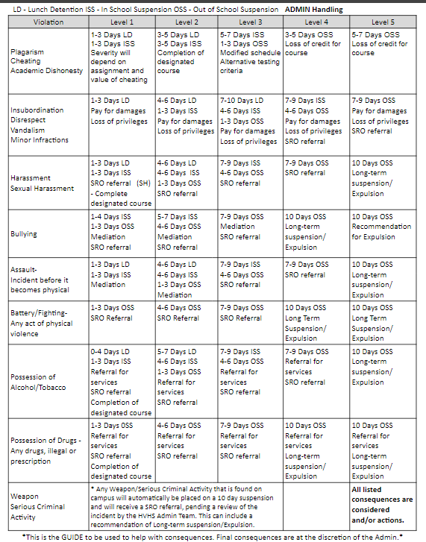

ATHLETICS -EXTRA CURRICULAR ACTIVITIES

ATHLETICS
Please see HVPS athletic handbook for policy and procedures concerning athletics

ACTIVITES
Because activities are an integral part of the total educational program, all students are encouraged to participate in the activity and athletic programs at Hatch Valley High School, either as an active member or as a spectator. The major goal of the extracurricular programs at HVHS is to give students the opportunity to develop their potential to the maximum level through mental, physical and social activities. School spirit can be measured directly by how many students attend various activities.
To this end, students are encouraged to support school-sponsored activities provided for their entertainment. However, it is important that one always strives to achieve better relationships with other schools.

NATIONAL HONOR SOCIETY MEMBERSHIP
Eligibility is based on the criteria of Scholarship, Service, Leadership, and Character.
- Candidates eligible for selection to this chapter must be members of the junior, or senior class.to be eligible for selection to membership in this chapter, the candidate must have been in attendance for a period of one semester at Hatch Valley High School.
- Candidates eligible for selection to the chapter shall have a minimum cumulative grade point average (GPA) of 3.5 (out of 4.0).
Discipline and dismissal are based on the following:
- Any member who falls below the standards of Scholarship, Service, Leadership, or Character may be dismissed from the National Honor Society.
- A member is expected to maintain his/her grade point average (GPA). If a member fails to do so, the member will be given a written warning and a time period to improve.
- Members do not take an active role in service and leadership at HVHS and community.
Please see sponsor for a copy of the By-Laws for National Honor Society.

HVPS PROCEDURES FOR USE OF DRUG DETECTION DOGS
The following procedures shall be implemented in conjunction with the other provisions of this regulation for conducting searches and seizures and as further outlined in HVPS student policies.
Preconditions for Use of Drug Detection Dogs
Notice: In any school year in which detection dogs are used by the school district to any extent, the school district shall publish notice of such use at the beginning of the school year. The publication of the notice shall be in the in the student handbook for each calendar year in which the detection dogs are used. The notice shall detail the general manner and occurrence of the detection dogs sweeps as described in this procedure.
Determination of Basis for Dog Sweeps
Prior to any use of detection dogs in a school’s classrooms, hallways, or other areas or facilities, the school administration shall determine that there is a significant and serious problem of student drug use/abuse in the school warranting the use of detection dogs. Such finding may be based upon one or more of the following:
- A compilation of the number of drug-related disciplinary actions in the school during recent years, showing a significant or increasing incidence of such actions.
- A compilation of the number of drug-related arrests of students of the school by local law enforcement authorities, showing a significant or increasing incidence of such arrests.
- A survey of students of the school showing significant levels of drug use.
- Strong and documented evidence from school personnel or students regarding significant levels of student drug use.
Review of Findings: The school’s finding of a significant and serious problem of student drug use at the school must be reviewed and approved by the Superintendent, prior to any use of detection dogs in school classrooms, hallways, or other areas or facilities.
Limited Use of detection-dog sweeps: Detection dogs may be used on a limited basis for sweeps of lockers, or student purses or backpacks while not in the physical possession of the student and vehicles on a school campus at the discretion of the superintendent, and without meeting the requirements of subsection A.2 above. At no time, may a detection-dog search the physical person of a student.
Preventative Measures
- The HVPS Safety and Security coordinator shall request, monthly or bimonthly, approval to conduct unannounced detection dog drug sweeps of schools. The Superintendent shall select the schools where the sweeps shall be conducted.
- Schools shall be selected for the sweeps on a scheduled basis, through equitable process. Principals of selected schools shall cooperate fully with the sweeps.
- Detection dogs may also be used for educational demonstrations at all district schools.
Qualification of Detection Dogs and Handler
- Certification and Record Keeping
  - Dogs and dog handlers provided by MOU for use in an HVPS school shall have been certified or recertified by a recognized training institution for all substances for which sweeps will be conducted at the school. Dogs and dog handlers shall maintain their certifications and must submit proof of certification status each year prior to the first day of school.
  - No MOU for services by a contractor providing dogs and dog handlers to be used in any school shall be executed prior to the contractor’s presentation of documentation of:
    - The reliability of the dog and dog handler in the form of the certification and training record of the dog and dog handler, and of the results of the dog’s field work during the prior three months; and
    - Insurance for liability arising out of the performance of the dog or dog handler, as approved by the superintendent or his/her designee.
- The contractor shall make and maintain records of the results of each sweep by the dog and dog handler, including the name of the dog and handler, the number of alerts, and description of contraband recovered (if any), as a result of each alert, and the number of false alerts (if any).
- Every contract for services by a contractor providing dogs and dog handlers to be used in any school shall include a provision which shall allow the school district to cancel the contract at any time that the dog’s record of false alerts is excessive as determined by the HVPS Safety and Security coordinator. Every contract for services by a contractor providing dogs and dog handlers may also be terminated should the contractor and/or dog handler fail to submit or maintain training certification records of the dog.
PROCEDURES FOR DETECTION DOG SWEEPS AND SEARCHES
Preparation
- The dog handler(s) shall meet with the Safety & Security Coordinator and the school Principal or his/her designee and review these procedures in their entirety prior to the conducting of any sweep, except as outlined in items V.A.4, V.A.5 and V.A.6 above.
- All school telephones shall be put on hold and no incoming or outgoing calls shall be permitted until further notice by the Principal. The use of cellular phones shall be monitored by the school staff, Principal, or his/her designee.
- The school Principal or his/her designee shall announce over the school’s public-address system that all classes and activities on campus are in a “freeze,” and that all students and staff are to remain in their classrooms or current activity location until further notice. Students observed using cell phones, or other electronic devices in an effort to transmit messages after the announcement of the freeze shall have the device confiscated until the freeze is over.
- All entrances to the building shall be monitored by the school Principal’s designees (entrance monitors). No one shall be allowed to enter the building, unless he/she is assisting with the freeze or authorized to enter by the principal or his/her designee. Entrance monitors shall keep a written record of the names of any students who leave the building despite such warning, and the time each such student left. The entrance monitor shall sign and date such record and present it to the Principal after the class freeze is lifted. In no event should an entrance monitor attempt to physically prevent any student or other person from leaving the building or suggest that such student or person may be physically prevented from leaving.
- During the freeze, a student shall be permitted to leave a classroom or activity under escort of a school employee for a visit to the restroom or for other such personal emergencies during periods when a sweep is not being performed in that student’s classroom.
- Students in classrooms or activities that have been designated to be part of the sweep will be escorted to a designated area within the school being swept. Students shall leave all purses, backpacks, coats, hats or other items which they may have brought with them to the classroom or activity in the classroom or activity location during the sweep. Monitors shall observe the room as the students leave.
Conducting Sweeps
- The dog handler shall be accompanied at all times by the HVPS Safety and Security Coordinator or his/her designee, school Principal and two school staff members selected by the Principal, one of whom shall remain with the dog handler to serve as an additional witness, and the second of whom shall accompany to the holding area any students who are directed there by the Principal.
- The dog handler shall, at all times be responsible for handling the dog and shall take care that the dog makes no physical contact with any student or school district employee while the dog is at work. The school Principal and his/her designees will facilitate any physical arrangements necessary to ensure that no such physical contact is made. The dog handler shall also be responsible for informing the Safety and Security Coordinator or his/her designee and the Principal or his/her designee when the dog is alerting.
- The school Principal or his/designee shall designate a room or office in the building as a holding area for students and/or staff who may be asked to wait for questioning or a reasonable suspicion search.
- The holding area shall be cleared before anyone is asked to wait there and the school Principal shall assign a school staff member to wait with those who are directed to the holding area.
- The holding-area monitor shall keep a written record of the names of any students who leave the holding area despite such warning, and the time each student left. The holding-area monitor shall sign and date the record and present it to the school Principal once the freeze is lifted. In the event the dog handler informs the Safety and Security Coordinator or school Principal that a student’s backpack, purse, desk, chair or area where student sits is the subject of an alert, the Principal shall ask the student to proceed to the holding area under the escort of one of the staff members selected by the principal in Item VI.B.1 above.
  - No one other than the school Principal or his/her designee shall direct any student to the holding area.
  - In no event should questioning or searches of students be conducted at the place and time at which the dog has “alerted” the dog handler and/or school staff to the possible presence of contraband.
  - Those directed to the holding area shall be questioned and searched or released as soon as possible by the school Principal or his/her designee after the after the sweep has been completed.
  - In the event the dog handler informs the Safety and Security Coordinator and school Principal that a detection dog has alerted to the possible presence of a potential controlled substance in a desk, backpack, purse, locker, other compartment, or a vehicle the dog shall be removed from the immediate scene and the school Principal or his/her designee shall summon the student who is the user of the desk, locker or other compartment, or is the owner or in possession of the vehicle and escort said student to the scene.
- Students may be directed to empty their pockets, remove jackets or other outerwear and shoes, to open bags or other containers; and/ may be subjected to a pat down by a same-gender searcher in the presence of a witness.
- If a search of a locker is to be conducted due to a dog alert as to the possible presence of drugs as defined by HVPS policy J-3050, the student using such locker shall be asked to facilitate the search by unlocking and opening the locker.
  - If any such locker is under the lock of a student who has refused to cooperate with the search, such lock may be cut or otherwise removed to open the locker.
  - In the event the reasonable suspicion for the search or the information received or observed by school personnel initiating the search prior to the student’s refusal leads the searchers or school Principal to believe the student is in possession of illegal drugs, the school Principal shall have discretion to contact local law enforcement for further investigation of the student’s conduct and to discipline the student in line with HVPS’s student conduct policy J-2300
  - The searcher may seize any drugs or prohibited items as defined in HVPS policies J-3000 (tobacco), J-3050 (drugs and alcohol), and J-3100 (weapons), in plain view. If no drugs or prohibited items are in plain view, the detection dog shall be returned to the scene to identify the specific location of the drugs or prohibited items, which then may be searched by the searcher.
  - For all items obtained in the search of a student’s locker, the searcher shall follow the chain of custody procedures. The searcher shall document that a search was conducted in each and every instance.
Searches of Vehicles on School Premises
- Observations of the exterior of such vehicle, and of so much of the interior as may be observed from the exterior, may be conducted at any time by the school Principal or his/her designee.
- Vehicles on school premises – interior searches: Before initiating an interior search of a vehicle, as to which a detection dog has alerted or the school Principal has reasonable individualized suspicion that a drugs or prohibited items are present in the vehicle, the school principal or his/her designee shall explain the basis of his/her suspicions to the student who is the owner or in possession of the vehicle to be searched, and shall give him/her an opportunity to explain the observations upon which the suspicion is based. A search may then be conducted, upon authorization by the school principal or his or her designee.
- The searcher shall request that the student facilitate such search; for example, opening the doors, trunk, glove compartment, etc.
- The searcher may seize any drugs or prohibited items, or suspected drugs or prohibited items, which are in plain view. If potential drugs or prohibited items are in plain view, the detection dog may be returned to the scene to identify the specific location of the potential items and said location may then be searched by the searcher.
- If a search of a vehicle produces drugs or prohibited, the searcher shall follow the chain of custody procedures. In each and every instance, a searcher shall document the search.

COMPLETION PROCEDURES
- Once the detection dog and dog handler have been escorted out of the school building, the school Principal or his/her designee shall announce over the school’s public address system that the freeze is over. The use of telephones and building entrances may then also return to normal.
- All records made by the dog handler, entrance monitors, etc., shall immediately be signed and dated and presented to the school Principal.
  - Confidentiality: No information of any type that leads to or results from a search or seizure shall be communicated, revealed or disclosed by school district personnel to any person, except as follows:
    - Such information shall be communicated to other schools or school district personnel only upon a “need-to-know” basis. A need-to-know basis means that the person to whom such information is communicated is authorized to act on behalf of the school district based upon such information and needs the information to discharge his/her official duties and responsibilities.
    - Such information may be communicated to the parent/guardian of any student to whom the information relates.
    - Such information shall be disclosed to law enforcement agencies upon the approval of the school Principal or his/her designee.
    - All documentations collected shall be maintained by the school.
    - The return of any confiscated items to the parents of the student(s) from whom it was seized shall be coordinated by the confiscating school Principal or the HVPS Safety and Security Coordinator. Items confiscated by law enforcement personnel as evidence of criminal activity shall be retained by law enforcement as needed in connection with an ongoing criminal investigation or prosecution.
Any SSO who finds or recovers suspected controlled substances as prohibited under federal law shall maintain custody by securing substance(s) in a lockable, inaccessible location, preferably a safe or specified file drawer until possession is turned over to the responding police officer.
The chain of custody will be documented. This should be coordinated with the Principal or his/her designee as per the customary law enforcement procedures, all controlled substance possession requires a Police response. The Principal or his/her designee must be contacted first, then the Police department or assigned SRO will be called. The item will be photographed, and the photo included with the submitted report. Any subsequent disciplinary investigation must not interfere with any on-going Police investigation. Always seek information from the SRO, Police, or DSS Supervisor about securing evidence, especially if you need to move the item.
Any item taken from a student for a violation of policy will be documented, securely retained, and disposed of consistent with policy and common sense. Under no circumstances will an SSO throw away any illegal substance. Always have a witness with you when handing over or contraband.
Any items used for a Police investigation will be handled as noted above. Items such as hats, cell phones, etc. will be turned over to the Principal or his/her designee for either return to the parent for destruction and disposal, as dictated by policy. Document in the Security Information Report the disposition of each item. If contraband is recovered/found but not associated with student discipline or police action, it will be thrown away (Again, except for controlled substances prohibited under federal law)
Any item recovered that is not contraband (lost and found) will be retained for an established reasonable amount of time to give the rightful owner the opportunity to claim it. If of value, it must be secured and turned over to Police as found property. If unclaimed, it will be disposed of in a suitable manner which may include donation or destruction. (Care should be taken to ensure the donated items are not distributed in the district area. It may cause undue embarrassment for the recipient, or a confrontation by the rightful owner.)
No SSO may achieve personal gain from the recovery or confiscation of any contraband or found item.

