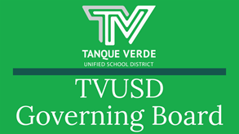

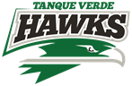
Governiing Board Meetiing Summary August 11, 2021

August 16, 2021

At the August 11, 2021 board meeting, Board Members were presented with enrollment information, and curriculum and construction updates. Information and discussion items included COVID-19 Mitigation and Student Learning Updates.

Cellebratiion of TVHS Summer Graduates

Dr. Amy Cislak, TVHS Principal presented summer graduates with their diplomas.

Congratulations to all Class of 2021 TVHS Graduates ~ You are to be commended for your perseverance and determination to achieve the fulfillment of your high school
graduation requirements, especially with the challenges of the current pandemic.

Superiintendent Report

Dr. Scott Hagerman presented hisSuperintendent Report for August 11, 2021.

Enrollment Information

Our enrollment numbers are up from this time last year.

IT & Curriculum Update

Gap funding should be released in the next two weeks. This will allow our ELA adoption which is overdue. Other areas of curriculum are also being prioritized.
IT is working on a complete update of the network, followed by WiFi updates. 1200 chromebooks are needed, and a request has been submitted for 725 chromebooks from ERate. The remainder will be purchased out of funds being provided by the Governor’s office to school districts that did not receive high levels of ESSER funds.

Construction Update

$18.5 million of SFB funding has been allocated to TVUSD. The projects funded include some projects already completed, for example the ACES HVAC project

which is carried over from last year. $1.4 million projects at TVHS and ACES are still waiting for final approval. Projects in the design phase at TVES include roofs, weatherization and drainage improvements.

Miitiigatiion Update

Mask and Vaccination Language in State Budget:

"Face Coverings & COVID-19 Vaccination 35. Prohibits, retroactive to July 1, 2021: a) a county, city, town, school district governing board (governing board) or charter school governing body (governing body) from requiring students or staff to use face coverings during school hours and on school property; and b) a school district or charter school from requiring a student or teacher to receive a COVID-19 vaccination or to wear a face covering for in-person instruction."

2. PIMA COUNTY HEALTH DEPARTMENT SANITARY MEASURE 2021-01- July 30, 2021
(1). All schools within the jurisdiction of Pima County must report all positive cases of COVID-19 to the Pima County Health Department.

(2). Once identified, all known or suspected cases must be sent home as soon as possible. PCHD Order - con’t.

(3). Within 24 hours of confirmation of a case by the Pima County Health Department, schools must provide the names and contact information for individuals who were within 6 feet for more than 15 minutes of the confirmed case during a 24-hour period (“close contacts”).

(4). Individuals who are confirmed cases must isolate for ten days; release from isolation occurs after ten days as long as the individual is asymptomatic. PCHD Order - con’t.

(5). Unvaccinated or partially vaccinated close contacts must remain at home and be excluded from school and extracurricular activities. Unvaccinated or partially vaccinated close contacts who remain asymptomatic may return on or after day seven (7) upon providing documentation of a valid negative COVID-19 test collected on or after day five (5) of the quarantine.

(6). Close contacts who can provide documentation of a completed COVID-19 vaccination series may return to school immediately if asymptomatic.

The Pima County Board of Supervisors failed to pass a Pima County Mask Mandate in Schools at their August 10 board meeting.

3. Current Case Counts being Reported by School Districts in Pima County Active Cases in Schools Definition:
-Person was in a school with symptoms or within 48 hours of symptoms. -Person is currently not at school due to the illness.
-The case was reported to the school.

Quarantine decisions will be made by the Pima County Health Dept. Students/Classes who are quarantined will be expected to immediately move to remote learning to avoid further learning gaps.

TVUSD COVIID-19 Dashboard::
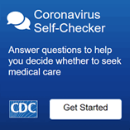
https://www.tanqueverdeschools.org/COVID-19Information.aspx

4. Updates on other Districts and Litigation (see presentation)

If the district decided to take legal action against the state law (regarding masks) it would need to be funded out of the district budget, so it would affect what the district could provide to students. The prepaid legal representation we have is provided by the Trust to manage risk and liability.

The withholding of federal funding is one suggested penalty for school districts not complying with the state laws regarding masks and vaccination mandates. Other suggested penalties include allowing ESAs for all students in districts not complying, sending notice to families of their options for school choice through open enrollment, and the initiation of legal action against non-compliant districts.

All of these potential penalties are financially untenable for our district.

5. Review of TVUSDSafe Return to In-Person Learning Plan a. The priority is full-time in-person learning.
b. Masks are strongly recommended regardless of vaccination level. c. Social Distance - to the extent possible.
d. Other measures.

View the full presentationhere.

Stay Home When Siick!

The number one thing we can do to keep schools open is make sure children stay home if they are sick. All attendance policies have been put on
hold for the 21-22 school year.
Launch tthe CDC Sympttom Sellff Checker Here::

Symptoms may appear 2-14 days after exposure to the virus. People with these symptoms may have
COVID-19: Symptoms of COVID-19 CDC

Student Learniing Update

School leaders presented information about the start of the school year and student learning.

Ellementtary

Presenttattiion - Ensuriing Hiigh Levells off Learniing ffor K-6

Presentters:: Emma Batttty,, Priinciipall,, Tanque Verde Ellementtary Schooll Chriis Riiettz,, Priinciipall,, Agua Calliientte Ellementtary Schooll

“Intention and Commitments - We must all fully participate in work that will support every student learning at high levels. We will avoid wasting time on variables we can not control or have little effect on student learning. This means all educators being


informed educators, supporting and responding to student learning as collaborative teams.” Please see presentation link above for more detailed information.

Secondary

Presenttattiion -TVUSD 7-12 Commiittmentt tto Hiigh Levells off Learniing

Presentters -Joell Bacalliia,, Assiisttantt Priinciipall,, Tanque Verde Hiigh Schooll -Elliizabetth Egan,, Assiisttantt Priinciipall,, Emiilly Gray Jr.. Hiigh Schooll

“Students have experienced delayed learning during the pandemic which requires us to focus on essentials. Last year gave us a taste of what that looks like as we paired down our content to the most important parts. This year we are adding tools and accountability to ensure teachers know students are learning at high levels and that teachers are equipped to support them when they aren’t.” Please see presentation link above for more detailed information.

Important Dates & Informatiion TVES Open House - August 16, 2021 EGJH Open House - August 19, 2021 ACES Open House - August 23, 2021

Regular Governing Board Meeting - August 25, 2021 Labor Day Holiday - September 6, 2021 NO SCHOOL

See more school event dates and information here:August District Events Calendar

The 21-22 SCHOOL YEAR CALENDAR may be found here:TVUSD School Year Calendar 2021-22 K-12th.

Next Governiing Board Meetiing Dates:

The next Regular Governing Board Meetingwill be held onWednesday, August 25th, at 6:00 p.m. at the Tanque Verde Elementary School Library. Seating is limited. The meeting will be livestreamed.

Board Meeting Agendas and Minutes

TVUSD Board Meeting Livestream Link

You May Qualliify! Free & Reduced Mealls and Otther Beneffiitts IInfformattiion

Dear TVUSD Parent/Guardian:

Children need healthy meals to learn. TVUSD will be offering healthy meals to
all students at no cost every school day in School Year 2021-2022. Your child(ren) will receive free breakfast and lunch meals every school day regardless of your

household income.

You may qualify for additional reduced fees and other resources!

Families are still encouraged to submit a school meal application for free or reduced-price meal benefits because this information may be used for other programs, including:
Pandemic-Electronic Benefit Transfer (P-EBT), Federal and State funding for your school, Reduced registration fees for academic tests, Discounted rates for internet service, and Other community resources

For more detailed information on eligibility, please visit our website at: TVUSD Food Services

Please help us qualify for more Federal and State funding for students! Our school is participating in programs that your child may benefit from if your child qualifies for free or reduced-price meals. The Free & Reduced Meals Application is the key to unlocking those benefits.

THE APPLICATION MAY NOW BE COMPLETED ONLINE!! CLICK ON THE MY SCHOOL APPS BUTTON BELOW!

Staff & Communiity Acknowlledgments - August 11, 2021

Superintendent Hagerman acknowledged the recent extraordinary efforts of the IT Department, Director Tony Blackwell, and Specialists Yefim Feldman and Jacob Yarbrough.
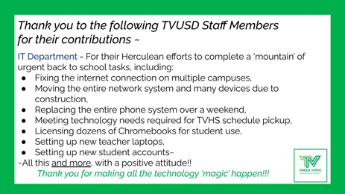
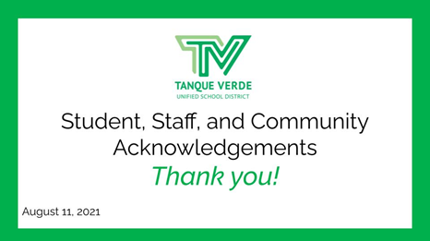

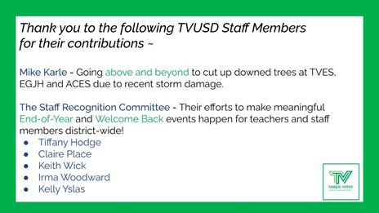
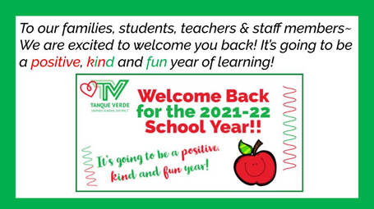
Connect with us
Visit our website

