**2024-2025 Travel Estimate Form Directions**

1. Download the Estimated Travel Form and Open using EXCEL ONLY. Google Sheets does not work.
2. Only complete YELLOW boxes. All other cells are locked to protect calculation accuracy.
3. Enter employee name
4. Enter Location
5. Enter name of conference/meeting
6. Enter name of destination (City, State, may add Name of Hotel)
7. Enter the FUND code received from Business/SPED Office
8. Enter dates and estimated time of departure/arrival. This must be entered in the following format: 1:00 PM (with a space after the minute, before the AM/PM). If this is entered incorrectly, you will see an error.

# Incorrect Time Format:

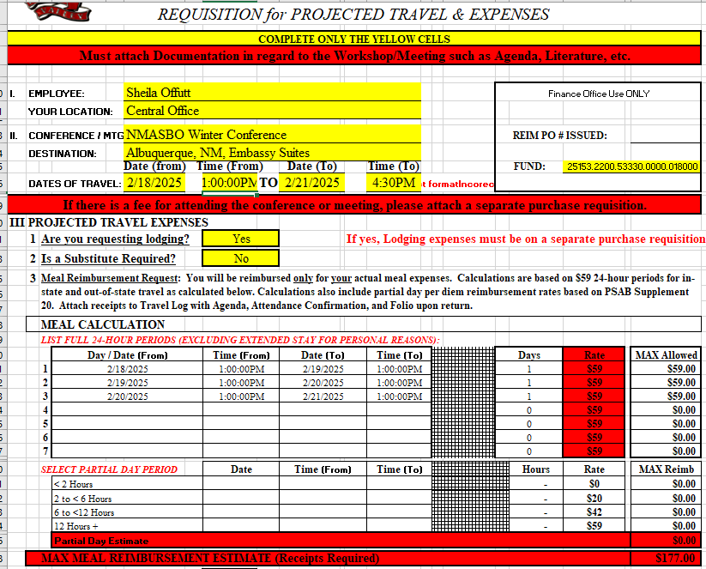

2 times entered incorrectly result in note.

Partial Day reimbursement will not populate

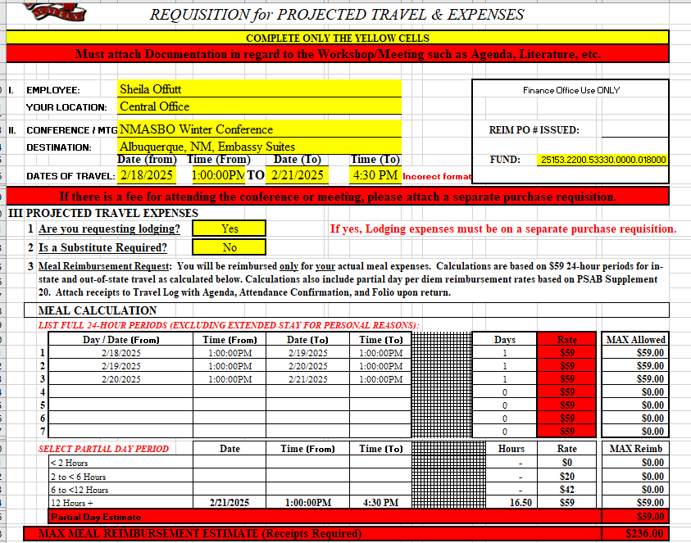

1 time entered incorrectly result in incorrect format error note.

Daily reimbursement periods may calculate incorrectly. 1:00 PM to 4:30 PM is 3 hours, 30 min., not 12 hours

# Correct Time Format:

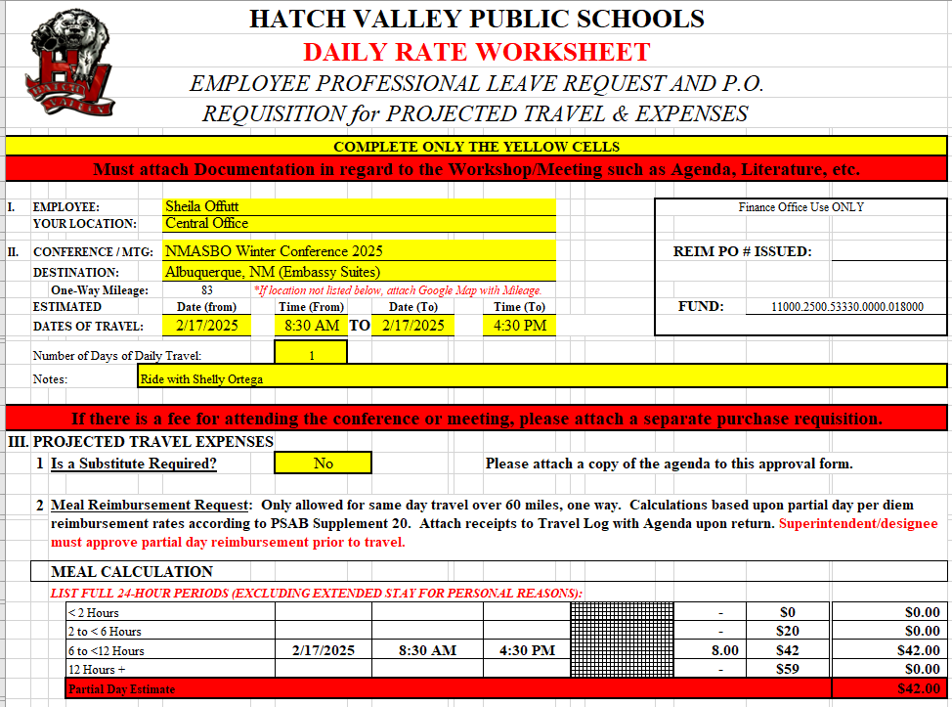

The error is gone!

1. Use the drop-down menu to select whether or not you will need lodging.
2. Use the drop-down menu to select whether or not a substitute is required for your absence.
3. Read #3 and review meal calculation times.

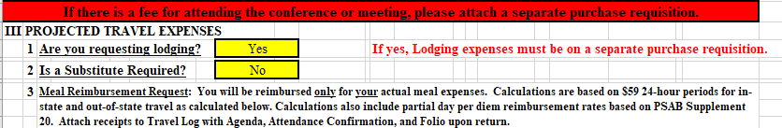

1. Use the drop-down menu to select whether or not you will be requesting a school car.
2. Choose appropriate vehicle in the drop-down menu.

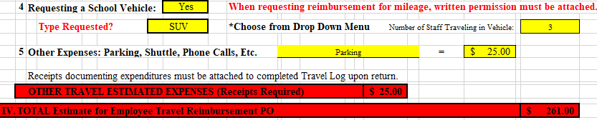

1. Enter a description and estimate of any other estimated travel expenses that you will pay out of pocket.



1. A total is calculated in section IV. This is the amount of the meal reimbursement PO to the employee.

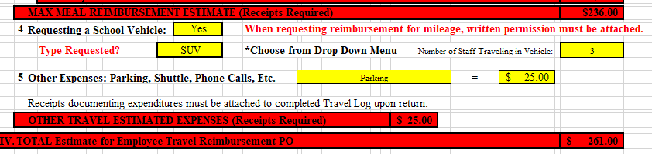

1. If Registration, hotel, hotel parking, airline, etc. charges will be incurred, fill out section V and attach backup documentation (quotes, flyer for conference with hotel info, etc.). POs must be created for all expenses. Registration POs should be created directly to the company/vendor if possible. Bank of America charges should be entered on one PO to Bank of America, include a line for each item.

***IMPORTANT: If hotel charges exceed $215 per night (including taxes and fees), the Superintendent must sign your travel log and the quote for the hotel and secretary must attach this and the quote to the PO.***

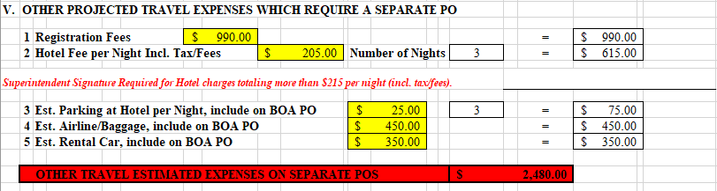

1. Section VI calculates the total estimated cost of your trip.

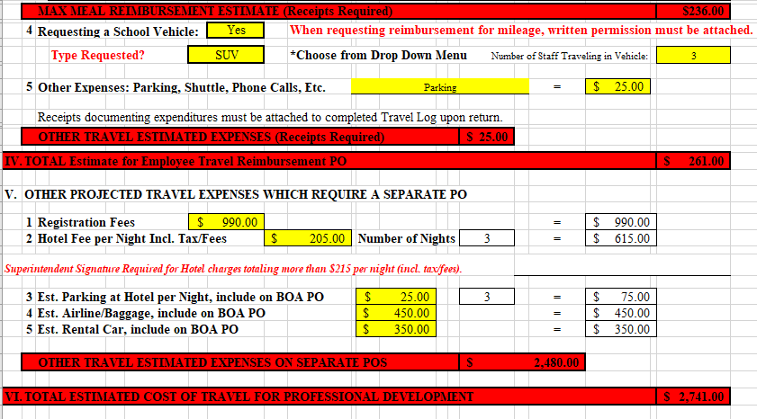

1. Enter the name of the Funding Source (Bottom Right)
2. Print and sign and submit to your supervisor for approval, or sign and send for approval via Adobe, following the following steps. The steps can be followed for any document.
3. Print document to PDF:
   1. Click File b. Click Print c. Click arrow on right of Printer,

and select pdf or Power PDF

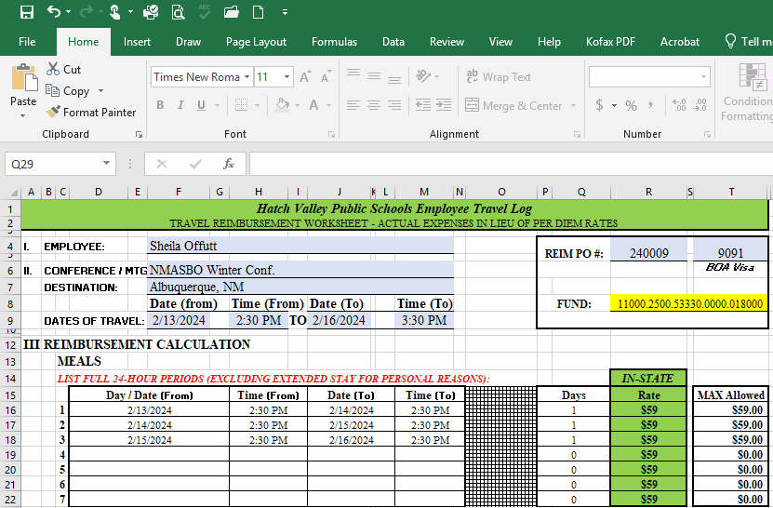 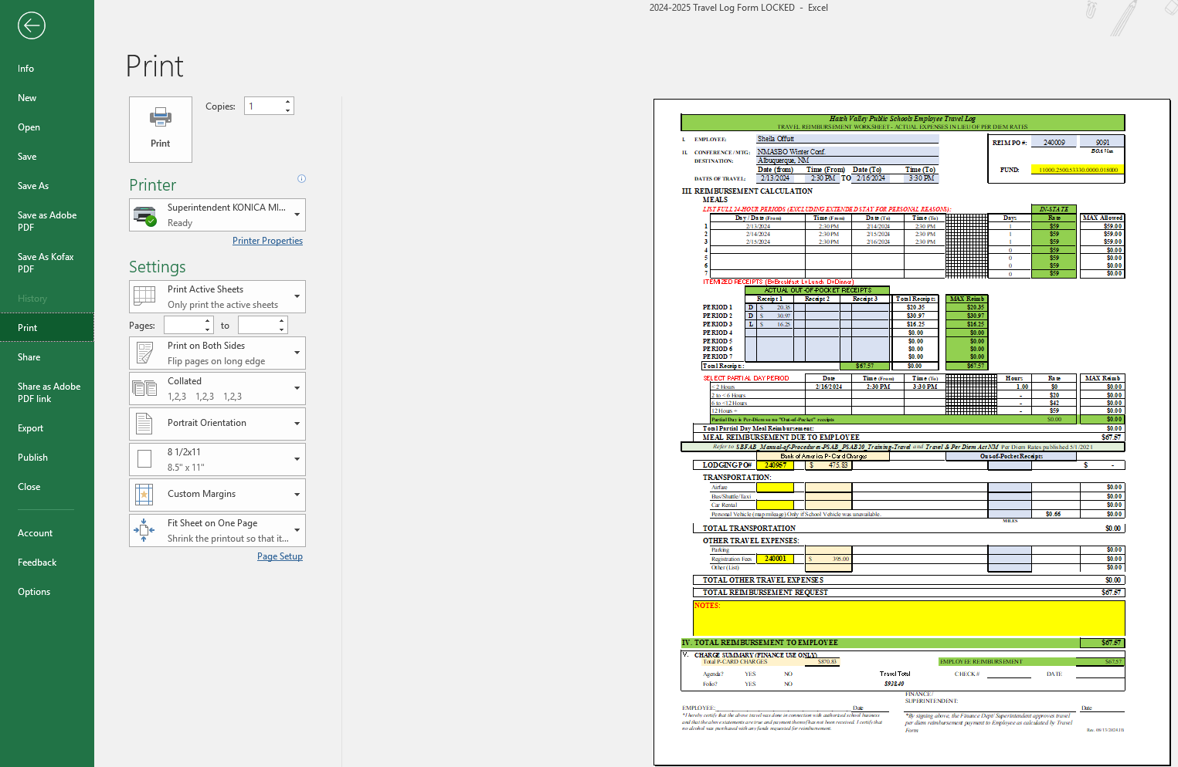 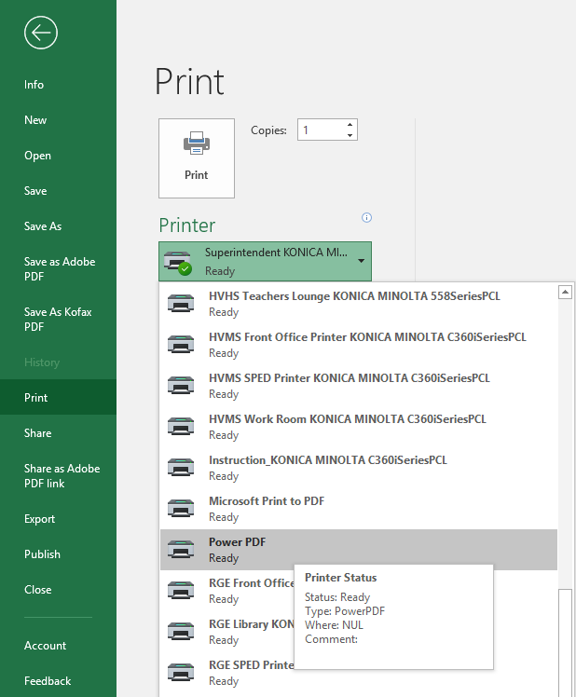

d. Click Print e. Choose file location, enter name of file, click save.

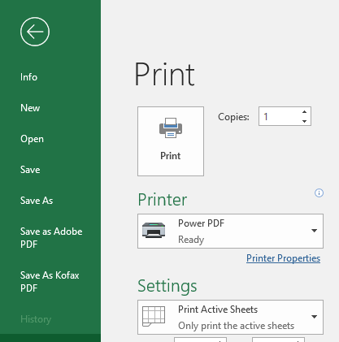 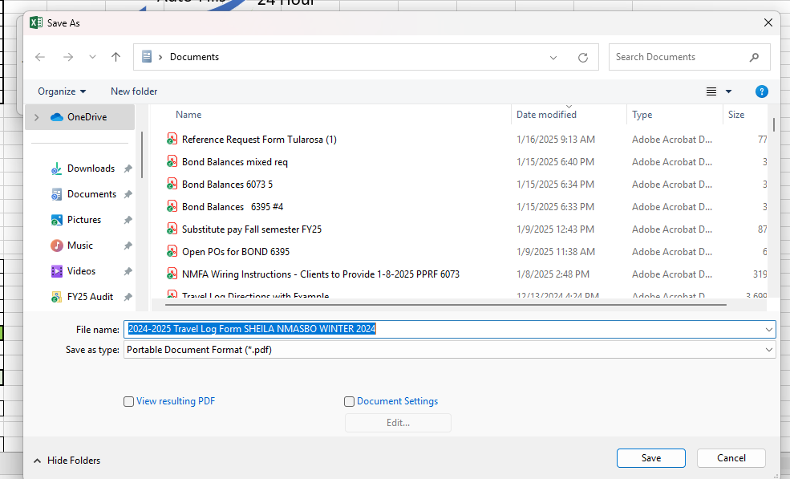

1. Sign/date via Adobe and send to Sheila Offutt for Approval via Adobe.
   1. Open file location to open your pdf in Adobe.
   2. If you do not have Adobe, Contact your Secretary or Technology for assistance.

NOTE: You may add pages to the Travel log before sending for signatures. Steps to do this:

* + - * 1. Open Adobe File. Click Edit.
        2. Click Organize pages.
        3. In another window, open the file location (My Documents) and drag/drop the additional files such as agenda, registration information/flyer, hotel information, etc.
        4. Click on the X to close the Organize pages window.
        5. Click Save.
        6. Proceed with e-signature steps below.
  1. Click e-Sign

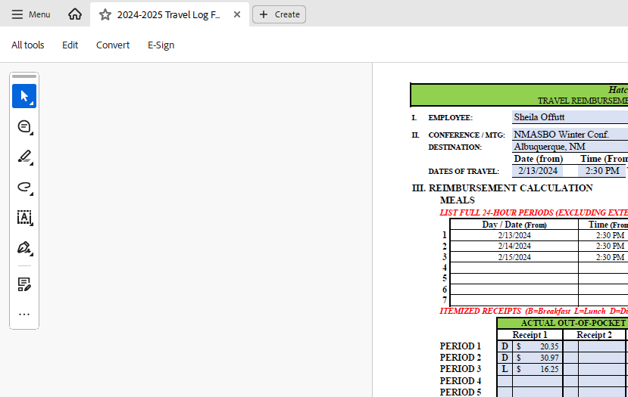

* 1. If signing for yourself, click the signature. If sending to another employee to sign, click Request e-signatures.

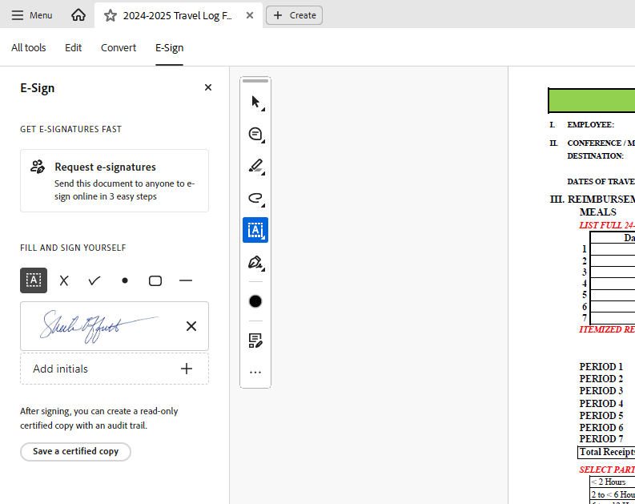

To send for signatures, click here

Click and drag to insert your own signature

* 1. Type the email addresses of the intended recipients, and enter message if needed. Click Specify where to sign

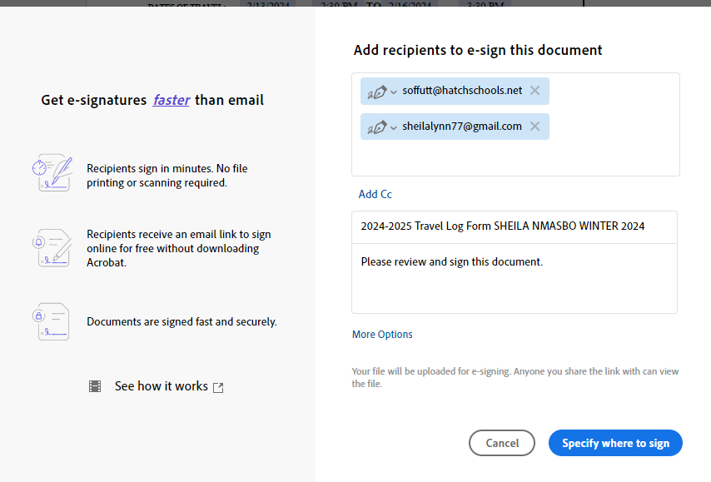

Enter addresses (using personal email for illustration purposes only)

Click to continue

* 1. Click and Drag “Signature” to the location where the signature should be entered. 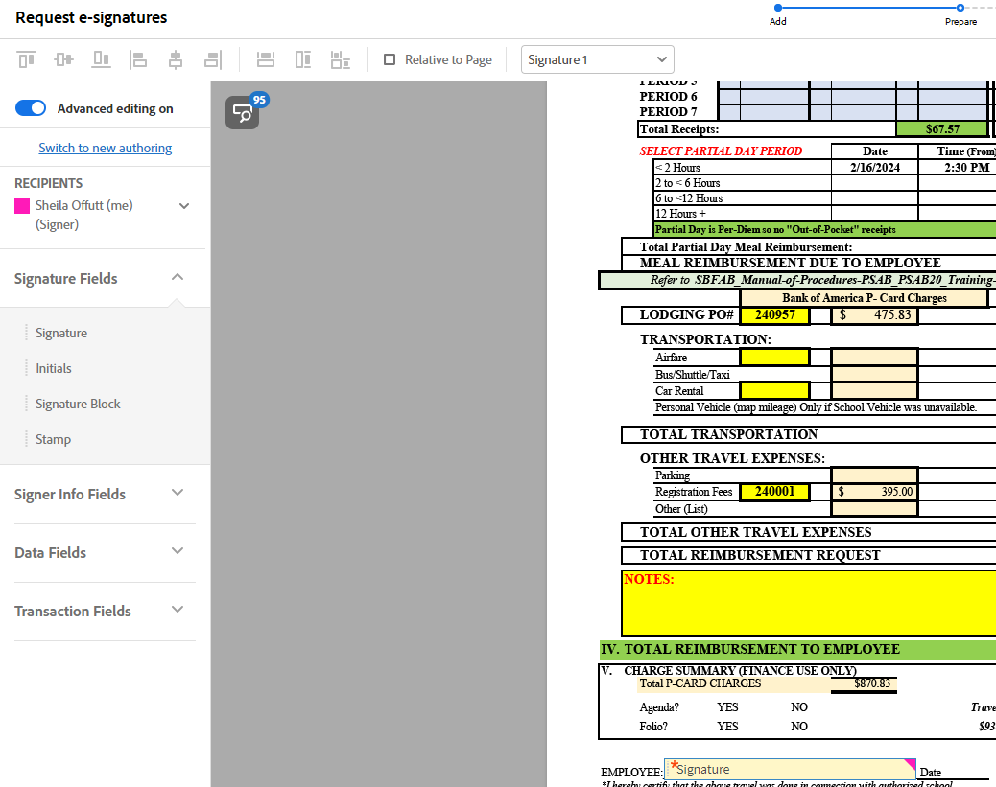
  2. Click “Signer Info Fields” and Click and Drag “Date” and any other relevant fields to the correct Location on the document.

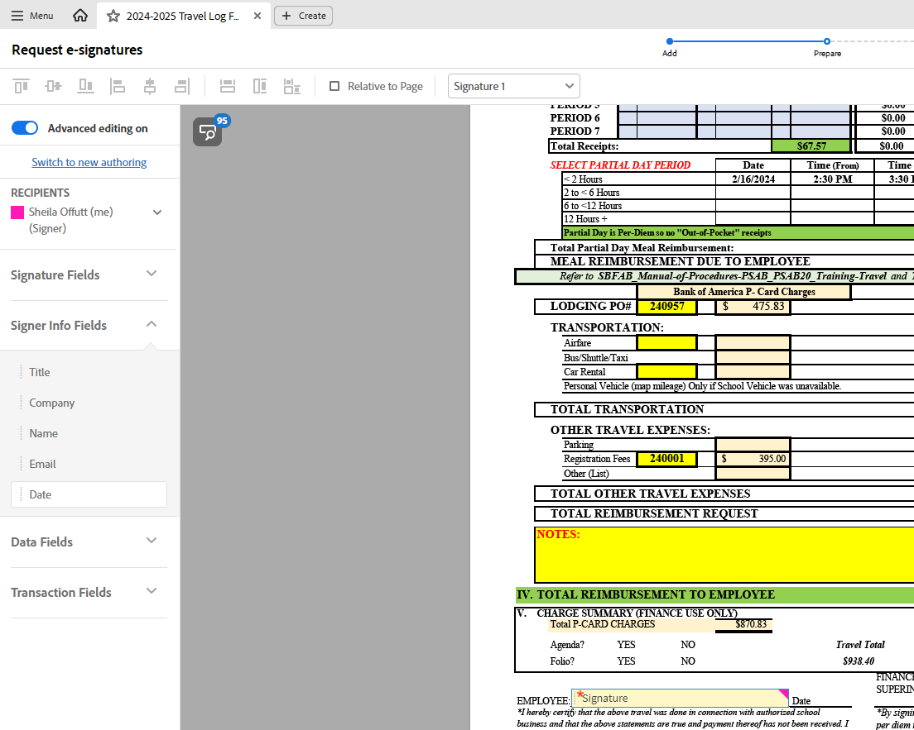

* 1. Click the drop-down button on the Recipients list and choose second (or third, etc.) recipient, and follow above steps. Click SEND (Bottom Left of screen)

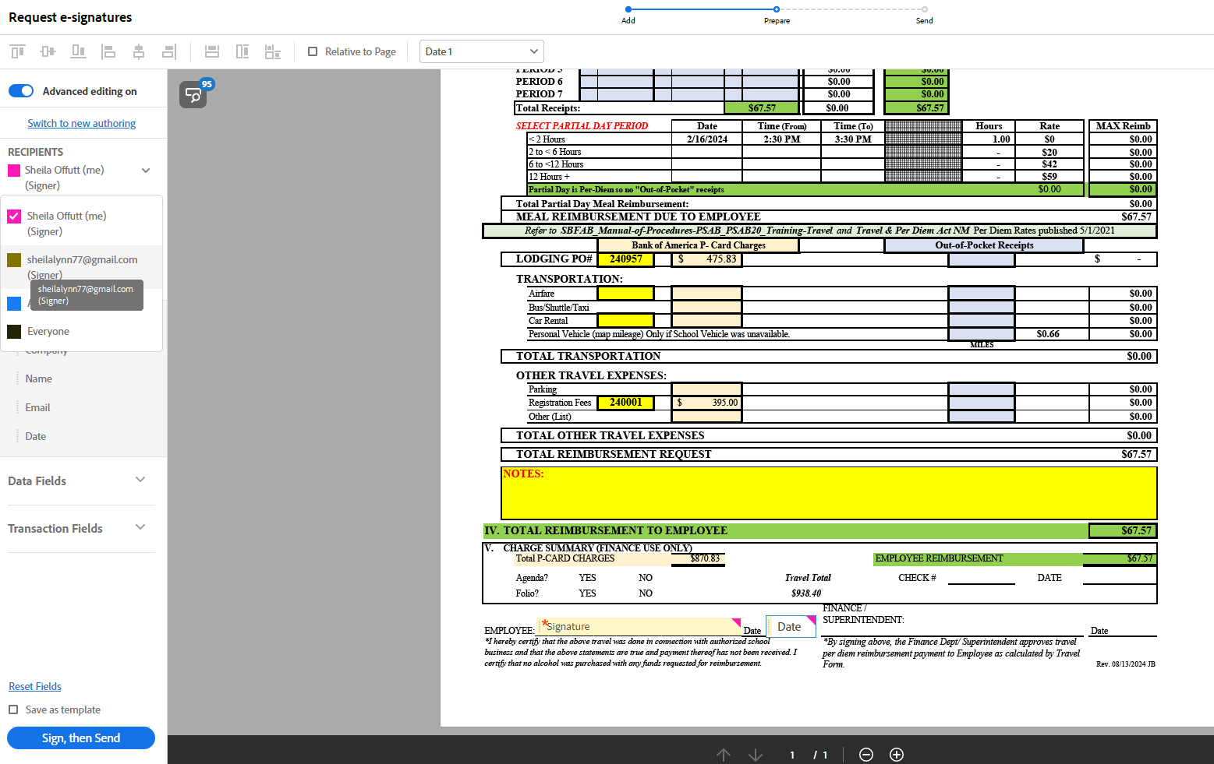

* 1. Click Close. Signers should receive an email to sign.

1. If you have not received the signed PDF back, you can log into Adobe via your Gmail account and send a reminder to the signer, or cancel if the PDF is no longer needed. Click on the file pending a signature, then additional options will appear on the right:

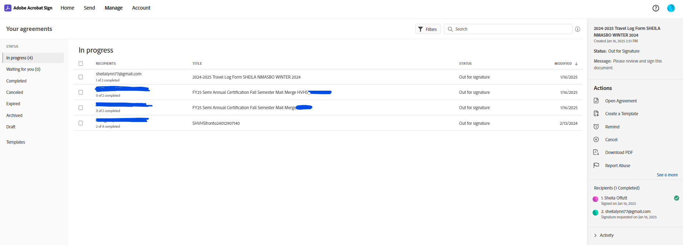

1. Submit all paperwork to your secretary so he/she can create your POs.