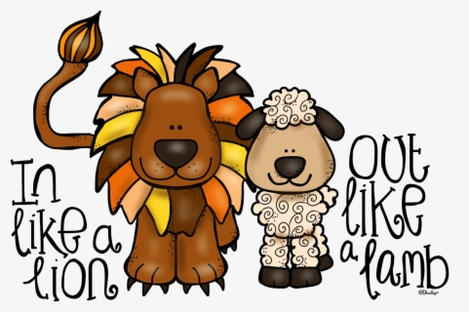
Reading News
Mrs. Williams
Date: March 2, 2026

Reading: Abraham Lincoln: The Great Emancipator

Word Study: sounds of ph,gh

Vocabulary:
determined – willing to work hard to achieve something
risk – something that could lead to danger or embarrasment
curiosity – a habit of being interested in learning things
narrow escape – when something unexpected event works out due to another unexpected event
wilderness – forest where no people live
challenges – anything that makes you work hard
unexpected – surprising
motivate – to give someone inspiration to do something
preach – talk in a convincing way

