

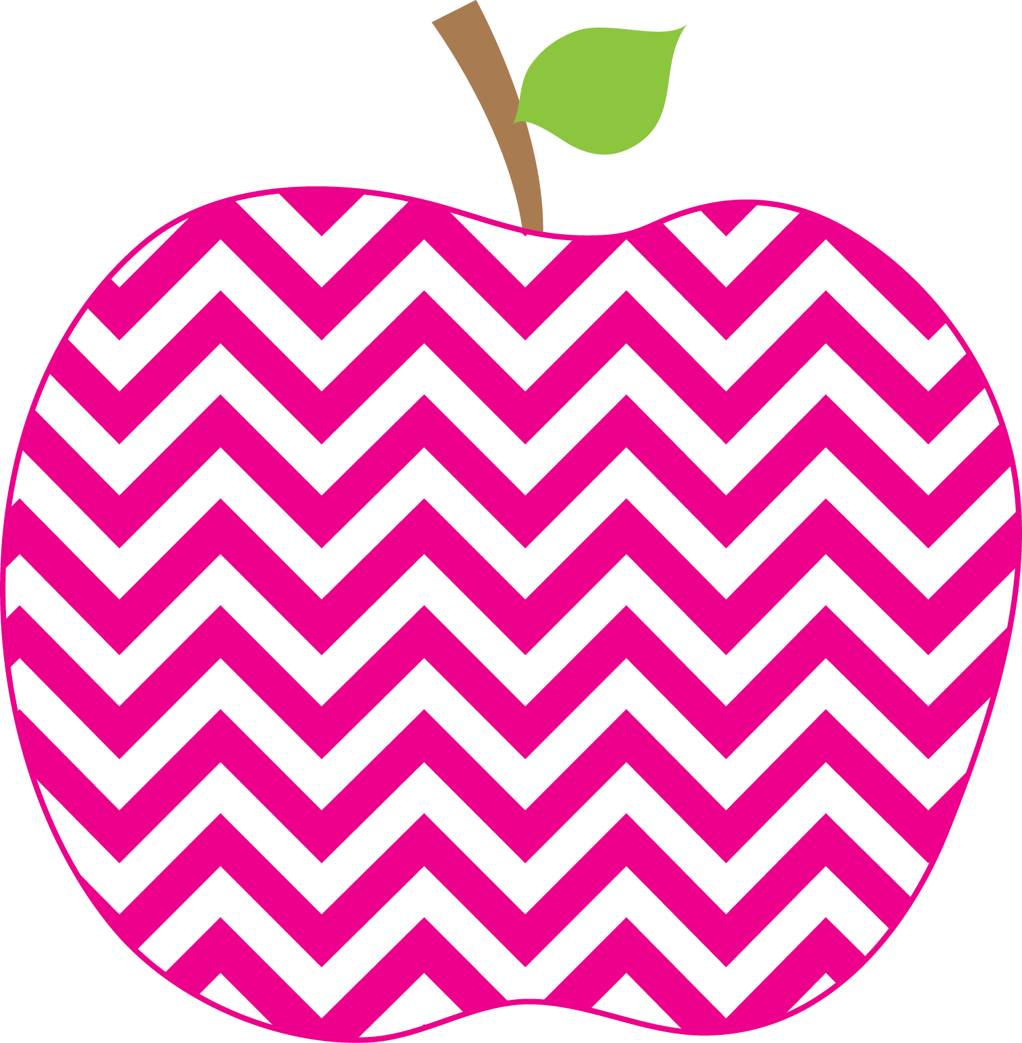



E. Robinson Weekly
Ms. E

January 27, 2025

Reading:
Phonics Skills:
*Long /e/ spelled e, e_e, ee, ea

High-Frequency Words:
or two green take be

RED Words:
here be

Grammar Skill: Commas and Plural Nouns

Math:
*Place Value: Tens and Ones

Social Studies/Science- The Water Cycle

This Week’s Focus:

Star Apple of the Week:
Rebekah Parker
* Please make sure that you are helping your child with his/her homework each night. By now, ALL students should be able to read his/her homework independently each night.

Friday, January 31st Special Snack

Friday, February 7th Money Due for P’zazz Art

Friday, February 14th P’zazz Art Session Valentine’s Party

Reminders:
Important Dates:

