WARRIOR FOOTBALL CAMP
JULY 9 & 10 2022
GRADES 3-6 3-5PM
GRADES 7-12 5:30-7:30 PM
AT THE FOOTBALL FIELD

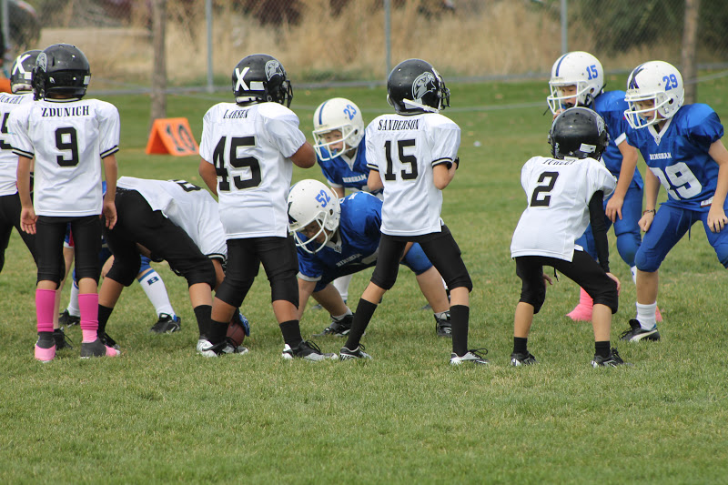
CAMP WILL BE HOST BY FORMER BISMARCK BUCK PLAYERS.
IF YOU HAVE ANY QUESTION CALL ROBERT WATSON @ 854-3461 EXT 3104 OR 701 455-1657

