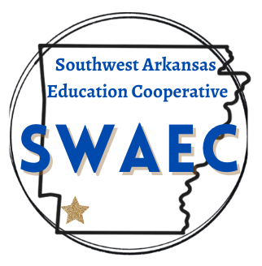

DATE: December 10, 2025

TO: S.W.A.E.C. Superintendents
FROM: Phoebe Bailey, Director
SUBJECT: December Board Meeting
The monthly Southwest Arkansas Education Cooperative Board Meeting will be held on Thursday, December 18, 2025, 10:30 A.M., at Fouke Performing Arts Center, Fouke, AR.

Agenda:

- Call to Order
- Old Business
  - Approval of Minutes for November
- Financial and Expenditure Reports for November
- New Business
  - Fouke Student Presentation
  - AEPA Bidding Contract Approval
  - Mental Health Update
  - Letter Grade Update
  - Monica Morris- Teacher Center Update
  - Phoebe Bailey- Director Update
  - Personnel Slate for Approval
  - Other Items May Be Added As Necessary

2502 South Main Street • Hope, AR 71801 • 870-777-3076

