Mrs. Cannon’s Newsletter
December 2-6, 2024

New

Reading:
- R Controlled Vowels- air, are, ear, ere
- Character, Setting, Plot
- 5 W Questions (Who, What, When, Where, Why)
- Story Structure
- Character point of view
- Central Message

Word Study Words:
hair where stairs wear chair
bear care square share pear

High Frequency Words:
another from boy hurt could
over out every far these

Math:
- Measurement

Language:
- Adverbs

Social Science:
- Lady Liberty
- Scholastic News

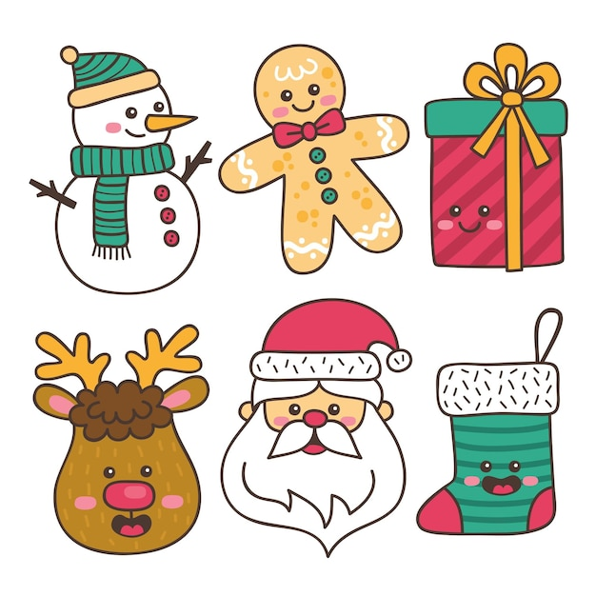
this week’s focus



Upcoming Events & Important Info

Student of the Week
Anthony
(If your child is student of the week and you would like to send in treats for the class, please send them in on Friday.
- PLEASE SEND EXACT CHANGE FOR SNACK. ($0.75 or $1.50) I do not have change to give back.
- PE: 11:20-112:05
- Lunch: 12:26-12:51
- Please label any money sent in (ex. -snack, field trip, etc.)
- Your child must wear tennis shoes or closed toe shoes to PE EVERYDAY!

- Wonderful Wednesday (special snack)- Wednesday for $2.00 (only send money on this day)
- Penguin Patch store next week
- Vision Screener- Dec. 10th
- ½ Day of school for students- Dec. 20th

Reminders

