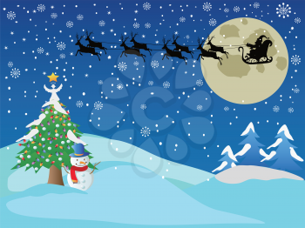
CLASS NEWS
Mrs. Williams
Date: December 16, 2024

Math: review of skills

Science/Social Studies: review matter; test moved to Tuesday

Upcoming Events:
December 20 - Breakfast Party
December 20 - 12:00 Dismissal/End of 9 Weeks
December 23-January 7 – Winter Break

Wishing you a wonderful Holiday Season!!



