Climate & Culture Parent Survey

Mobile County Public Schools is conducting a parent survey. We value your opinion and ask that you please take time to complete this survey. Please be assured that your responses to this survey will be anonymous.
Please select the school/schools that your child/children currently attend.
This is a very short survey.

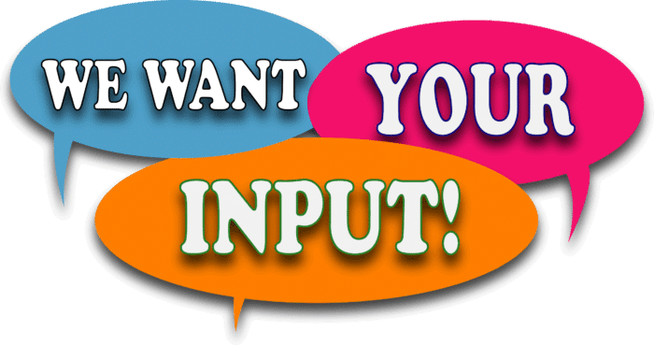

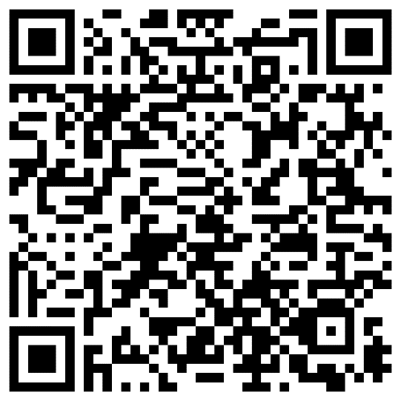

Thank you for taking your time to complete the survey. (CB)

