**Bean Station Elementary School**

**Kindergarten Supply List**  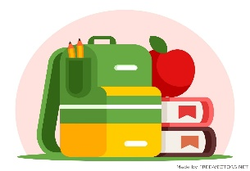

**2025-2026**

* **3 ring zipper Pouch with clear front**
* **4 packs of 8 count glue sticks**
* **1 pencil box (no metal ones)**
* **Backpack (no rolling ones, please)**

**Teacher Wish List**

* **1 box of tissues**
* **1 bottle of germ x (20 oz or larger)**
* **Lysol wipes**
* **Paper towels**
* **Two 24 packs of Crayola Crayons**

**Other:**

**Every student will need a complete change of play clothes.**

**Socks, underwear, shirt, and pants. Please place all these items in a large Ziplock bag and write the child’s name on the outside in bold letters.**

**PLEASE BRING ALL SUPPLIES TO YOUR PARENT MEETING AT THE FIST OF THE YEAR!**

**Bean Station Elementary School**

**First Grade Supply List**

**2025-2026**

* **1 large backpack (no rolling ones)**
* **6 packs of 24 count Crayola crayons**
* **1 large pencil pouch**
* **2 packs of #2 pre sharpened yellow pencils**
* **8 Elmer Glue sticks**
* **1 10 packs of thin Crayola markers**
* **1 pair of headphones**

**In a pencils pouch, please place a box of crayons, 2 glue sticks 7 4 sharpened pencils.**

**Teacher Wish List**

**1 pack of white copy paper**

**2 boxes of tissue**

**Boys bring: 1 pack of white cardstock, 1 box of disinfectant wipes, 1 box of tissues**

**Girls bring: 1 pack of colored Astro brights copy paper, 1 bottle of germ-x with pump dispenser-6.75 oz, 1 box of tissues**

**Bean Station Elementary School**

**Second Grade Supply List**

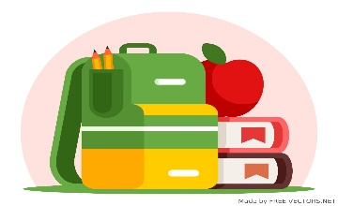

**2025-2026**

* **1 Large pack of Ticonderoga per sharpened pencils**
* **1 plastic school box**
* **2 boxes of 24 count Crayola Crayons**
* **1 Corded headphones (USB or headphone jack)**

**No Rolling Backpacks**

**Teacher Wish List: Kleenex, Disinfectant Wipes, Paper Towels, Germ-X, Copy paper, Astro Bright Colored Copy Paper, individually packaged snacks, and small waters.**

**Bean Station Elementary School**

**Third Grade Supply List**

**2025-2026**

* **Tab Dividers**
* **JBL or similar set of headphones**
* **Red Grading Pens**
* **One Dry Eraser**

**Teacher Wish List**

**Kleenex, Germ-X, Clorox Wipes, Paper Towels, Copy Paper, Zip-loc Bags, candy for prizes.**

**Bean Station Elementary School**

**4th Grade Supply List**

**2025-2026**

* **Backpack (NO rolling backpacks)**
* **1 pack of pencils**
* **Pencil Pouch**
* **Headphones for computers**
* **Wireless mouse (optional)**

**Classroom Needs and Wishes**

* **2 bottles of Germ-X**
* **4 boxes of Kleenex**
* **2 bottles of Clorox Wipes**
* **2 rolls of paper towels**

**Bean Station Elementary School**

**5th Grade Supply List**

**2025-2026**

* **One pack of Dividers (pack contains at least 5 dividers)**
* **1 pack of notebook paper reinforcements rings (to be turned into Mrs. Stroud)**
* **Inexpensive pair of earbuds to use with Chromebooks you may want to buy a few pairs because the kids use them all year.**
* **Inexpensive portable mouse to use with chrome books (not required)**
* **Pencils will be used all year. You will need to purchase throughout the year.**

**Teachers’ Wish list:**

**Tissues, Clorox Wipes, Wooden pencils, and one pack of white copy paper.**

**Do not buy locks for lockers they will not be allowed to use.**

**Bean Station Elementary**

**6th Grade Supply List**

**2025-2026**

(3)    TWO INCH THREE RING BINDERS (*Do not purchase one inch as they are not big enough.*)

(3)    Tab dividers *(5 count)*

(3)    Three-ring pencil pouches (one for each binder)

Pencils

Headphones to use with Chromebooks.

Red ink pens

***Optional Supplies***

Clorox Wipes

Kleenexes

Copy paper

*\*Monday, August 4th, 2025, is the first day of school. Bring all your school supplies since you change classes, take notes, and assemble your binder.*