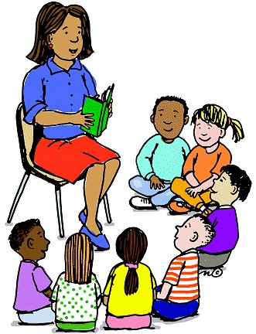

**Counselor’s Newsletter**

***Ms. Cunningham***

***October 2022***

**Dear Parents/Guardians,**

This month’s lessons will be about Bullying and Drug Education. Our bullying lesson will center around kindness, what to do if you’re being bullied, how not to be bullied and more. Our drug education lessons will center on how drugs affect your body, the consequences, just saying no, and other ways to protect yourself from drugs.

**News**

Parents/guardians the Bullying T-shirts were given out this week. Thank you to all who supported the cause. Those who ordered will be able to wear their t-shirt one day during Bullying Week. We have lots of activities for Red Ribbon Week, these activities will be posted on our school’s website and Face Book Page. We will also have Bayou La Batre Police Department come to visit us during Bullying & Red Ribbon Week.

**Important Dates/Events**

**Report Cards**

**Bullying Week-17th-21st**

**Club Day-20th**

**Magnet School Visits**

**Phillips-19th**

**Dunbar-24th**

**Red Ribbon Week-24th-28th**

**District Attorney Office-Ms. Ryals**

**Monthly Character Word**

**Caring**

Caring is displaying kindness and concern for others. Have you ever been bullied? Bullying can include name calling, being made fun of, being pushed or shoved or other mean-spirited actions. What can we do to make sure that our school is a safe and caring place for all students? We can remember that bullying can be very hurtful and can hurt for a long time. Some people never forget the times they have been bullied.

It’s never too soon to be caring to others. Today, do your part to create a more caring school by doing two simple things:1. Don’t stand for bullying and 2. Look for ways to be caring to others.