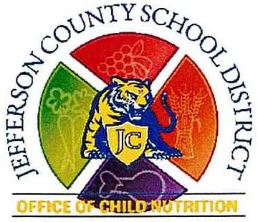
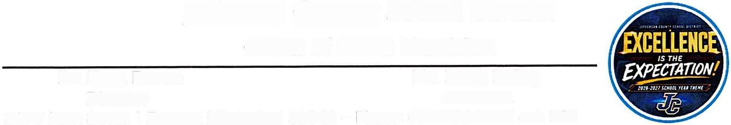
Jefferson County SChOOl District
Office of Child Nutrition
Dr. Faye Brown Ms. Maya Irving
Director Assistant
2277 Main Street/Fayette, Mississippi 39069 — Phone: 601.786.3919 ext. 505
July 8, 2026
Letter to Households in Schools/Districts Participating in Community Eligibility Provision
Dear Parent 0r Guardian:
We are pleased to inform you that Jefferson County School District
will be implementing an option available to schools participating in the National School Lunch and School Breakfast Programs called the Community Eligibility Provision (CEP) for School Year 2026—2027.
What does this mean for you and your children attending the school(s) identified above?
Great news for you and your students! All enrolled students of Jefferson County School District are eligible to receive a healthy breakfast and lunch at school at no charge to your household each day of the 2026—2027 school year. No further action is required of you. Your child(ren) will be able to participate in these meal programs without having to pay a fee or submit an application.
If we can be of any further assistance, please contact us at the Jefferson County Office of Child Nutrition (601-786-7687 or fbrown@jcpsd.net).
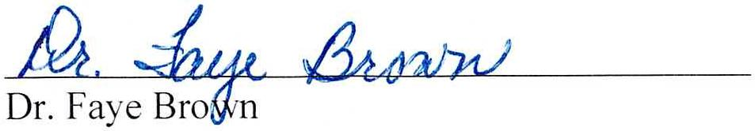
Sincerely,
Child Nutrition Director
This institution is an equal opportunity provider.
Revised 06—2026

