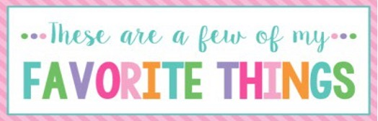

Name: | Shannon Hollingsworth | T-Shirt Size: | L/XL
Birthday: | January 20th | Monogram: | sHr
Favorite Color: | green | Favorite Flower: | Gerber daisy
Favorite Scent: | clean scents | Favorite Candy: | Peanut M&Ms
Favorite Drink: | Coffee, water | Favorite Food: | Mexican
Favorite Snack: | Chex Mix and popcorn | Favorite Fruit: | bananas
Favorite Restaurant: | Maria’s Cantina | Favorite Fast Food: | Arbys and Lennys
Favorite Places to Shop: |  | Target, Dilliards, Ulta,
Favorite Bath & Body Works Scent: |  | Anything but fruity scents
Things I Collect: |  | Pottery, llamas, candles
Favorite Author/Book Series for Personal Reading: |  | I love mysteries and thrillers
Wish List for Classroom: |  | Card stock, construction paper, and candy

