How to access the DRC INSIGHT testing app on a Chromebook

The DRC INSIGHT kiosk app is available on all student District Chromebooks. A kiosk app appears ONLY on the sign-in screen. The student must SIGN OUT of the Chromebook in order to see the app. To sign out of the Chromebook, click the menu by the clock and choose Sign out.

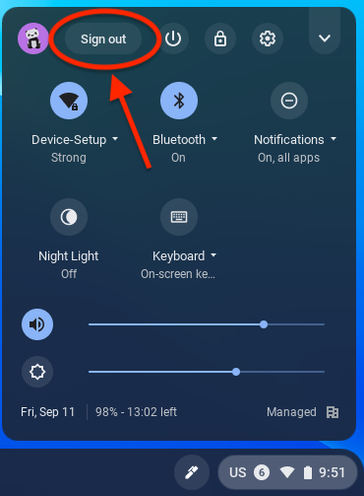

Once the student signs out, they will see a menu of kiosk apps in the system tray on the sign-in screen. The student must select the DRC INSIGHT Online Assessment app to launch it and take the test.

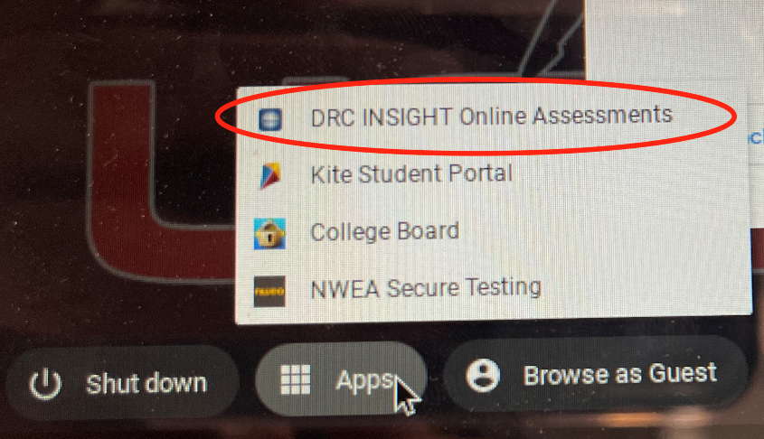

You may see a loading screen for a few seconds while the app loads. PLEASE WAIT until the app loads and the choice appears for which test you will be taking. For WIDA tests, please choose DRC.

Follow instructions from your teacher regarding which option to choose and what username and password to use (if applicable) to begin testing.

After the test is complete, you can exit the kiosk app by clicking the exit button, and sign back into a Chromebook user session.

