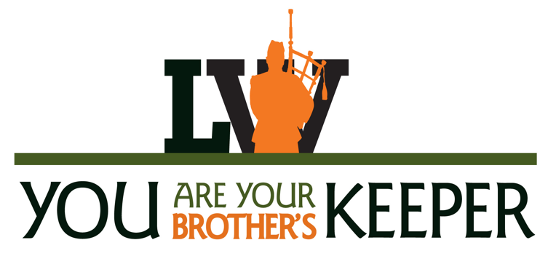

Lake Wales High School
School Advisory Council

SAC Agenda
Thursday, October 13, 2022

- Welcome SAC Members & Guests/Call to Order - June Ullman, Chair

- Approval of September 8, 2022 Meeting Minutes - June Ullman, Chair

- Principal's Report - Anuj Saran, LWHS Principal
  - Personnel Changes
  - Enrollment and Wait Lists

- Superintendent’s Report – Dr. Wayne Rodolfich, LWCS Superintendent
  - Choose Lake Wales initiative
  - READ 20

- Title I Update– Donna Geils, LWHS Media Specialist

- SAC Information and Reminders - June Ullman, Chair
  - REMINDERS: In Person meetings and attendance is important
  - ALL stakeholders are invited to attend meetings, only members can vote.
- Handbook Training and Worksheet
- Sunshine Law Reminder
- Bylaws Review Committee
- Community Representatives

- New Business - June Ullman, Chair
  - Academic and Fall Sports - Coach Arianne Seidl, LWHS Athletic Director
  - Calendar updates

- Old Business
  - School Safety

- Comments, Concerns, and Questions

- Adjournment

Next meeting: Thursday, November 10, 2022

REMINDER for MEETING DAYS:
PLEASE Bring a government ID and enter through the office to receive a visitor ID.
Office will open at 6:45 for the 7 AM meeting.

