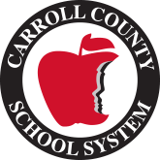 | 

Title I
School Improvement Plan

Draft Date: 9/16/2026
Approval Date: 9/16/2026
School | Temple Middle School
Principal | Dr. Sean Schinella
Year | FY 27
Superintendent | Dr. Jessica Ainsworth

Schoolwide Components

The Comprehensive Needs Assessment must be conducted by teachers, principals, paraprofessionals, other school leaders, parents, and the community.

Name | Role
Sean Schinella | Principal
Monica Chason | Assistant Principal
Larry Weaver | Assistant Principal
Sean Bruso | Counselor
Diana Fundeburke | ISC
Amy Fleming | Teacher
Lindsay Minton | Teacher
Brandon Dickson | Parent
Lance Hill | Teacher
Matt Smith | Teacher
Kelly Steele | Teacher
Stephanie Covington | Teacher
Rebecca Raines | Teacher
Kylee Joiner | Teacher
Nicole West | Teacher
Emily Tucker | Instructional Coach/FEC

Comprehensive Needs Assessment Planning Committee
* A Parent Must Be Present at the Meeting

- Comprehensive Needs Assessment-1114(b)(1)(A)

Academic Achievement Data Collection
Add Documentation for the Data Tools Below
Instrument Used | Content Area | Process/Procedure
EX: Star Reading | ELA | How it was used to determine at-risk students
STAR Reading | ELA | Data is analyzed in collaborative meetings at both the school and district levels. At-risk students and standards are identified. Reteaching and remediation activities are developed to address the needs of specific students through classroom instruction, flexible or tutoring groups.
BEACON | Math and ELA | Data is analyzed in collaborative meetings at both the school and district levels. At-risk students and standards are identified. Reteaching and remediation activities are developed to address the needs of specific students through classroom instruction, flexible or tutoring groups.
Georgia Milestones Assessment | Reading/ELA | Data is analyzed in School Improvement meetings, Collaborative Planning meetings, and during our school’s Needs Assessment development. Specific students are identified by their teachers for specific and focused instruction. Scores also place students in Corrective Reading and Math Connections classes.
Georgia Milestones Assessment | ELA, Math, and 8th grade Science and Social Studies | Data is analyzed in School Improvement Team meetings, Collaborative Planning meetings, Faculty meetings, and during the development of our school’s Needs Assessment. The information is used to guide planning and instruction for the following year.
Common Assessments | Math | Teachers use this data to adjust instruction to meet academic needs and to determine students who are at risk of not meeting the standards or who may need remediation or acceleration. Carroll County School District has worked with content leaders to develop spirals and Common Assessments, which are used to measure student achievement upon completion of specific units of study. Data from these assessments are analyzed by teachers to identify students who need additional support at Tier I or Tier II level. Computer programs such as Progress Learning are also employed as a strategy for students to receive additional instruction on priority standards.
TMS Subgroup Data Tracking Document | All subgroups grades 6, 7, 8 in ELA, Math, Science, and Social Studies | TMS tracks assessments over standards in each classroom on Milestones, STAR, Beacon, and Common Assessments. Teachers use the data to adjust instruction to meet students’ academic needs and to determine students who are at risk of not meeting the standard or who may need remediation or acceleration on priority standards. Data from these assessments are analyzed by teachers to identify students who need additional support at the Tier I or Tier II level. Computer programs such as Progress Learning are also employed as a strategy for students to receive additional instruction on priority standards.

Is based on a comprehensive needs assessment of the entire school and takes into account information on the academic achievement of the children in relation to the challenging State academic standards, particularly the needs of those children who are failing, or at risk of failing, to meet the challenging State academic standards and any other factors as determined by the local educational agency. A root cause analysis should be completed for academic areas and/or subgroups that are identified as needing additional support.
Temple Middle School developed its school wide plan with the participation of individuals who will carry out the comprehensive school wide/school improvement plan. A diverse committee was selected based on their grade level, content area expertise, and leadership skills. The committee consisted of Sean Schinella, Larry Weaver, Monica Chason, Diana Funderburke, Emily Tucker, Kelly Steele, Lance Hill, Matt Smith, Rebecca Raines, Kylee Joiner, Stephanie Covington, Amy Fleming, Brandon Dickson, and Sean Bruso. An in-depth data review involving the 2025-2026 Georgia Milestones assessment results, end of year STAR reading and Beacon results, content area spirals, common assessments, surveys from students, staff, and parents, and climate-related data was conducted on June 3rd, 2026, from 9:00 am – 3:00 pm with Dr. Cynthia Beers and Dr. Sean Schinella facilitating the meeting. A root-cause analysis was conducted to identify and understand the factors that contributed to the areas where we did not meet the established targets. An additional review of the draft school improvement plan was conducted on June 3, 2026 and changes were made to the plan. Principal Dr. Sean Schinella provided the entire faculty an opportunity to review and provide input and complete a rough draft of the school-wide plan and school improvement plan. The staff identified and highlighted areas where they were involved and/or were responsible for action to be taken in the improvement process. The plan was uploaded to the school website, placed in the parent resource center, and uploaded to the Teacher HUB in Google Drive.
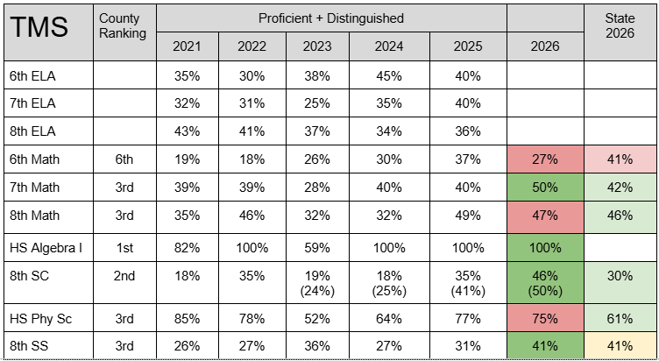
Compared to 2025, TMS demonstrated strong growth across four assessed areas in 2026. The greatest gains were seen in 8th Grade Science, increasing 11 percentage points from 35% (2025) to 46% (2026), and 7th Grade Social Studies, increasing 10 percentage points from 31% (2025) to 41% (2026) . 7th Grade Math also increased from 40% (2025) to 50% (2026).
TMS experienced declines in two areas in 2026. 6th Grade Math decreased from 37% (2025) to 27% (2026), a 10 percentage-point decline, while 8th Grade Math decreased slightly from 49% (2025) to 47% (2026), a 2 percentage-point decline. High School Physical Science also declined from 77% (2025) to 75% (2026), representing a 2 percentage-point decrease. These areas should be prioritized for data analysis to identify specific standards, student groups, and instructional practices contributing to the decreases and to determine targeted supports for continued improvement.
EOG performance data indicates that subgroup overall perform below average. Hispanic students were the closest to the Regular Program group at 40.6%, followed by Black students at 28.4%. English Learners and Students with Disabilities demonstrated the greatest areas of need, with only 2.8% and 9.1%, respectively, performing at the Proficient or Distinguished levels. Both groups also had substantially higher percentages of students performing at the Beginning Learner level, highlighting a need for targeted interventions, differentiated instruction, and additional academic support.

During our summer meeting, the team conducted a root cause analysis reflecting on the data listed above to determine strategies to address these weaknesses and how we will monitor our progress. We found several barriers to success including academic vocabulary, students reading below grade level, and attendance issues that interfere with instruction, resulting in low performance in the domains of in patterning and reasoning in 6th and 7th-grade math, and Numerical Reasoning: Irrational Numbers, Radicals & Integer Exponents in 8th grade math. In addition, in 6th and 7th grade ELA, a weakness in understanding of key ideas was uncovered and in 8th grade, additional focus on craft and structure was needed. Overall, the team discussed a continued lack of persistence and resilience in our students to tackle rigorous academic work.
Based on comprehensive needs assessment results for the 2026-2027 school year, two focus priorities were established for Temple Middle School: 1) Improve tier one instruction and academic achievement through daily integration of research-based literacy strategies and Science of Reading initiatives and 2) Improve student achievement by implementing the 4Cs of instruction (critical thinking, collaboration, communication and creativity) in rigorous and engaging lessons.
TMS has written a plan based on these priorities with an enhanced focus on professional learning and teacher observations with timely face-to-face feedback, including discussion over how to increase rigor by integrating the 4Cs. We believe these focus priorities will help create a positive culture within the building. We feel these priorities will have the greatest impact on student achievement.
We will continue to offer year-long tutoring during the school day and after school, and we are implementing spiral reviews/quizzes to build persistence and stamina in our students. Students are selected for tutoring based on academic performance on assessments and also subgroup data. A second strategy to address our subgroups performing below expectations is during our collaborative planning meetings we will discuss specific academic strategies for our subgroup students to make the content more relatable. We will monitor these interventions through our digital data room and our collaborative planning minutes.
Due to a considerable number of employees with less than 3 years of experience, a focus has been placed on professional learning for TMS’s novice teachers, including instructional strategies for intervention, remediation, and acceleration. Through the onboarding process, teachers attended extensive new teacher meetings on the school and district level, which included the Teacher Induction Program. All new teachers have also been assigned a veteran teacher mentor for the duration of the 26-27 school year. All new teachers will meet monthly from August to May. New teachers will receive one on one feedback and coaching from administration and the instructional coach from August to May, while receiving individualized feedback throughout the school year.
Based on data from the 2025-2026 school year, a climate and culture initiative was created, which will continue to build momentum this coming year. The initiative includes a calendar for the 2026-2027 school year that establishes dates, events, and plans that will positively affect staff and students for the duration of the school year. During the first three days of school, teachers delivered school-wide expectations, procedures, and the handbook to all students. One school-wide expectation is a positive behavior intervention system (PBIS) that is used daily for student behavior and there are also PBIS events throughout the school year from August to May. All staff at TMS also received refresher training on the Capturing Kids’ Hearts program and the program has been implemented school-wide. School spirit will also be promoted through spirited dress-up days and events throughout the year that encourage cohesiveness and inclusion in the building, such as homecoming week and red ribbon week.
The data reflected a need for a reorganized concept of collaborative planning. The new planning includes a heightened presence of administration and the instructional coach in collaborative planning meetings. Weekly collaborative meetings will occur on Wednesdays with an agenda each week. This agenda will identify what we are going to work on each week and then keep us focused on that work. The administration and instructional coach will attend all collaborative planning. The focus of collaborative planning will include formative assessment, engagement strategies, explicit vocabulary instruction and using data to inform instruction. Time will be spent on ensuring high levels of rigor in our lessons through the use of content ALDs, higher order thinking questions and DOK 3 and 4 level in class assignments.

a. Academic Achievement Data

*Insert your school profile data, including demographic data, GMAS results, STAR and any other data used to determine strengths and weaknesses. Make sure to include subgroup information.

Sub  Group | 6th ELA STAR |  |  |  | 7th ELA STAR |  |  |  | 8th ELA STAR |  |  |  | 8th Sci GMAS
 | 1 | 2 | 3 | 4 | 1 | 2 | 3 | 4 | 1 | 2 | 3 | 4 | 1 | 2 | 3 | 4
All | 24 | 19 | 42 | 15 | 33 | 34 | 30 | 3 | 26 | 31 | 34 | 8 | 25 | 29 | 40 | 6
White | 22 | 17 | 46 | 16 | 30 | 37 | 29 | 4 | 22 | 29 | 41 | 7 | 25 | 28 | 39 | 8
Black | 30 | 30 | 28 | 11 | 50 | 17 | 31 | 3 | 35 | 37 | 20 | 8 | 28 | 33 | 38 | 3
Hisp | 29 | 14 | 39 | 18 | 25 | 38 | 38 | 0 | 38 | 15 | 35 | 12 | 19 | 25 | 56 | 0
Multi | 19 | 13 | 56 | 13 | 29 | 43 | 21 | 7 | 11 | 67 | 11 | 11 | 29 | 29 | 36 | 7
SWD | 74 | 12 | 14 | 0 | 84 | 13 | 3 | 0 | 71 | 18 | 11 | 0 | 68 | 14 | 14 | 4
ELL | NA | NA | NA | NA | NA | NA | NA | NA | NA | NA | NA | NA | NA | NA | NA | NA

Sub  Group | 6th Math GMAS |  |  |  | 7th Math GMAS |  |  |  | 8th Math GMAS |  |  |  | 8th SS GMAS
 | 1 | 2 | 3 | 4 | 1 | 2 | 3 | 4 | 1 | 2 | 3 | 4 | 1 | 2 | 3 | 4
All | 24 | 50 | 19 | 8 | 11 | 39 | 37 | 13 | 15 | 37 | 29 | 18 | 18 | 41 | 30 | 11
White | 22 | 49 | 21 | 9 | 8 | 30 | 47 | 15 | 16 | 32 | 34 | 19 | 18 | 35 | 34 | 13
Black | 33 | 47 | 14 | 6 | 15 | 57 | 17 | 11 | 18 | 51 | 18 | 13 | 20 | 58 | 13 | 9
Hisp | 26 | 53 | 16 | 5 | 24 | 36 | 32 | 8 | 5 | 42 | 32 | 21 | 11 | 56 | 22 | 11
Multi | 14 | 71 | 7 | 7 | 0 | 70 | 20 | 10 | 20 | 33 | 20 | 27 | 27 | 20 | 47 | 7
SWD | 53 | 44 | 3 | 0 | 36 | 47 | 17 | 0 | 61 | 29 | 4 | 7 | 64 | 25 | 7 | 4
ELL | NA | NA | NA | NA | NA | NA | NA | NA | NA | NA | NA | NA | NA | NA | NA | NA
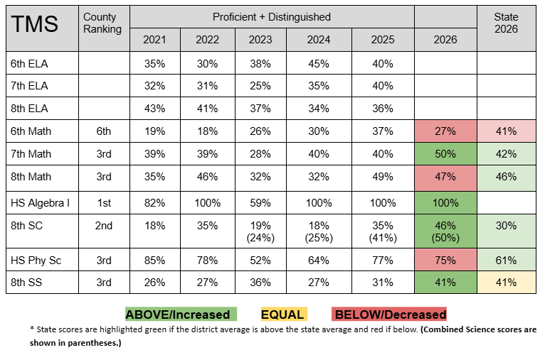
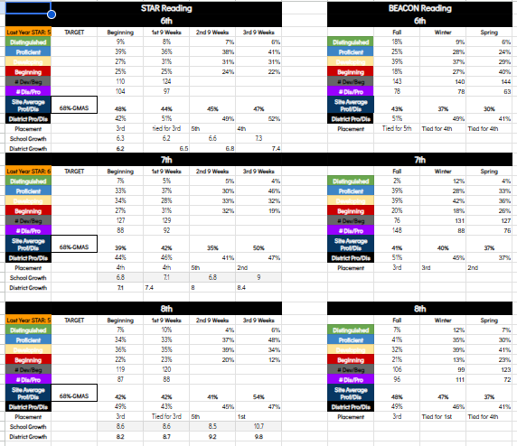
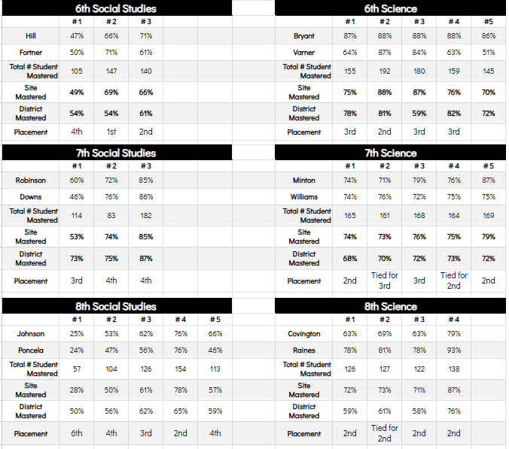

2. Schoolwide Reform Strategies Sec. 1114(b)(7)(A)(i-viii) that the school will be implementing to address school needs, including a description of how such strategies will address academic weaknesses and root causes.

a. Provide opportunities for all children, including each of the subgroups of students(economically disadvantaged students, students from major racial and ethnic groups, children with disabilities, and English learners [Sec 1111(c)(2)]) to meet the challenging State academic standards. Include your method of monitoring the effectiveness of your strategies throughout the school year.
- Through the use of a specific data protocol, students will be identified across all subgroups.
- Teachers and students will set goals based on current data and track progress in their Google Classroom.
- Specific instructional methods and instructional strategies will be implemented to address their individual needs based upon the data and goals set between the teacher and student to address their needs.
- For our ELL subgroup, STAR renaissance has a Spanish version that can be used to help further diagnose cognitive weaknesses as opposed to a language barrier. Other strategies include providing words in the native language of our ELL students to improve fluency and comprehension.
- Progress Learning has a range of lessons that are scaffolded to provide activities that have lower entry points so that all students can enter the lesson, based on their current level of understanding and have high ceilings that keep them engaged and challenged as they move toward greater understanding. This math curriculum provides structure and is designed to increase the difficulty level as students show mastery at the lower levels. Our students with disabilities (SWD) and black subgroups will be provided targeted interventions from this math curriculum to meet them where they are and accelerate their understanding of the required math curriculum.
- In the area of ELA, the lowest performing subgroups are the black, hispanic and SWD students. STAR Renaissance provides diagnostic data to guide our interventions and then programs such as NewsELA and Progress Learning provide strong remedial lessons to reach these students. Tracking student progress using these programs will allow us to refine our interventions over the course of the school year.
- In the areas of Science and Social Studies, the lowest performing subgroups are the black and SWD students. Our district-developed common assessments provide guidance on intervention needs, and then programs such as NewsELA and Progress Learning provide strong remedial lessons to reach these students. Tracking student progress using these programs will allow us to refine our interventions over the course of the school year.

b. Use methods and instructional strategies that strengthen the academic program in the school, increase the amount and quality of learning time, and help provide an enriched and accelerated curriculum, which may include programs, activities, and courses necessary to provide a well-rounded education. Include strategies used to identify and serve the gifted and talented.
- Class Size Reduction- One additional teacher will be hired in math and one in ELA in order to reduce class size. Smaller class sizes provide the opportunity for more individualization and support for students who are having difficulty mastering the standard being presented. Smaller class sizes also provide opportunities for small group instruction that is specifically designed for students. In addition, teachers will be better equipped to identify the needs of students through observation and formative assessment in a timely manner.
- Renaissance Learning (STAR Reading)- The Renaissance Learning Program will be used to screen students and identify particular areas of weakness at a minimum of once per nine weeks. The program allows teachers to identify specific standards on which individual students have not reached mastery. The program then provides goal-specific instructional tools and methods for providing remediation and support.
- Utilization of Computer Programs - Progress Learning, NewsELA, Gimkit, Navigate 360, and EdPuzzle will be employed to remediate and accelerate student academic performance in all content areas. These programs are designed for individualization and will challenge the student at his/her current level of performance.
- For our gifted students, teachers will plan collaboratively to create higher rigor assignments in our advanced classes and also provide additional learning opportunities like a marine science field trip with the UGA Marine Science Lab that includes hands-on, higher order thinking activities.
- Ongoing professional development for teachers and other personnel will be provided in-house monthly. The professional development opportunities are designed to directly correlate to the district and state academic standards, the expectations for rigorous instruction, and the assessment and accountability measures currently employed. As a result, the students will experience better instruction which will lead to increased student achievement.
- A full-time Instructional Support Specialist will be hired to assist both teachers and students with attaining instructional and achievement goals. The Instructional Support Specialist will provide professional learning to school staff (monthly) and will assist with the disaggregation of data. She will work with staff members during collaborative planning sessions in the gathering of resources so that they are better equipped to provide additional support and differentiation opportunities for students. Additionally, she will work directly with our intervention specialists to target our at-risk students and develop a plan of action regarding skill and behavior deficiencies. She will also work with small groups of students to provide targeted interventions and small group instruction (as needed).
- Progress Learning will be added to our instructional technology resources in order to allow for additional review of essential skills through the Green Dot Challenge. Students across all grade levels will complete the Green Dot Challenge for any skills identified in Progress Learning as areas for growth. This challenge will allow teachers to remediate targeted skills in our math and ELA classrooms.

c. Address the needs of all children in the school, but particularly the needs of those at risk of not meeting the challenging State academic standards, through activities which may include—

i. Counseling, school-based mental health programs, specialized instructional support services, mentoring services, and other strategies to improve students’ skills outside the academic subject areas.
All students receive CCS grade-level appropriate Advisement and Guidance lessons throughout the year related to mental health, academics, personal/social issues, and career exploration. The focus on student Social Emotional Wellness and the Carroll County Student Essentials is incorporated in the advisement lessons. The students identified as needing more assistance are invited to participate in small group activities during the school year. Students, parents, and teachers, are able to refer students to the school guidance counselor for individual sessions. We use the Willowbrooke referral process to address the mental health needs of students identified as needing extra assistance. We are also working to bring outside resources into the school so that students and families with limited resources are still able to take advantage of opportunities offered at school.

ii. Preparation for and awareness of opportunities for postsecondary education and the workforce, which may include career and technical education programs and broadening secondary school student’s access to coursework to earn postsecondary credit while still in high school (such as Advanced Placement, International Baccalaureate, dual or concurrent enrollment, or early college high schools).
Temple Middle School encourages our students to be “Future Focused.” Students who have met certain academic requirements have the opportunity to take 9th-grade classes and earn high school credit as eighth graders. All students receive career counseling through GCIS each year of middle school and have the opportunity to attend college and career-related field trips. They start in 6th grade by taking a Career Cluster Inventory Survey designed to help them consider future career areas of interest and visiting a technical college. In 7th grade, they take the Interest Profiler, which matches their interests with careers they may enjoy. Our 8th Graders complete the YouScience Career inventory and explore careers that match their interests and aptitudes. Throughout their 8th-grade year, students complete a career exploration capstone project that investigates four of the recommended careers from the YouScience inventory. In addition, students complete an individual graduation plan by selecting the courses they will take at Temple High School. They also visit the College and Career Academy and attend the Career Expo to learn about three careers of interest. All 8th graders learn about the Dual Enrollment opportunity available to them in high school, and their parents are invited to attend a separate meeting on the same subject. In an effort to prepare students for the 21st-century career market, TMS utilizes various technology devices to enhance student learning and instruction. In our advisement sessions, we focus on the Carroll County Schools Student Essentials to help guide and develop our students so they will either be enrolled in post-secondary schools, employed, or enlisted. Individual career counseling is available as needed or requested.

iii. Implementation of a schoolwide tiered model to prevent and address problem behavior, and early intervening services, coordinated with similar activities and services carried out under the Individuals with Disabilities Education Act (20 U.S.C. 1400 et seq.);
PBIS at Temple Middle School is a behavior management process used to create a safe, positive school environment. TMS encourages our students to ROAR: be respectful, on task, accountable, and responsible. These should be pervasive across the school in the areas of: classroom, hallways, cafeteria, restrooms, and buses. In each of these areas achievable expectations were developed and are posted throughout the building in the designated areas. Teachers instruct, demonstrate, and communicate these expectations during monthly advisement mini-lessons. Students who adhere to these expectations are rewarded with incentives given weekly, monthly, quarterly, biannually, and annually. TMS uses Navigate 360, a PBIS reward program, to manage and monitor the use of PBIS points for rewards. Students can use their points in the school store and/or to buy snacks from the concession stand. In addition to a reward system, TMS created a school-wide behavior discipline plan. All teachers adhere to this multi-step behavior modification process that outlines consequences for misbehavior. Teachers and administrators carry radios to be responsive to any disciplinary concerns efficiently, so that the learning environment is not disturbed and a safe and positive school environment is maintained.
MTSS at Temple Middle School provides a multi-tiered system of support for our students. This consists of three tiers to support students and a final tier of intensive intervention through Exceptional Children’s Services. In tier one, teachers provide a robust data-driven instructional program based in the Georgia Standards of Excellence. At this tier, teachers provide “standards plus,” with the plus being STEM (science, technology, engineering, and math) learning opportunities for our students. At tier two, students are given more intensive individual, small group, and pull-out models to support student success in learning. Students are identified based on historical, diagnostic, formative, and summative assessment data. Teachers use research-based instructional strategies to provide a second layer of support to individual and small groups of students. In addition, students are identified and scheduled into ROAR groups that can provide academic interventions three days a week. At tier three, again based on student performance data, students are provided individual and small group intensive intervention research-based strategies to address student learning needs. Finally, students not showing growth or improvement may be referred for further testing with our school psychologist to identify any learning disabilities. If learning disabilities are identified, an IEP (Individual Education Plan) is developed, and the appropriate services are identified and implemented.

iv. Professional development and other activities for teachers, paraprofessionals, and other school personnel to improve instruction and use of data from academic assessments and to recruit and retain effective teachers, particularly in high-need subjects.
TMS has included teachers, principals, paraprofessionals and, if appropriate, pupil services personnel, parents, and other staff in our professional learning that addresses the root causes of our identified needs. Teachers establish professional learning communities based on identified areas that are determined by assessment data, which indicate a need for improvement to increase instructional effectiveness in the classroom. These areas of need will be addressed through multiple methods of professional development such as peer observations and study groups, horizontal collaborative planning, and coaching with educational consultants, system academic coaches, and school-based Instructional Lead Support Specialists on effective and innovative teaching strategies. To enhance the professional development of our faculty and staff, TMS will provide release time for collegial planning to analyze student data, receive in-house professional learning, and to research and develop implementation of appropriate instructional strategies to address student deficits in ELA. This release time will be coordinated through the Instructional Lead Support Specialist. In addition, professional learning is provided at the system level for teacher-specific needs. New staff are provided mentoring opportunities with veteran staff members to clarify school and system expectations on teaching and learning, and to provide local support and development. We also provide monthly professional learning sessions to teachers on topics identified as needed by the staff.
Additionally, this year we will add three vertical planning dates. These vertical planning opportunities for ELA and math teachers will allow time for planning based on curriculum and assessment data.
Two teachers will accompany the principal and instructional coach to the Deeper Learning Conference to learn more about bringing project-based learning back to our campus. The conference connects to the district’s focus on the 4Cs of STEM. Research shows students in Deeper Learning environments consistently outperform peers on standardized assessments, develop superior interpersonal and intrapersonal skills, graduate at higher rates, and demonstrate greater college persistence.
Subs will be provided for any teachers who require coverage during the school day.
v. Efforts to recruit and retain effective teachers in high-need content areas:
Temple Middle School is focused on recruiting and retaining effective teachers in high need content areas, including ELA, math, science, and social studies. Temple Middle School works to attract highly effective teachers by providing a strong induction and mentoring program to support new teachers, as well as embedding in-house professional learning communities to develop a culture of instructional best practices throughout the school, along with collaborative planning. For additional support, the Carroll County School System holds a Teacher Induction Program (TIP) prior to pre-planning of the new school year for first-year teachers and for teachers new to the county.
We have aligned professional development with the State’s academic content and student academic achievement standards through multiple learning opportunities for all content teachers. For example, Carroll County Schools is providing instructional support in both math and ELA, intervention curriculum specialists who work with the teachers on instructional strategies for differentiating instruction and implementing best practices in ELA and math. The Instructional Lead Support Specialist provides classroom support to all teachers, professional learning on best practices, modeling, feedback, and data analysis. The ILSS leads and directs collaborative planning.

TMS has included teachers in professional development activities regarding the use of academic assessments to enable them to provide information on, and to improve, the achievement of individual students and the overall instructional program in the following ways: Teachers are involved in grade level sessions to review the annual Georgia Milestones data and plan the unit lessons accordingly to accommodate the needs of students. The district created common assessments and interim assessment data are analyzed with teachers at grade level meetings to determine overall strategic plans for remediation and acceleration. Weekly grade level data talks and professional learning are conducted to review and establish plans with a focus on identifying effective strategies to address individual student needs. In essence, there is an intentionality of alignment among curricula, instruction, and assessments. In addition, new teachers are coached by assigned mentors regarding the use of academic assessment data to guide instruction.

vi. Strategies for assisting preschool children in the transition from early childhood education to elementary schools. N/A for middle school.

vii. If a middle or high school, describe how the school will implement strategies to facilitate effective transitions for students from middle grades to high school and from high school to postsecondary education.

- Fifth graders and their teachers participate in a Rising 6th grade orientation day at Temple Middle in May. They are introduced to Temple Middle, work in teams to solve a challenge, and then have time to ask questions and sign up for fine arts programs.
- A parent-preview program for rising 6th graders is held in the spring so that parents are familiar with what to expect in the fall when school officially starts.
- Rising 6th graders have the opportunity to attend Tiger Camp to become acclimated to TMS, meet their teachers, and meet peers from the 3 feeder elementary schools before the start of the school year.
- Rising 9th-grade orientation and student elective selection will occur in January. Counselors from the high school will visit all 8th grade science classes and provide teachers with instructions and methods to recommend students for 9th-grade classes in December.
- Eighth-grade students transitioning to high school also participate in a visit to the high school during the school day in May. Students are taken by bus for a field trip to the high school. They are given a tour and an overview of the typical high school day and provided with information regarding graduation requirements, how credits are earned, and scheduling. High school counselors also visit all 8th-grade classrooms to assist with high school registration for the upcoming year. Counselors also use interest inventories with 8th-grade students to help guide them in choosing appropriate graduation pathways.
- 8th Graders participate in the “Crossing the Tracks” Ceremony and walk to the THS gym to hear from the high school principal and teachers about what the future holds for them at THS and they participate in a ceremony where they pledge to graduate from high school.
- Students enrolling during the school year and their parents are provided with the School-Home Compact and the Temple Middle School Handbook, containing a copy of grade-level standards/expectations, a copy of the Parental Involvement Plan, and information on school program offerings.
- Students withdrawing during the school year are provided the necessary information to present at their new school, demonstrating progress, levels of performance, and information pertinent to their appropriate placement at the new school. Relevant test scores and vital information are sent to the new school in a timely manner through a request for records.

viii. Middle Schools: Discuss opportunities for students to take high school courses and career counseling opportunities for students. How are they informed about the various technical and dual-enrolment opportunities available in high school?
Elementary Schools: Discuss opportunities for students to learn about various careers.
Temple Middle School offers four ninth-grade courses to qualifying students when they enter the eighth grade. These courses include Lit & Comp I, Ninth Grade Physical Science, Algebra I, and Spanish I.
Our 8th Graders complete the YouScience Career inventory and explore careers that match their interests and aptitudes. Throughout their 8th-grade year, students complete a career exploration capstone project that investigates four of the recommended careers from the YouScience inventory. In addition, students complete an individual graduation plan by selecting the courses they will take at Temple High School. They also visit the College and Career Academy and attend the Career Expo to learn about three careers of interest. All 8th graders learn about the Dual Enrollment opportunity available to them in high school, and their parents are invited to attend a separate meeting on the same subject.

3. Evaluation of the Schoolwide Plan–34 CFR 200.26

a. Address the regular monitoring, the implementation of, and results achieved by, the schoolwide program, using data from the State’s annual assessments and other indicators of academic achievement.

The Schoolwide Plan is reviewed throughout the year (at least 10 times) at each of our leadership monthly meetings. School leadership meeting dates for the 2026-2027 school year are as follows: August 5, August 6, August 14, August 28, September 25, October 30, December 11, January 29, February 26, March 26, April 30, and May 14. Other dynamic and operational teams meet throughout the year each month to address actionable steps and progress. Leadership Team meets at 7:15 and dynamic teams meet in the afternoons.

b. Determining whether the schoolwide plan has been effective in increasing the achievement of students in meeting the challenging State academic standards, particularly for those students who had been farther from achieving the standards.

Monthly data analysis of performance on STAR, BEACON, and use of Progress Learning will help us know if we are reaching our most at-risk students down to the subgroup level. This data analysis will be combined with usage data to determine which classroom teachers had the greatest impact on our struggling learners, and we will make program and intervention decisions for the coming year based on these combined data. Progress Learning will allow further data regarding mastery of standards through the Green Dot Challenge, which students will complete in all ELA and math courses.

c. Explain how the Schoolwide plan is revised, as necessary, based on regular monitoring to ensure continuous improvement of students in the schoolwide program.

The School Leadership Team reviews the plan monthly to determine if changes are appropriate or budget amendments are needed based on the ongoing assessment of student needs and priorities. Initial priorities are established with the previous year's state assessment and continue to be adjusted throughout the year based on our STAR data and end-of-unit assessments that are given each 9 week grading period. All of our stakeholders have opportunities throughout the year to continue to contribute and monitor the plan through our scheduled Title 1 events. This allows us to address student strengths and pinpoint weaknesses with all students by providing timely feedback and interventions throughout the school year. The Title 1 Input Meeting, the administration reviewed the plan, data, research, and input to edit the plan already in progress.

4. ESSA Requirements to Include in the Schoolwide Plan-Section 116(b)(1)

a.Jointly develop with, and distribute to, parents and family members of participating children a written parental and family engagement involvement policy, agreed on by such parents that shall describe the means for carrying out the requirements of Subsections (c) through (f). Parents shall be notified of the policy in an understandable and uniform format and, to the extent practicable, provided in a language the parents can understand. Such policy shall be made available to the local community and updated periodically to meet the changing needs of parents and the school.
In support of strengthening student academic achievement, TMS has developed this parent and family engagement plan that establishes the district’s expectations and objectives for meaningful family engagement and guides the strategies and resources that strengthen school and parent partnerships in the district’s Title I schools. This plan will describe TMS's commitment to engage families in the education of their children and to build the capacity in its Title I schools to implement family engagement strategies and activities designed to achieve the district and student academic achievement goals. When schools, families, and communities work together to support learning, children tend to do better in school, stay in school longer and enjoy school more. Title I, Part A provides for substantive family engagement at every level of the program, such as in the development and implementation of the district and school plan, and in carrying out the district and school improvement provisions.

The Parent and Family Engagement Plan is revised annually after input from parents, teachers, community members and other stakeholders. This year, Temple Middle School is inviting all parents to attend input sessions on September 8 to review and revise this parent and family engagement policy, as well as, the schoolwide plan, our school-parent compact, and our 1% parenting budget. Additionally, the plan is posted on our school website for parents to view and submit feedback throughout the year. All parent feedback received during the year will be used to revise the plan for the next school year. We also distribute an annual survey online, or one can request a paper copy. This survey allows parents and family members an additional format to provide feedback to the school.

Parents and family members are also provided the opportunity to give feedback during several parent meetings and activities during the school year, including our annual Curriculum Nights. Meetings are held at a variety of times throughout the school year or virtually in hopes of including those that may not be available to attend sessions at TMS but can attend and give feedback virtually. Parents/guardians can also request home visits, individual meetings, or group meetings to accommodate parent/guardian needs. Please contact Cynthia Beers to set up an appointment date and time. Parents are welcome to submit comments and feedback regarding the policy at any time on the school district website or by submitting written comments to their child’s school.

TMS is afforded the ability to translate any document and request translators for parent events as needed. This has helped create a clear and open line of communication between the school and parents of English Learners. These resources are utilized on an on-going basis to ensure staff members can provide parents with the information they need to ensure student successes in the classroom. Google Translate in addition to translator services has allowed for much quicker communication to occur between EL learners, parents, and community partners.

5. Schoolwide Plan Development-Section 1114(2)(B) (i-iv)

a). Is developed during 1 year; unless – the school is operating a schoolwide program on the day before the date of the enactment of Every Student Succeeds Act, in which case such school may continue to operate such program, but shall develop amendments to its existing plan during the first year of assistance after that date to reflect the provisions of the section;
Temple Middle School developed its school wide plan following an in-depth data review involving the 2025-2026 Georgia Milestones assessment results, end of year STAR reading and Beacon results, content area spirals, common assessments, surveys from students, staff, and parents, and climate-related data was conducted on June 3rd, 2026, from 9:00 am – 3:00 pm with Dr. Cynthia Beers and Dr. Sean Schinella facilitating the meeting. They provided the entire faculty an opportunity to review and provide input and complete a rough draft of the school wide plan and school improvement plan. The staff identified and highlighted areas where they were involved and/or were responsible for action to be taken in the improvement process. The plan was uploaded to the school website, placed in the parent resource center, and uploaded to the Teacher HUB in Google Drive. This plan is revisited throughout the year and revised for the next school year each summer.

B.The Title I Schoolwide Plan is developed with the involvement of parents and other members of the community to be served and individuals who will carry out such plan, including teachers, principals, other school leaders, paraprofessionals present in the school, administrators (including administrators of programs described in The Title I Schoolwide Plan remains in effect for the duration of the school’s participation under this part, except that the plan and its implementation shall be regularly monitored and revised as necessary based on student needs to ensure that all students are provided opportunities to meet the challenging State academic standards;
Temple Middle School developed its school-wide plan with the participation of individuals who will carry out the comprehensive school-wide/school improvement plan. A diverse committee was selected based on their grade level, content area expertise, and leadership skills. The committee consisted of Sean Schinella, Larry Weaver, Monica Chason, Diana Funderburke, Emily Tucker, Blair Robinson, Kelly Steele, Lance Hill, Matt Smith, Rebecca Raines, Kylee Joiner, Stephanie Covington, Amy Fleming, Brandon Dickson, and Sean Bruso. An in-depth data review involving the 2025-2026 Georgia Milestones assessment results, end of year STAR reading and Beacon math results, content area pulse checks, common assessments, surveys from students, staff, and parents, and climate-related data was conducted on May 22, 2026, from 9:00 am – 3:00 pm with Dr. Cynthia Beers facilitating the meeting. A root-cause analysis was conducted to identify and understand the factors that contributed to the areas where we did not meet the established targets. An additional review of the draft school improvement plan was conducted on June 3, 2026 and changes were made to the plan. Principal Dr. Sean Schinella provided the entire faculty an opportunity to review and provide input on and complete a rough draft of the school-wide plan and school improvement plan. The staff identified and highlighted areas where they were involved and/or were responsible for action to be taken in the improvement process. The plan was uploaded to the school website, placed in the parent resource center, and uploaded to the Teacher HUB in Google Drive.

c). Remains in effect for the duration of the school’s participation under this part, except that the plan and its implementation shall be regularly monitored and revised as necessary based on student needs to ensure that all students are provided opportunities to meet the challenging State academic standards.

The Title I School-wide Plan for Temple Middle School will be the guiding document for the Title I program for the 2026-2027 school year. Implementation of the school-wide plan will be regularly monitored through discussions at leadership team meetings, faculty meetings, and school council meetings. Following any budget amendments, the plan will be revised to reflect the changes, along with the aligned data disaggregation to support the changes and adjustments to meet Temple Middle School students’ academic needs.

d). Is available to the local education agency, parents, and the public, and the information contained in such a plan shall be in an understandable and uniform format and, to the extent practicable, provided in a language that the parents can understand.

Temple Middle School’s comprehensive school-wide program plan is made available to the LEA, parents, and the public by posting it on the school website, providing a copy to the LEA, having a copy available at the front desk/parent center at TMS, and making copies available at all family engagement sessions and academic parent meetings. The school-wide plan is available for parents at the quarterly School Advisory Council meetings, the Annual Title I Meeting, Academic Parent meetings, parent informational meetings, Facebook, and the school website. The Parent Right to Know letters and School/Parent Compacts are sent home to parents/guardians with all students. These documents are also located in the Parents’ Resource Center and are available to parents and the public during office hours. Temple Middle School will provide this school-wide plan translated into a language at the request of any parent/guardian or other community stakeholder. All documents are written in parent-friendly language with input from parents used to guide development.

e). Is developed in coordination and integration with other Federal, State, and local services, resources, and programs, such as programs supported under this Act, violence prevention programs, nutrition programs, housing programs, Head Start programs, adult education programs, career and technical education programs, and schools implementing comprehensive support and improvement activities or targeted support and improvement activities under section 1111 (d), if appropriate and applicable.
Temple Middle School’s comprehensive school-wide program plan was developed with both MTSS and PBIS as a basis for meeting the needs of all students. PBIS at Temple Middle School is a behavior management process used to create a safe, positive school environment. PBIS has two sides, it is a reward system for those students that are doing the right things, and also a school-wide behavior discipline plan. All teachers adhere to this multi-step behavior modification process that outlines consequences for misbehavior and rewards for meeting and exceeding behavioral expectations. Teachers and administrators carry radios in order to be responsive to any disciplinary concerns efficiently so that the learning environment is not disturbed and a safe and positive school environment is maintained.
Temple Middle School coordinates Title I resources with federal, state, and local agencies to address academic, social, and basic needs. In addition to internal MTSS/PBIS frameworks, TMS collaborates with Tanner’s Willowbrooke program to provide on-site behavioral counseling services. Federal Title I funds are integrated alongside McKinney-Vento services to ensure students experiencing housing instability receive necessary supplies and support. TMS partners with the USDA School Nutrition Program and local churches in our community to provide daily meals and weekend snack packs for families in need.

Define how your interventions are evidence-based or other effective strategies to improve student achievement. Sec. 1111(d)(B)

Resource
(Attach)
Evidence-Based Intervention | List Subject: Math, Reading, or Other Subjects | Strong Evidence | Moderate Evidence | Promising Evidence | Rationale Evidence | Resource  (Attach)
Reducing Class Size | All Content Areas | X |  |  |  | Class Size Reduction
Tutoring/Extended Learning Time | All Content Areas | X |  |  |  | Tutoring/Extended Time
Professional Learning | All Content Areas | X |  |  |  | Teacher Led Professional Learning
Renaissance Learning | Math and Reading |  |  | X |  | STAR Reading
Instructional Lead Support Specialist | All Content Areas | X |  |  |  | Instructional Support Specialist
EdPuzzle | All Content Areas |  |  | x |  | EdPuzzle
Gimkit | All Content Areas |  |  | x |  | Gamification - Gimkit
Securly | All Content Areas |  |  | x |  | Securly
NewsELA | ELA, Sci, SS |  | x |  |  | NewsELA
Progress Learning | ELA, Math, Sci, SS |  |  | x |  | Progress Learning
Deeper Learning Conference | All Content Areas | x |  |  |  | Deeper Learning Conference

Title I Budget Crosswalk
(List all expenditures included in Title I Budget and specify the page number of where it is located in this Title I Schoolwide Plan. Note the level of evidence as outlined in your budget and Section IV of this plan). This will be added after you receive carryover funds.
Expenditure | Page in Title I Schoolwide Plan | Level of Evidence
Class Size Reduction Teachers | 12 | Strong
Vertical Planning | 16 | Strong
Professional Learning | 6, 7, 12, 15-16 | Strong
Tutoring/Extended Time | 3, 6 | Strong
Progress Learning | 12-13, 20 | Promising
EdPuzzle | 12 | Promising
Securly | 12 | Promising
Gimkit | 12 | Promising
NewsELA | 11, 12 | Moderate
Instructional Lead Support | 15, 16 | Strong
Library Books | 13 | Promising
Deeper Learning Conference | 16 | Strong

**You will need to resubmit your Title I Schoolwide Plan if you add additional items to your Carryover Budget that are not included in the original Title I Budget.

** Add your assessment results as an appendix if you did not insert them earlier.

□ This plan was reviewed and updated for the current school year. The content of the plan will be used to budget Title I funds. A review of the plan will be conducted as student achievement data is reviewed throughout the year.

______________________________ ____________________
Principal Date

______________________________ ____________________
Title I Specialist Date of Approval
______________________________ _____________________
Director of Federal Programs Date

___________________________ _______________________ Superintendent Date

