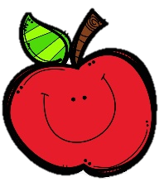
Mrs. Burns’ Messages
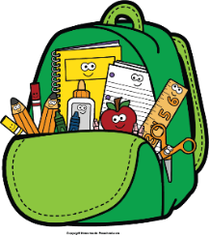
November 7-10, 2022
Reading Assessments
Wednesday Quizzes: Phonics, Sequence, Singular and Plural Nouns, Vocabulary
Thursday Assessments: Reading Skills Test, Grammar Test, Spelling Test
Wednesday, November 9: Progress Reports
Thursday, November 10: Parent Picnic
Friday, November 18: Spirit Day; Special Snack;
Santa Pictures
November 21-25: Thanksgiving Break
(NO SCHOOL)
Friday, November 11: Veterans Day
(NO SCHOOL)
Reading Story and Skills:  Story:  In My Own Backyard  Phonics/Fluency:  /e/: ee, ea, e,  e_e  Homophones and  Homographs  Text-Based Comprehension:  Sequence  Grammar/Language:  Singular and  Plural Nouns |  | Vocabulary Words  - blurry – dim or hard to see; unclear  - brook – a small stream  - grazed – fed on growing grass  - haze – mist, smoke, or dust in the air  - mist – a cloud of tiny drops of water or other liquid  that is in the air  - plowed – turned over and cut through  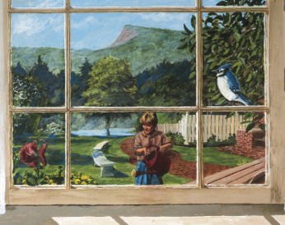  - pulsed – beat or vibrated  - settlers – people who come to  live in a new land or  country  - sheets – thin, broad pieces or  surfaces of something  - skimmed – moved over lightly  and swiftly
Math  Topic 5: Subtract Within 100 Using Strategies  Lesson 5: Subtract Using Compensation  Lesson 6: Practice Subtracting Using Strategies  Lesson 7: Solve One-Step and Two-Step Problems  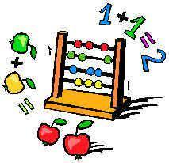  Lesson 8: Problem Solving (Critique Reasoning) |  |  |  |  | Social Studies/Science  We will continue our unit on Earth’s systems this week as we continue to look at examples of Earth events that happen over a short or long period of time. We will also discuss solutions that address changes caused by such events.
Spelling Words:
- real  - sleep | - we  - eve |  | - steel  - steal | - creek  - creak |  | - knee  10. reel

