**ESP Calendar and Non-School Day Schedule**

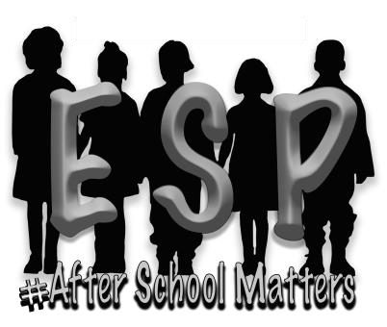

**H**

**AMBLEN COUNTY DEPARTMENT OF EDUCATION**

**EXTENDED SCHOOL PROGRAM**

210

EAST MORRIS BOULEVARD

MORRISTOWN, TN 37813

PHONE (423)

581

-

3017

FAX

(423) 585

-

377

3

**2024-2025**

**Site Location: Hillcrest**

**August 2 After-school ESP Begins**

**September 27 Teacher Forecast Planning**

**October 7-11 Fall Break**

**October 14 Teacher Professional Development**

**November 5 Election Day**

**November 25-27 Thanksgiving Holiday**

**December 20* Early Dismissal/Winter Break**

**December 26-27,30 Winter Break**

**January 2-3 Winter/Semester Break**

**January 17 Teacher Professional Development**

**January 20 Martin Luther King Day**

**February 17 President’s Day**

**March 7 Professional Development**

**March 24-28 Spring Break**

**May 6 Morristown City Election**

**May 21 Last Day for After-school ESP**

**June 2 1st Day of Summer ESP**

**\*December 20- ESP will begin at 11:15 at your child’s school.**

* **ESP will be closed 9/4, 11/28, 11/29, 12/23, 12/24, 12/25, 12/31, 1/1, 4/18 and the program reserves the right to make changes to the schedule as needed.**
* **ESP hours of operation are 6 a.m.-6 p.m. during Non-school days. Breakfast and snack will be provided by ESP. Please send a bag lunch EVERY non-school day that your child attends.**