Mike Hovde Memorial Scholarship

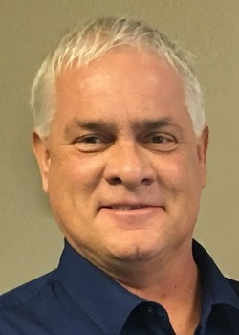
Michael “Mike” Dean Hovde graduated from Willow Lake High School in 1983. He took great pride in attending Willow Lake School and always encouraged his classmates to show up for their yearly alumni banquet. Mike was pleased to have THREE children graduate from WLHS: Zachary in 2011, Savannah in 2013, and Maggie in 2022. Unfortunately, his life was cut short on March 3, 2018 at the age of 53. In honor of his memory and love for being a “Pirate,” the family would like to offer two $500 scholarships to exiting WL seniors who exemplify good character, attendance, and the same passion for WLHS as Mike did.
Criteria for Scholarship:
- The recipient must be a Willow Lake School senior advancing their academic career at a post-secondary institution.
- The recipient must also have a GPA of 2.5 or higher.
- The recipient must complete a one-page essay answering the designated questions listed below.
Application material to be returned to the school office by April 1, 2026, includes:
- Completed application
- Transcript
- Attached essay
  - Do not put your name on it. Put your student ID number in the upper left-hand corner.
  - Do not identify names of family and friends in the essay.
  - Essay must be:
    - Double-spaced
    - 12-point size
    - ONE PAGE ONLY
  - Designated questions:
    - How has attending a small rural school benefited your character and values?
    - What does it mean to you to receive a diploma from Willow Lake High School and become a Willow Lake Alumnus?

*Scholarship winners will receive the scholarship money made payable to the post-secondary institution at the beginning of their second semester.

