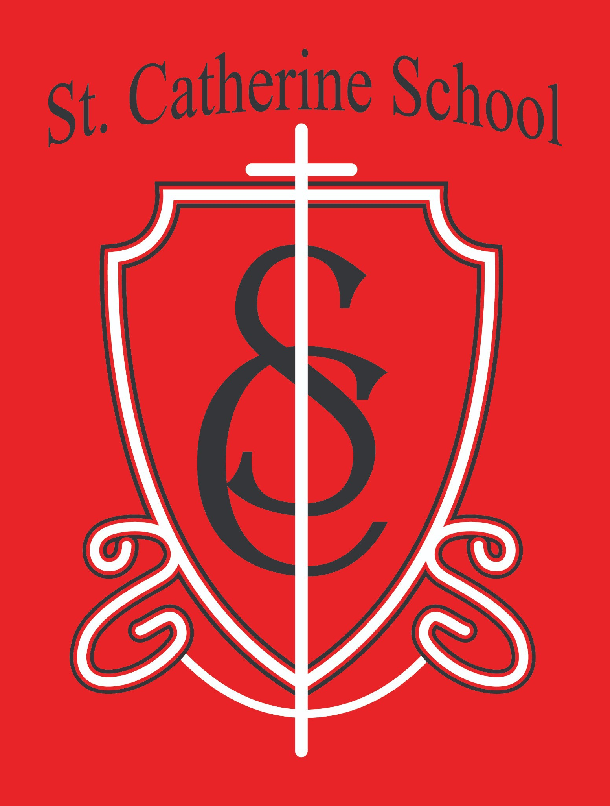

St. Catherine School Weekly Newsletter (Week of November 3-7)
https://www.stcatherine.k12.nd.us/parents

Principal's Message
Dear St. Catherine Families,
What an incredible night we had at our 53rd Annual Fall Auction! I want to extend my heartfelt thanks to the many people who helped make this year’s event such a success. Whether you donated, decorated, bid, attended, baked, or prayed for our auction—your support truly made a
difference. A special thank you goes out to Alison Kasowski, our Fall Auction Chair, and Patricia Buck, our Decorating Chair. Their dedication, creativity, and countless hours of preparation made this year’s auction both beautiful and meaningful. So many parishioners, school families, school staff, alumni, businesses, and community members gave their time and talents to this event. It was truly a heartwarming reminder of how blessed we are to have such a strong community standing behind St.
Catherine School's mission. This year’s theme, “Clearing the Way for a Bright Future,” could not have been more fitting. It was evident in the generosity, spirit, and love that filled the room. I am humbled and deeply appreciative to be the principal of a school surrounded by people who so clearly believe in and support its mission.
We are excited to share the final total with you soon once all contributions and expenses are tallied.

Reminders

No School: Tuesday, November 11.

School is in session on Monday, November 10, and Wednesday–Friday, November 12–14.

We know it’s a little unusual to have a break in the middle of the week—thank you for planning accordingly!
Please RSVP for the All-School Mass next Thursday by calling the school office at 701-845-

1453 or emailing Ms. Giesen at terra.giesen@k12.nd.us.
Report Cards: If you haven’t returned your child’s report card yet, please send it back this week. (You may keep the report card itself and return the signed envelope.)
Dress for the Weather: It is fall—and dare I say— approaching the season that comes after fall!

Please make sure your child has the proper clothing to stay warm outside. Fresh air and outdoor play are essential, and we go outside unless there is inclement weather or temperatures are too cold for safety. Students should have coats, hats, and gloves each day. Once snow arrives or temperatures drop further, they will also need boots and snow pants.
Parking Lot Safety: Some of our school days are particularly busy during morning drop-off and afternoon pick-up. With St. Catherine School, Circle of Friends Preschool, and Little Saints Childcare all sharing the parking lot, please use extra caution when entering and exiting. Always pull into a parking spot rather than stopping in the driving lane. Please pass this reminder along to grandparents or others who may be picking up your child—these procedures help keep all of our students safe.
Little Saints Childcare: We are slowly meeting our enrollment goals. We view Little Saints as a beautiful extension of our school ministry, and we aim to enroll 50 children by January. If you know of

a family looking for childcare, please don’t hesitate to refer them to Little Saints!
For more information, please visit the Little Saints Childcare tab on our website or contact Beth Nadelin, Director, at beth.nadelin@k12.nd.us or 701-490-3800.

St. Catherine Spotlight
The Fall Auction was truly a highlight of our school year. The entire week leading up to it was filled with generosity and charity—a virtue that only makes sense when grounded in faith in the Lord. I was glad to see that virtue so clearly on display as an example of His goodness at work in our school and parish community.
I was especially moved to see several parishioners and community members attend the auction for the very first time. One person came up to me afterward and said they couldn’t believe they had never participated before! What a testament to the spirit and sense of community that surrounds St. Catherine School. Thank you for being a part of our St. Catherine Family!


📘 Follow Us on Facebook: St. Catherine School on
Stay Connected with St. Catherine School
📍 Address: 540 3rd Ave. NE, Valley City, ND 58072
Email: nicholas.lee1@k12.nd.us
📧
Phone: 1-701-845-1453
📞
Website: www.stcatherine.k12.nd.us
🌐
Facebook

“Inspiring excellence through faith, learning, and service.”

