0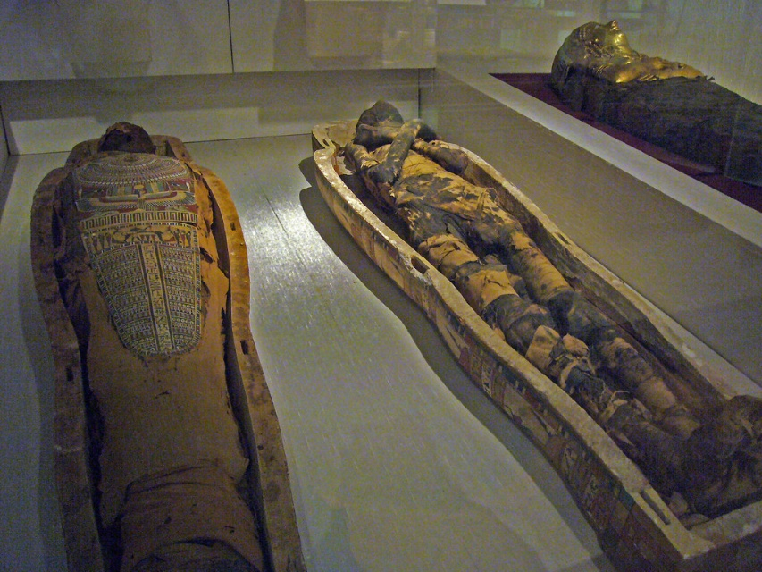
Reading News
Mrs. Williams
Date: April 20, 2026

Story: The Mystery of the Mummies Curse

Word Study: -silent letters

Vocabulary:
exhibit – a display
grimace – to look like you are in pain
artifact – objects that are made, used, or modified by humans and give us information about life in the past
valuable – worth a great deal of money
publicity – making information public
overheard conversation – to hear what others are saying without meaning to
sensation – a feeling you get from your senses
description – means talk or writing that tells about something
invitation – a formal request to go somewhere or do something
escape – to get away

