Ms. Johnston’s Class
School Supply List
You do not need to label items unless indicated.

- 2 boxes of Crayola crayons
- 4 glue sticks
- 4 black dry erase markers
- 1 white short sleeved t-shirt **write name on tag in permanent marker
- 1 tote bag (No book bags! PPS tote bags can be purchased at Orientation) **Make sure name is visible

Classroom Wish List
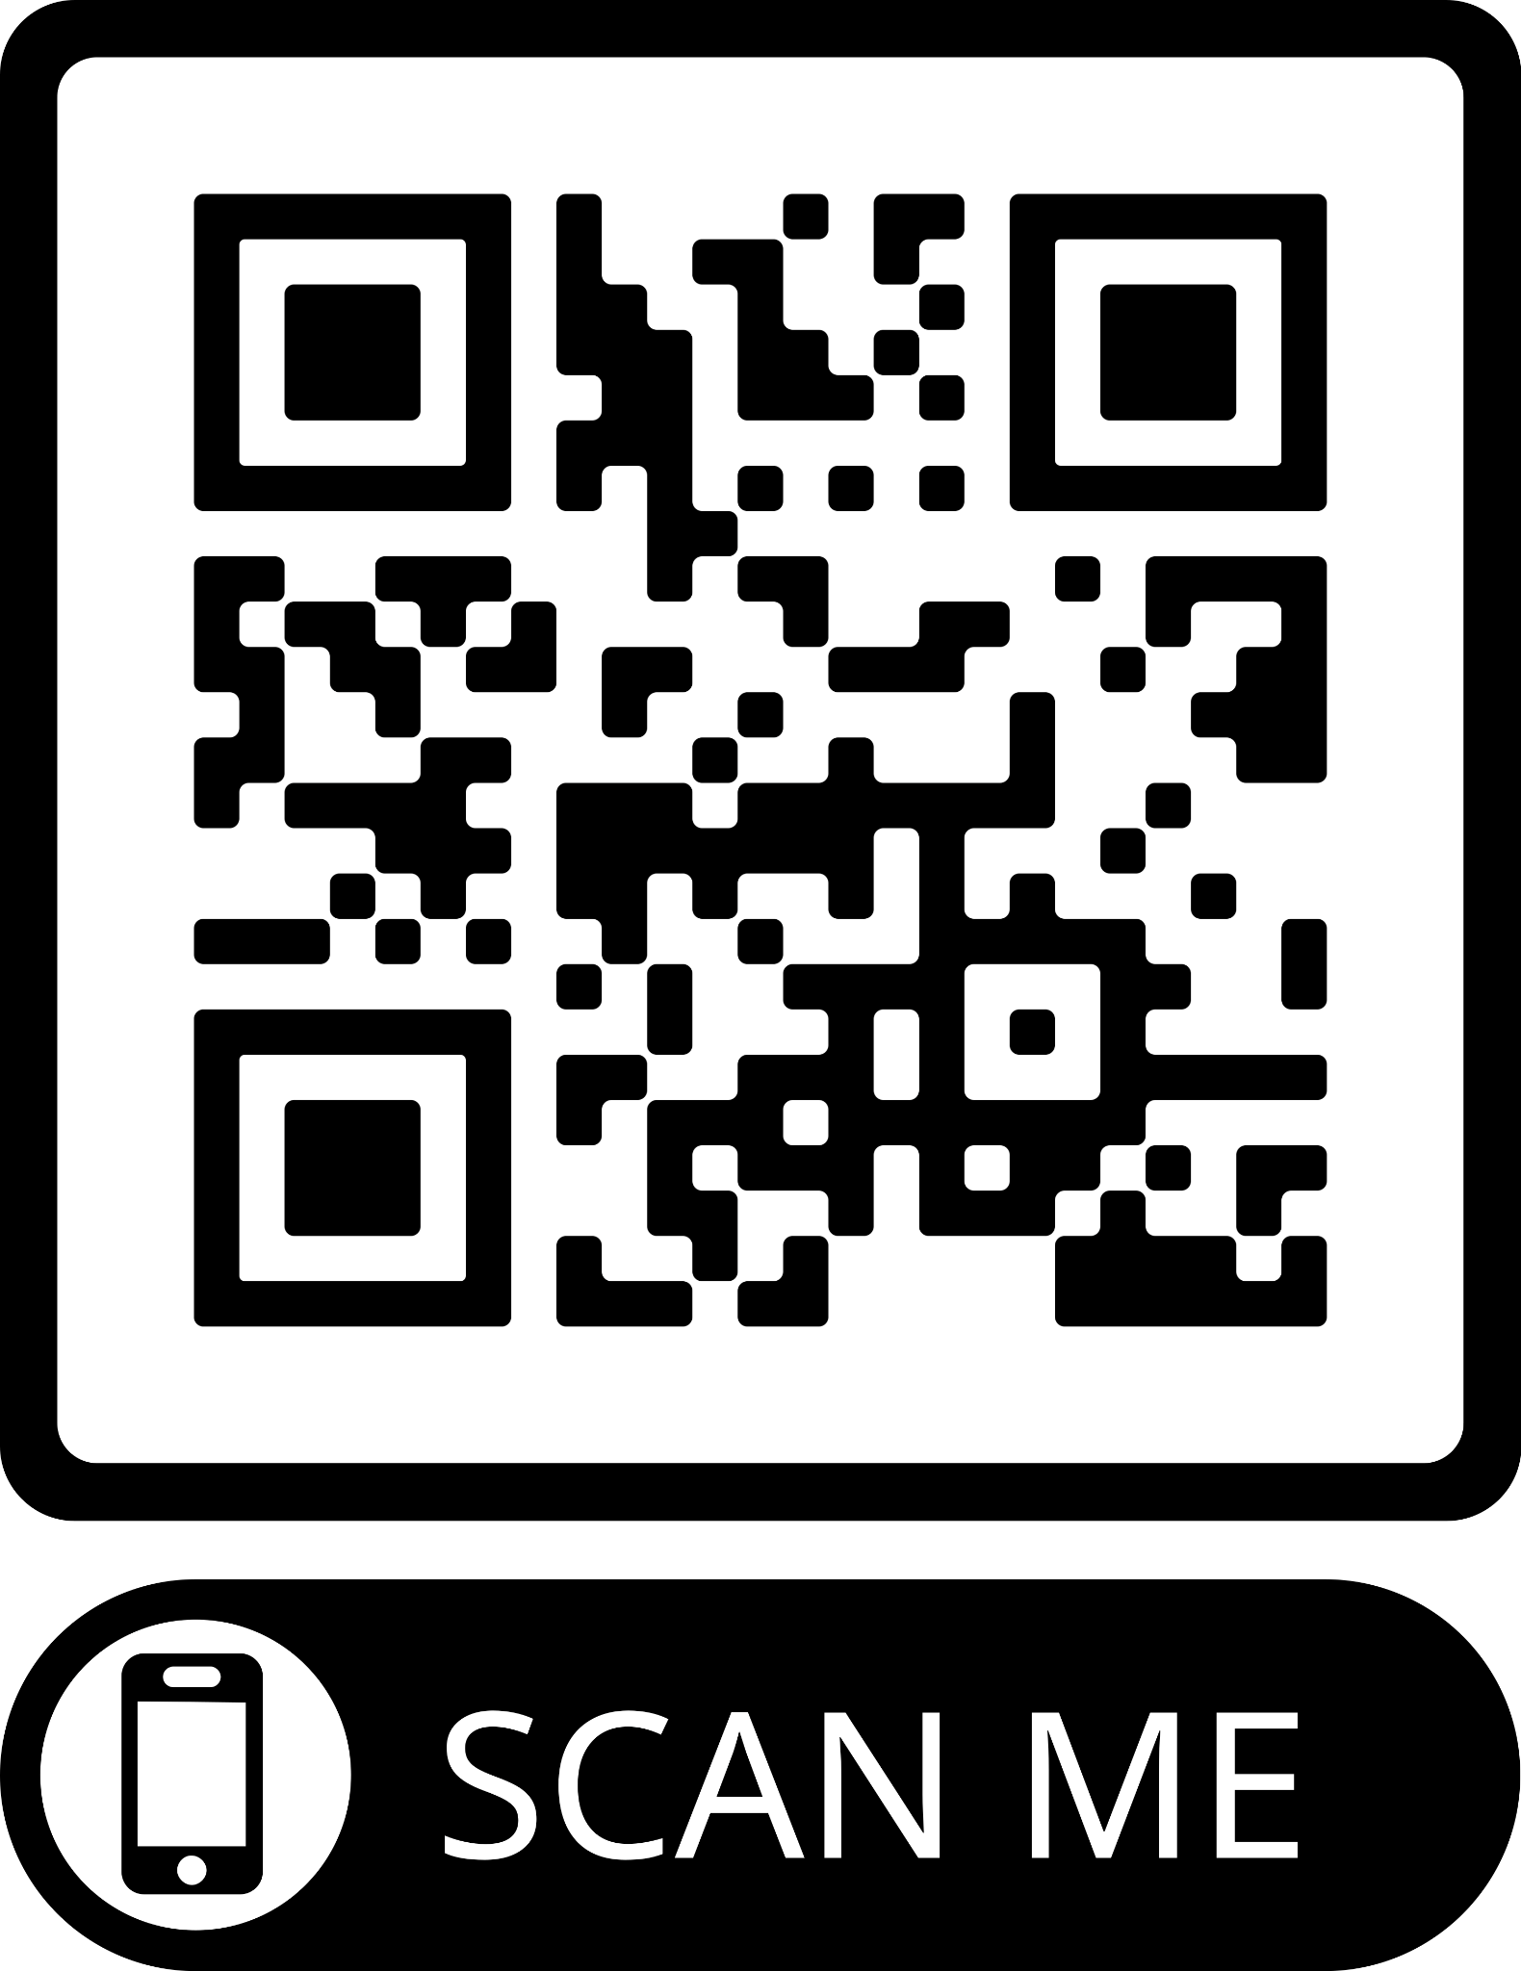
If you would like to donate any of the following supplies for our classroom, it would be greatly appreciated.
- Hand sanitizer
- Band-aids (gender neutral)
- Paper plates
- Spoons
- Tissues
- Ticonderoga pencils
- Dum-Dum suckers
- Link to Amazon Wish List

