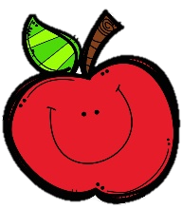
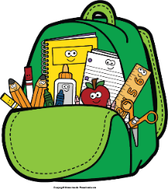
Mr. Marks’ Messages
March 3rd-7th, 2025
Assessments
No ELA Assessments this week. No spelling, vocabulary, or reading test.
Friday Assessments: weekly math quiz
Reminders
- Book Fair Tuesday March 4th and Tuesday March 11th
- Read Across America March 3rd through March 7th
- Monday- wear pj pants Tuesday- dress up as favorite character Wednesday- wear Read Across America
t-shirt Thursday- wear a hat Friday- wear sunglasses
- Please check your child’s binder daily for important information, homework, and their behavior chart.
Reading Story and Skills:  Story: Busy Bees  Phonics/Fluency:  /oo/ spelled oo, prefixes re- and non-  Writing:  Personal Narratives  Text-Based Comprehension:  Classify and categorize  Grammar/Language:  contractions | Vocabulary Words  - design: to make for a purpose  - products: things that are made or created  - limbs: branches or a tree  - vacant: empty  - invade: to enter without permission  - antenna: thin feelers on the head of an insect
Math  Topic 15 Graphs and Data  The students will learn to create and answer questions using line plots, bar graphs, and picture graphs. We will do the study guide on Wednesday and test on Thursday. |  | Social Studies/Science  Science:  We will continue to discover animal habitats and biomes. This week we will conduct research on various biomes and create an informational writing piece.
Spelling Words:
- hoop  - tooth | - mood  - bloom | - food  - pool | - nonstop  - nonfat | - repaid  10. rewrite

