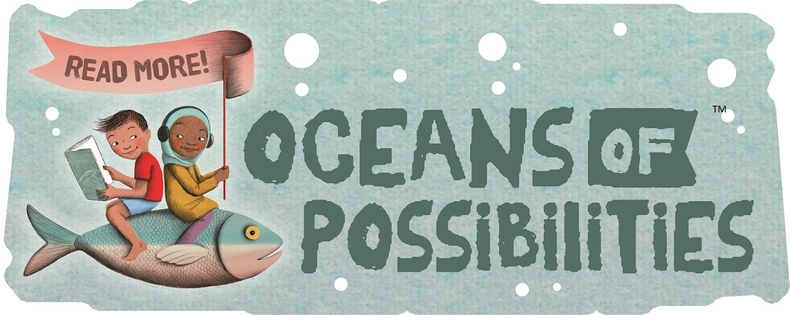
The Rappahannock County Library
2022 Summer Reading Program
June 8th – August 8th
Join the SRP and help prevent “Summer Slide”. Children who don’t read during the summer can lose up to two months of learning by the time they return to school in the fall.
_______________________________________________________________
How the 2022 Summer Reading Program Works:
- Children and Teens register/set reading goals in-person at the Library starting June 8, 2022.

- Children ages 0-11 record books read/ teens ages 12-18 record hours read on a reading log provided by the library. Participants can choose their own reading material.

- Earn prizes for meeting your reading goals and attend fun events at the Library!

AND VIEW UPCOMING LIBRARY EVENTS!

