Quick Instructional Sheet on Using CCB (Church Community Builder)
to “Check-in” Prior to an Event for Attendance Purposes

Purpose: This document will explain how to use the Pre-check-in feature on the DRLC app to check into an event at Divine Redeemer for attendance purposes. Events could include Bible Study, Class, Church, Online worship, etc. Note: Check in is different than RSVP. Please utilize Check-in. Check in is only allowed by the system 2 hours prior to the event – 30 minutes into the event.
What is CCB?
In a nutshell, Church Community Builder, or CCB, is the secure online computer program to build an online community for our church that is used by both staff and congregants. Learn more at drlc.org/ccb.
How do I access CCB?
You can access CCB by going to https://drlc.ccbchurch.com on your computer or mobile phone. We suggest bookmarking this website for future reference. If you know your login information, enter it. If you have never logged in then click “Request Account” or “I forget my password”.
How do I upload a photo or change my contact information?
First, login. If you need further instructions on uploading a photo or changing your contact information or communication and privacy preferences, find training and instructions at drlc.org/ccb.

How do I CHECK IN to events to record my attendance?
1. Download the DRLC App:
2. Open the DRLC App.

3. At the bottom click the “Check-in Feature”
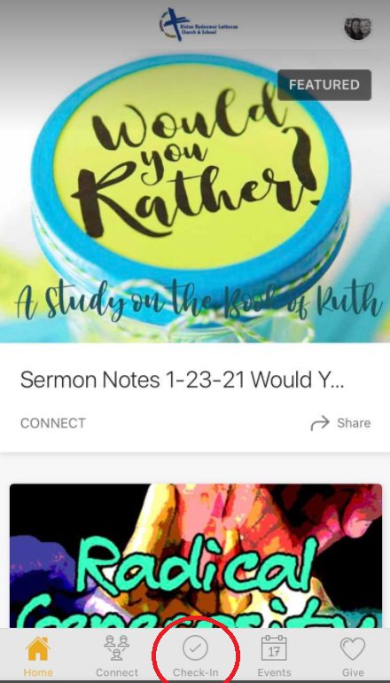

Note: You will either see an option to check in or a screen that says, “No Events Available”.
If there is nothing to check into you will see this screen:
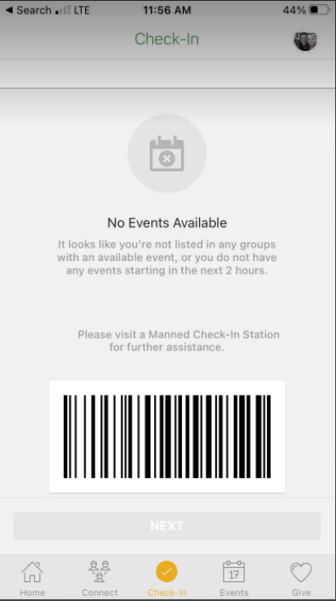
Remember, check-in time is open 2 hours prior to an event and ½ hour into an event. Online worship check is only allowed from 6pm -8:30pm on Sunday evenings. For in person church, for example, if you are trying to check into church on Sunday for the 9:15 service, you can check in from 7:15 – 9:45 for this event only.

If there is an event you can check into, this screen will show up:
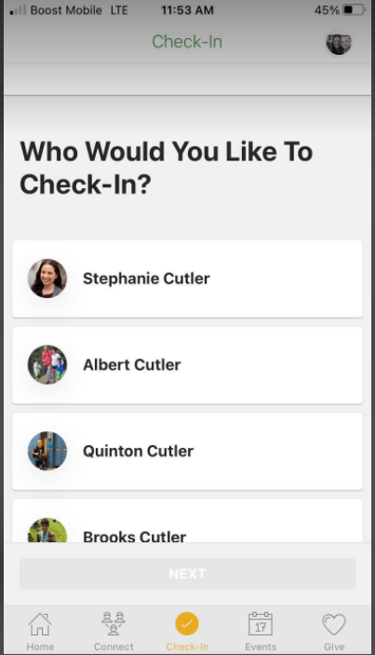

4. Click the names of those in your family checking-in and click NEXT.
5. Click on the event box of the event you want to check into.
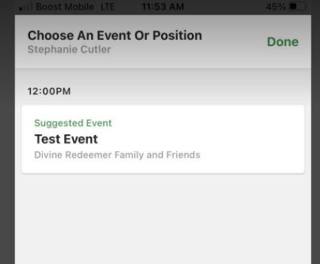
6. You are all set and checked in!

Note: RSVP’ing for an event is different than Checking-in. Checking in marks your attendance in the system, RSVP’ing does not.

