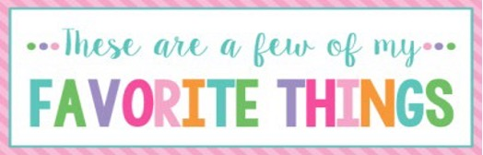

Name: | Andrea Yates | T-Shirt Size: | XL
Birthday: | January 28th | Monogram: | aYb
Favorite Color: | Green, Maroon | Favorite Flower: | Hydrangea, rose
Favorite Scent: | Clean, Fall (not pumpkin) | Favorite Candy: | Sugar Free
Favorite Drink: | Coke Zero & Water, COFFEE | Favorite Food: | Mexican
Favorite Snack: | Whisps | Favorite Fruit: | Strawberry
Favorite Restaurant: | Mexican | Favorite Fast Food: | Sonic
Favorite Places to Shop: |  | Amazon, Wal-Mart, Kroger
Favorite Bath & Body Works Scent: |  | Any clean-smelling scent
Things I Collect: |  | Candles, Jewelry, T-Shirts
Favorite Author/Book Series for Personal Reading: |  | Devotionals
Wish List for Classroom: |  | Colored ink pens, Math Flash Cards, Amazon Wish List

