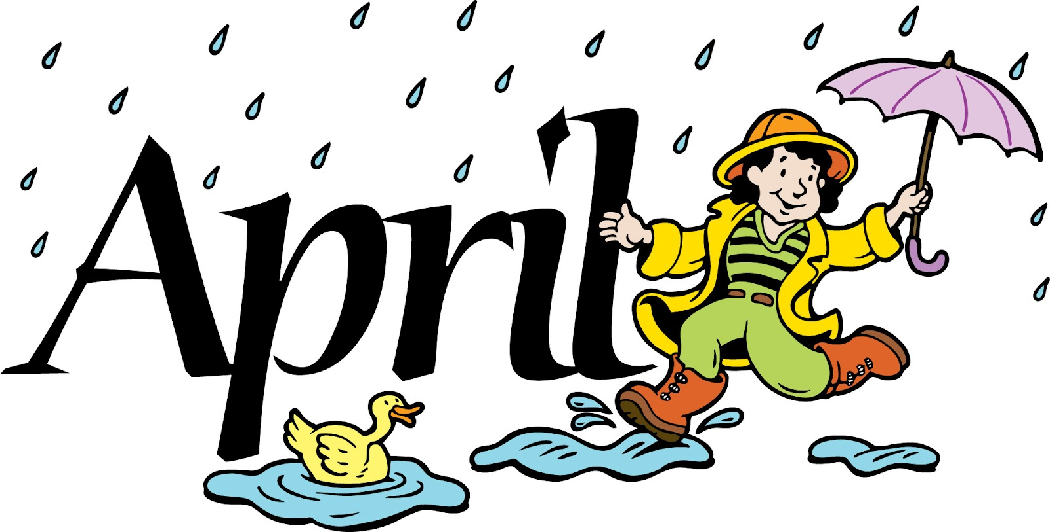

CLASS NEWS
Mrs. Williams
Date: April 27, 2026

Math: finish measurement;

SS/Studies: continue plants

Upcoming Events:
May 1st – ALL Field Trip forms/money are due – FINAL NOTICE
May 15th – Luray Caverns Field Trip

