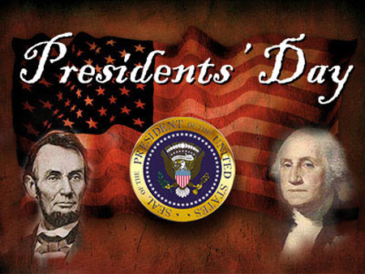

CLASS NEWS
Mrs. Williams
Date: February 16, 2026

Math: continue unit on money

Science/Social Studies: continue unit on famous people

Upcoming Events:
February 16– Presidents’ Day – No school

