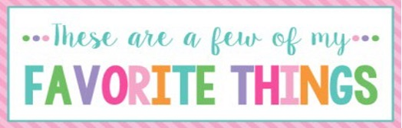

Name: | Kristi Sparrenberger | T-Shirt Size: | Large
Birthday: | October 30 | Monogram: | KLS or KSL (last in the middle)
Favorite Color: | Blue | Favorite Flower: | Gerber daisy
Favorite Scent: | clean linen, lavender, peppermint (nothing harsh) | Favorite Candy: | Anything chocolate
Favorite Drink: | Coke | Favorite Food: | cookies
Favorite Snack: | Salt – n- vinegar chips | Favorite Fruit: | Cantaloupe
Favorite Restaurant: | Firebirds | Favorite Fast Food: | Chick-fil-a
Favorite Places to Shop: |  | Amazon, Hobby Lobby, TJ Maxx, HomeGoods, Ulta
Favorite Bath & Body Works Scent: |  | Stress Relief Line, Champagne Toast
Things I Collect: |  | Organizational items
Favorite Author/Book Series for Personal Reading: |  | Harlan Coben, or any thriller/suspenseful books
Wish List for Classroom: |  | Colored copy paper, individually wrapped candy

