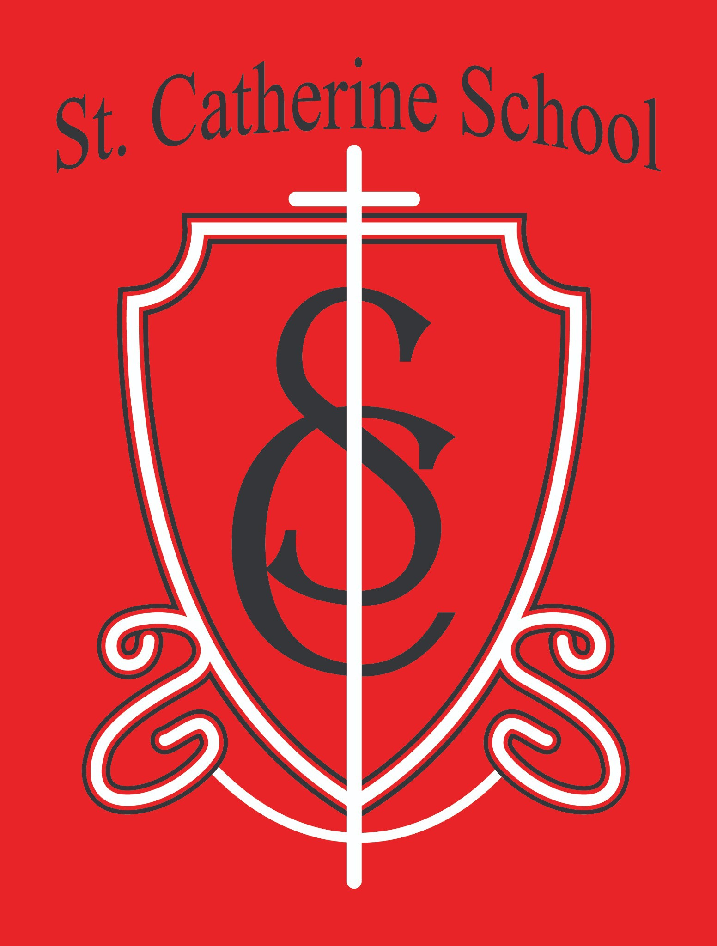

St. Catherine School Weekly Newsletter - Week of October 27-October 31
https://www.stcatherine.k12.nd.us/parents

Principal's Message
The 53rd Annual St. Catherine School Fall Auction is almost here!

Friday, November 7 at the Valley City Eagles Club Bake Sale & Silent Auction: 5:00 PM
Live Auction: 6:30 PM
The Fall Auction is one of my favorite events of the year, and this year’s theme—“Clearing the Way for a Bright Future”—feels especially meaningful because it reflects our mission. Each year, we work harder to keep our school strong, and we are so thankful for the incredible support we receive from our businesses, donors, parishioners, community members, alumni, teachers, staff, and families.
My personal plea to you: invite as many people as you can to attend the auction and come out to support our school. Every bid, every dollar, and most importantly, every prayer helps make this event a success. Get a babysitter and have fun! The auction is a school event. Still, it’s genuinely an evening designed for adults to relax, celebrate, and be part of something that sustains Catholic education right here in Valley City. Get there early to get a good seat and get your bids on the silent auction items. Every single dollar that is raised goes right back into the school to support our mission. The auction’s success helps us keep tuition costs much lower than the cost of educating each child. Please know that your support, however big or small, goes right back into the school!

Auction Setup & Decorating Help Needed
We would love your help as we prepare for this fantastic event.

Decorating: Thursday, November 6, any time after 4:00 PM at the Valley City Eagles Club.
Item Transport: Friday at 8:30 AM – all auction items will be moved from the school to the Eagles Club. Meet at the school at 8:30.
Note: For safety and to protect the auction items, please no children under age 10 at setup or decorating events. There are too many temptations in the form of fun items and potential hazards in the setup area.
Many hands make light work—we’d be so grateful for your help getting everything ready!

Volunteers Needed – Fall Auction Kick-Off Breakfast
We still need 1–2 more volunteers per shift to help with the Fall Auction Kick-Off Breakfast on Sunday, November 2nd.
Shifts: 8:30–10:30 AM and 10:30 AM–12:30 PM
Serving Time: 9:00 AM–12:00 PM
Goal: Raise $3,500–$4,000 at the breakfast
All are welcome: You do not need to be Catholic to attend—bring friends and family!
Sign Up: Email Mrs. Janessa Kennedy, Breakfast Chair, at janessa.kennedy@k12.nd.us
A massive thank-you to the Knights of Columbus and everyone who has already volunteered!

Reminders

No School – Friday, November 7
There will be no school as we prepare for and host the Fall Auction at the Eagles Club.

No School – Tuesday, November 11 (Veterans Day)
School will be in session on Monday, November 10.

Signed Report Cards
Please remember to return your child’s signed report card to school. I know we just had Parent-Teacher Conferences, but report cards are another valuable way to see how your child is progressing in each subject and to start good conversations both at home and with teachers. We try to create multiple points of connection with families throughout the year, which helps us ensure communication remains consistently a priority.
You can always request an additional copy of report cards, and final copies will go home at the end of the year.

Dress for the Weather
As temperatures drop, please send students with coats, hats, and gloves each day. We’ll continue to have outdoor recess whenever possible.

We will let you know when we need snow pants or snow boots, but if snow is on the ground, we will need all gear. You are welcome to send more for your child if they need it to keep warm.

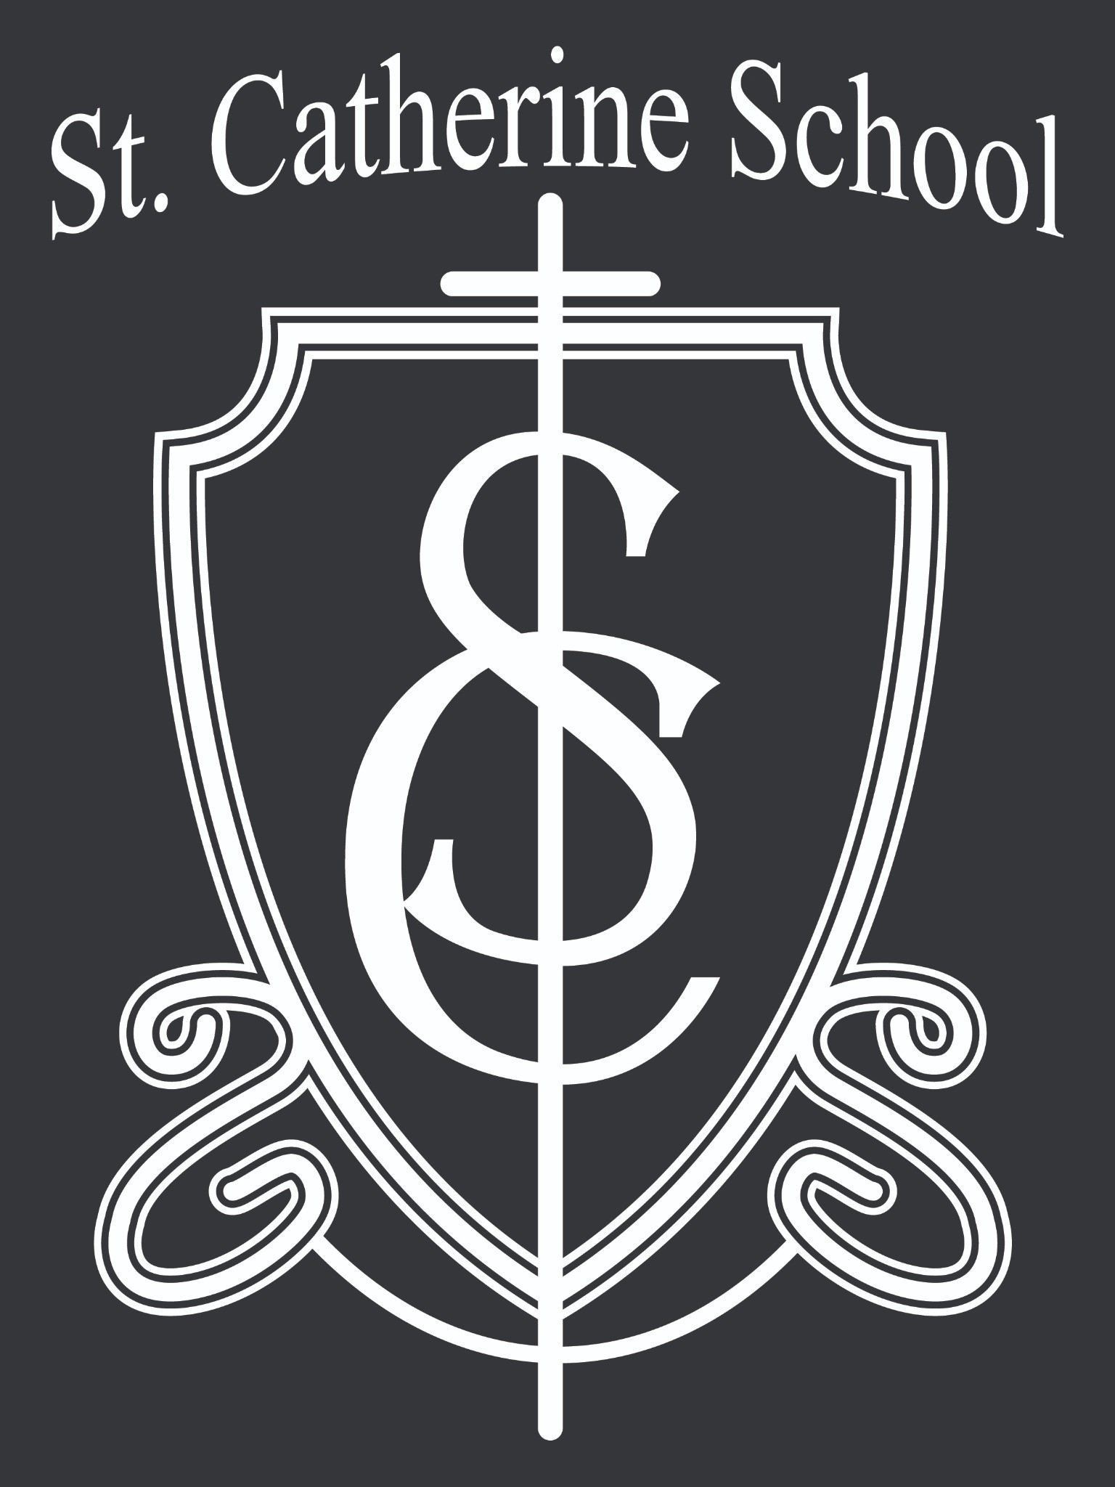St. Catherine Spotlight
This week, we had the joy of celebrating one of our favorite traditions—the Saints Parade! Students dressed as their chosen saints and shared a little about each saint's life and virtue. It was such a joy to see them proudly walking through the halls, honoring the heroes of our faith.
I had the privilege of dressing as Blessed Carlo Acutis, the first “millennial” saint to be canonized. His example of faith in a digital age is timely and relevant—he reminds us that holiness is possible in every time and place.
We also got to celebrate one of the many fun items from last year’s auction—our Principal for the Day, Mr. Muske! He did a fantastic job leading the school, making special announcements, and spreading joy throughout the day.
Seeing our students reflect on faith, leadership, and service this week was a wonderful reminder that our mission at St. Catherine School is alive and thriving—to inspire excellence through faith, learning, and service.

Stay Connected with St. Catherine School
📍 Address: 540 3rd Ave. NE, Valley City, ND 58072
Email: nicholas.lee1@k12.nd.us
📧
Phone: 1-701-845-1453
📞
Website: www.stcatherine.k12.nd.us

🌐
📘 Follow Us on Facebook: St. Catherine School on Facebook

“Inspiring excellence through faith, learning, and service.”

