Mrs. Cannon’s Newsletter
October 28-November 1, 2024

New

Reading:
- R controlled vowels- er, ir, ur
- Character, Setting, Plot
- 5 W Questions (Who, What, When, Where, Why)
- Main Idea and Details

Word Study Words:
her burn never nurse winter
bird hurt girl shirt girl

High Frequency Words:
all done away even better
found by learn change only

Math:
- Addition strategies

Language:
- Verb Tenses (eat/ate, teach/taught, go/went, eat/will eat, jump/will jump)
- Informational Writing

Social Science:
- Lady Liberty
- Scholastic News

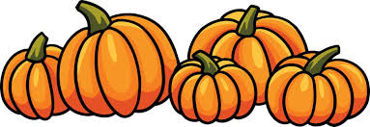
this week’s focus



Upcoming Events & Important Info

Student of the Week
None
(If your child is student of the week and you would like to send in treats for the class, please send them in on Friday.
- PLEASE SEND EXACT CHANGE FOR SNACK. ($0.75 or $1.50) I do not have change to give back.
- PE: 11:20-112:05
- Lunch: 12:26-12:51
- Please label any money sent in (ex. -snack, field trip, etc.)
- Your child must wear tennis shoes or closed toe shoes to PE EVERYDAY!

- Wonderful Wednesday (special snack)- Wednesday for $2.00 (only send money on this day)
- Red Ribbon Week begins Oct. 28th
- Halloween Special Snack- Thursday
- Monday- Wear Red
- Tuesday- Dress in Western Wear
- Wednesday- Wear Hawaiian attire
- Thursday- Wear your costume (NO scary costumes or weapons)
- Friday- Wear pajamas

Reminders

