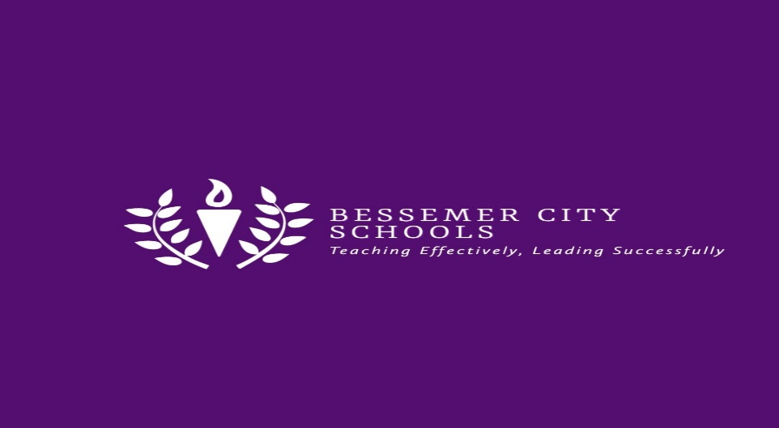
September 15, 2021

FINANCE DEPARTMENT
Invitation to Bid #BCS-2021-111-3
Bessemer City Board of Education will be accepting sealed bids to install and erect an aluminum canopy with gutters at Bessemer City Middle School from the existing building to the curb.

SEALED BIDS WILL BE RECEIVED BY THE FINANCE DEPARTMENT, BESSEMER CITY BOARD OF EDUCATION, 1621 5TH AVENUE NORTH, BESSEMER, ALABAMA 35020-5736 UNTIL: Wednesday, October 13th, 2021 @ 4:00 p.m.

THE SEALED BIDS WILL BE OPENED AND READ PUBLICLY Thursday, OCTOBER 14TH, 2021 @ 5:30 p.m. at CENTRAL OFFICE (BOARD OF EDUCATION)

RETURN ENTIRE COMPLETED PROPOSAL TO: Finance Department
Attention: Patricia Stewart
Bessemer City Board of Education
1621 5th Avenue North
Bessemer, AL 35020

VENDOR WILL BE REQUIRED TO OBTAIN ANY BUILDING PERMITS IF NEEDED.
IT IS THE RESPONSIBILITY OF THE PROSPECTIVE BIDDER TO MAKE CERTAIN THAT THE BIDS ARE RECEIVED IN THE FINANCE DEPARTMENT BEFORE THE SCHEDULED BID OPENING. ANY BIDS RECEIVED AFTER THE DESIGNATED DATE AND TIME, WILL NOT BE CONSIDERED.

Outside of your bid envelope must be marked with the Bid number, date and time of bid opening, General Contractor’s license number, if applicable (US MAIL, FEDERAL EXPRESS, UPS, ETC.).

FOR FURTHER INFORMATION, RELATED TO THE PRODUCTS OR PROJECT CONTACT: Reginald Mitchell, Director of Facilities and Maintenance at 205.432.3900

