Mrs. Cannon’s Newsletter
November 18-22, 2024

New

Reading:
- R Controlled Vowel- or, ore, oar
- Character, Setting, Plot
- 5 W Questions (Who, What, When, Where, Why)
- Story Structure
- Character point of view
- Central Message

Word Study Words:
year here near steer clear
cheer fear ears deer hear

High Frequency Words:
always draw any four blue
great buy city how live

Math:
- Addition strategies to 100
- Adding 3 and 4 addends

Language:
- Adjectives

Social Science:
- Lady Liberty
- Thanksgiving Activities

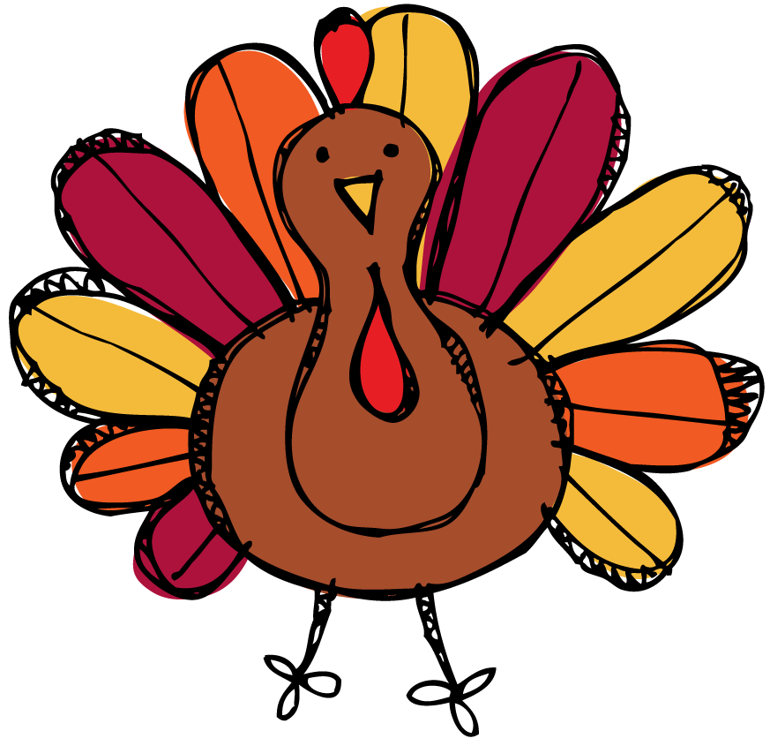
this week’s focus



Upcoming Events & Important Info

Student of the Week
Cameron
(If your child is student of the week and you would like to send in treats for the class, please send them in on Friday.
- PLEASE SEND EXACT CHANGE FOR SNACK. ($0.75 or $1.50) I do not have change to give back.
- PE: 11:20-112:05
- Lunch: 12:26-12:51
- Please label any money sent in (ex. -snack, field trip, etc.)
- Your child must wear tennis shoes or closed toe shoes to PE EVERYDAY!

- Wonderful Wednesday (special snack)- Wednesday for $2.00 (only send money on this day)
- Thanksgiving Lunch- Nov. 20th at 12:10
- You must have your ticket in order to attend!!
- Thanksgiving Break- Nov. 25th-29th (No school)

Reminders

