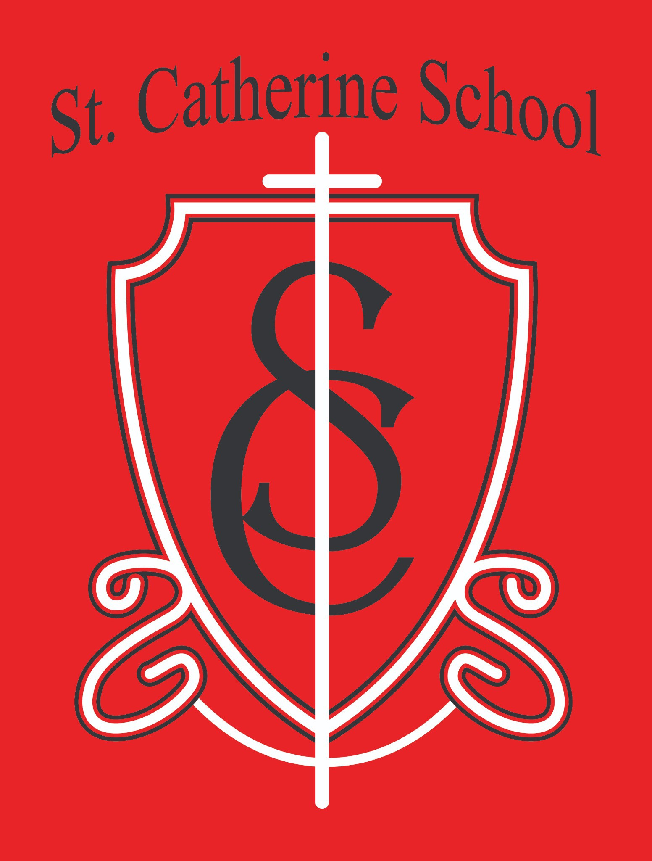

**St. Catherine School Weekly Newsletter** [**https://www.stcatherine.k12.nd.us/parents**](https://nam02.safelinks.protection.outlook.com/?url=https%3A%2F%2Fwww.stcatherine.k12.nd.us%2Fparents&amp;data=05%7C02%7CTerra.Giesen%40k12.nd.us%7Ca9a3a818746945a3217e08dd537119b2%7Cdbbf782acef14af186c81f9201061db6%7C0%7C0%7C638758467453660109%7CUnknown%7CTWFpbGZsb3d8eyJFbXB0eU1hcGkiOnRydWUsIlYiOiIwLjAuMDAwMCIsIlAiOiJXaW4zMiIsIkFOIjoiTWFpbCIsIldUIjoyfQ%3D%3D%7C0%7C%7C%7C&amp;sdata=Tx7eHxD4TOelEevWWeZUxm4l%2FBT1979JYQOT0iH6B6k%3D&amp;reserved=0)

# Principal's Message

Dear St. Catherine Families,

Our Kindergarten Round-Up is a wonderful opportunity for our school community to welcome new families. We are seeking a current parent to speak for 3–5 minutes this coming Friday, February 29th, around 9:15–9:30 AM. We’d love for you to share what drew you to our school and, more importantly, why you continue to enroll your child here. Your personal story reinforces the power of choice and reminds us all of the trust you place in us. We take that trust seriously, and your voice helps new families feel confident about joining our community.

# Reminders

## Daycare Updates:

Our new daycare initiative is progressing well! This week, we will post the position for our daycare director. Work on the furnaces by Bakkegaard and Schell in the daycare areas began in earnest last week. Although the school was a bit louder than usual, we’re excited for next year’s more up-to-date heating system that will better serve both our school and daycare. Additionally, flooring will be installed in the daycare hallway in March, and the lockers will be removed from

the daycare area soon. Thank you to the parishioners and school families who have already pledged their help.

## School Choice Reminder:

Please refer to the email sent on Friday, February 21st for detailed information. We must advocate for the passing of school choice legislation. It is crucial for legislators to hear about the bill’s impact on ND families, and your testimony is an essential part of that effort.

## Pie Day Reminder:

Join us for a time of fellowship and thanksgiving at our Pie Day event on March 13 at 2:00 PM in the church hall. More details on how to RSVP will be shared next week. We look forward to celebrating together!

## Ash Wednesday:

Please note that Wednesday, March 5th is Ash Wednesday. Our school will be attending the 12:10 PM Mass that day as we begin the Lenten season together.

* **Virtue of the Week – Justice: Obedience (Feb 17–28): Focus:** Listening and responding promptly to rightful authority. **Saint:** St. Pio of Pietrelcina

**Scripture:** “Let it be done to me according to your word.” (Luke 1:26–38)

**Application:** We encourage our students to practice obedience in small tasks and engage in class discussions on respect. This virtue helps build a foundation for responsible, caring individuals.

**St. Catherine Spotlight**

## Kids Heart Challenge:

We are thrilled to announce that our Kids Heart Challenge has surpassed its fundraising goal! Your generous contributions make a real difference in the lives of children and families.

## Reading Celebration:

Congratulations to two of our 4th grade boys who successfully completed their reading challenges. Their happiness and joy were evident as they were recognized in chapel—a truly heartwarming moment for our community.

## A Special Thank You:

Our sincere gratitude goes to Bishop Folda for visiting our school last Thursday. His participation in Mass, classroom visits, and the shared meal was a testament to his supportive leadership over our Diocese and his commitment to Catholic schools.



Stay Connected with St. Catherine School

📍 **Address:** 540 3rd Ave. NE, Valley City, ND 58072

**Email:** [nicholas.lee1@k12.nd.us](mailto:nicholas.lee1@k12.nd.us)

📧

**Phone:** 1-701-845-1453

📞

**Website:** [www.stcatherine.k12.nd.us](https://nam02.safelinks.protection.outlook.com/?url=https%3A%2F%2Fwww.stcatherine.k12.nd.us%2F&amp;data=05%7C02%7CTerra.Giesen%40k12.nd.us%7Ca9a3a818746945a3217e08dd537119b2%7Cdbbf782acef14af186c81f9201061db6%7C0%7C0%7C638758467453678764%7CUnknown%7CTWFpbGZsb3d8eyJFbXB0eU1hcGkiOnRydWUsIlYiOiIwLjAuMDAwMCIsIlAiOiJXaW4zMiIsIkFOIjoiTWFpbCIsIldUIjoyfQ%3D%3D%7C0%7C%7C%7C&amp;sdata=iJ57GTmaWM2MlNxj2BabKnJFjx4ZA%2FBzZeAHSpl5QgQ%3D&amp;reserved=0)

🌐

📘 **Follow Us on Facebook:** [St. Catherine School on Facebook](https://nam02.safelinks.protection.outlook.com/?url=https%3A%2F%2Fwww.facebook.com%2Fst.catherineschoolvc%2F&amp;data=05%7C02%7CTerra.Giesen%40k12.nd.us%7Ca9a3a818746945a3217e08dd537119b2%7Cdbbf782acef14af186c81f9201061db6%7C0%7C0%7C638758467453692539%7CUnknown%7CTWFpbGZsb3d8eyJFbXB0eU1hcGkiOnRydWUsIlYiOiIwLjAuMDAwMCIsIlAiOiJXaW4zMiIsIkFOIjoiTWFpbCIsIldUIjoyfQ%3D%3D%7C0%7C%7C%7C&amp;sdata=KYn4x4ipHaEDwd%2FEtiV8LEtBMHJ3hHhLh7dmIhUnz04%3D&amp;reserved=0)

*“Inspiring excellence through faith, learning, and service.”*