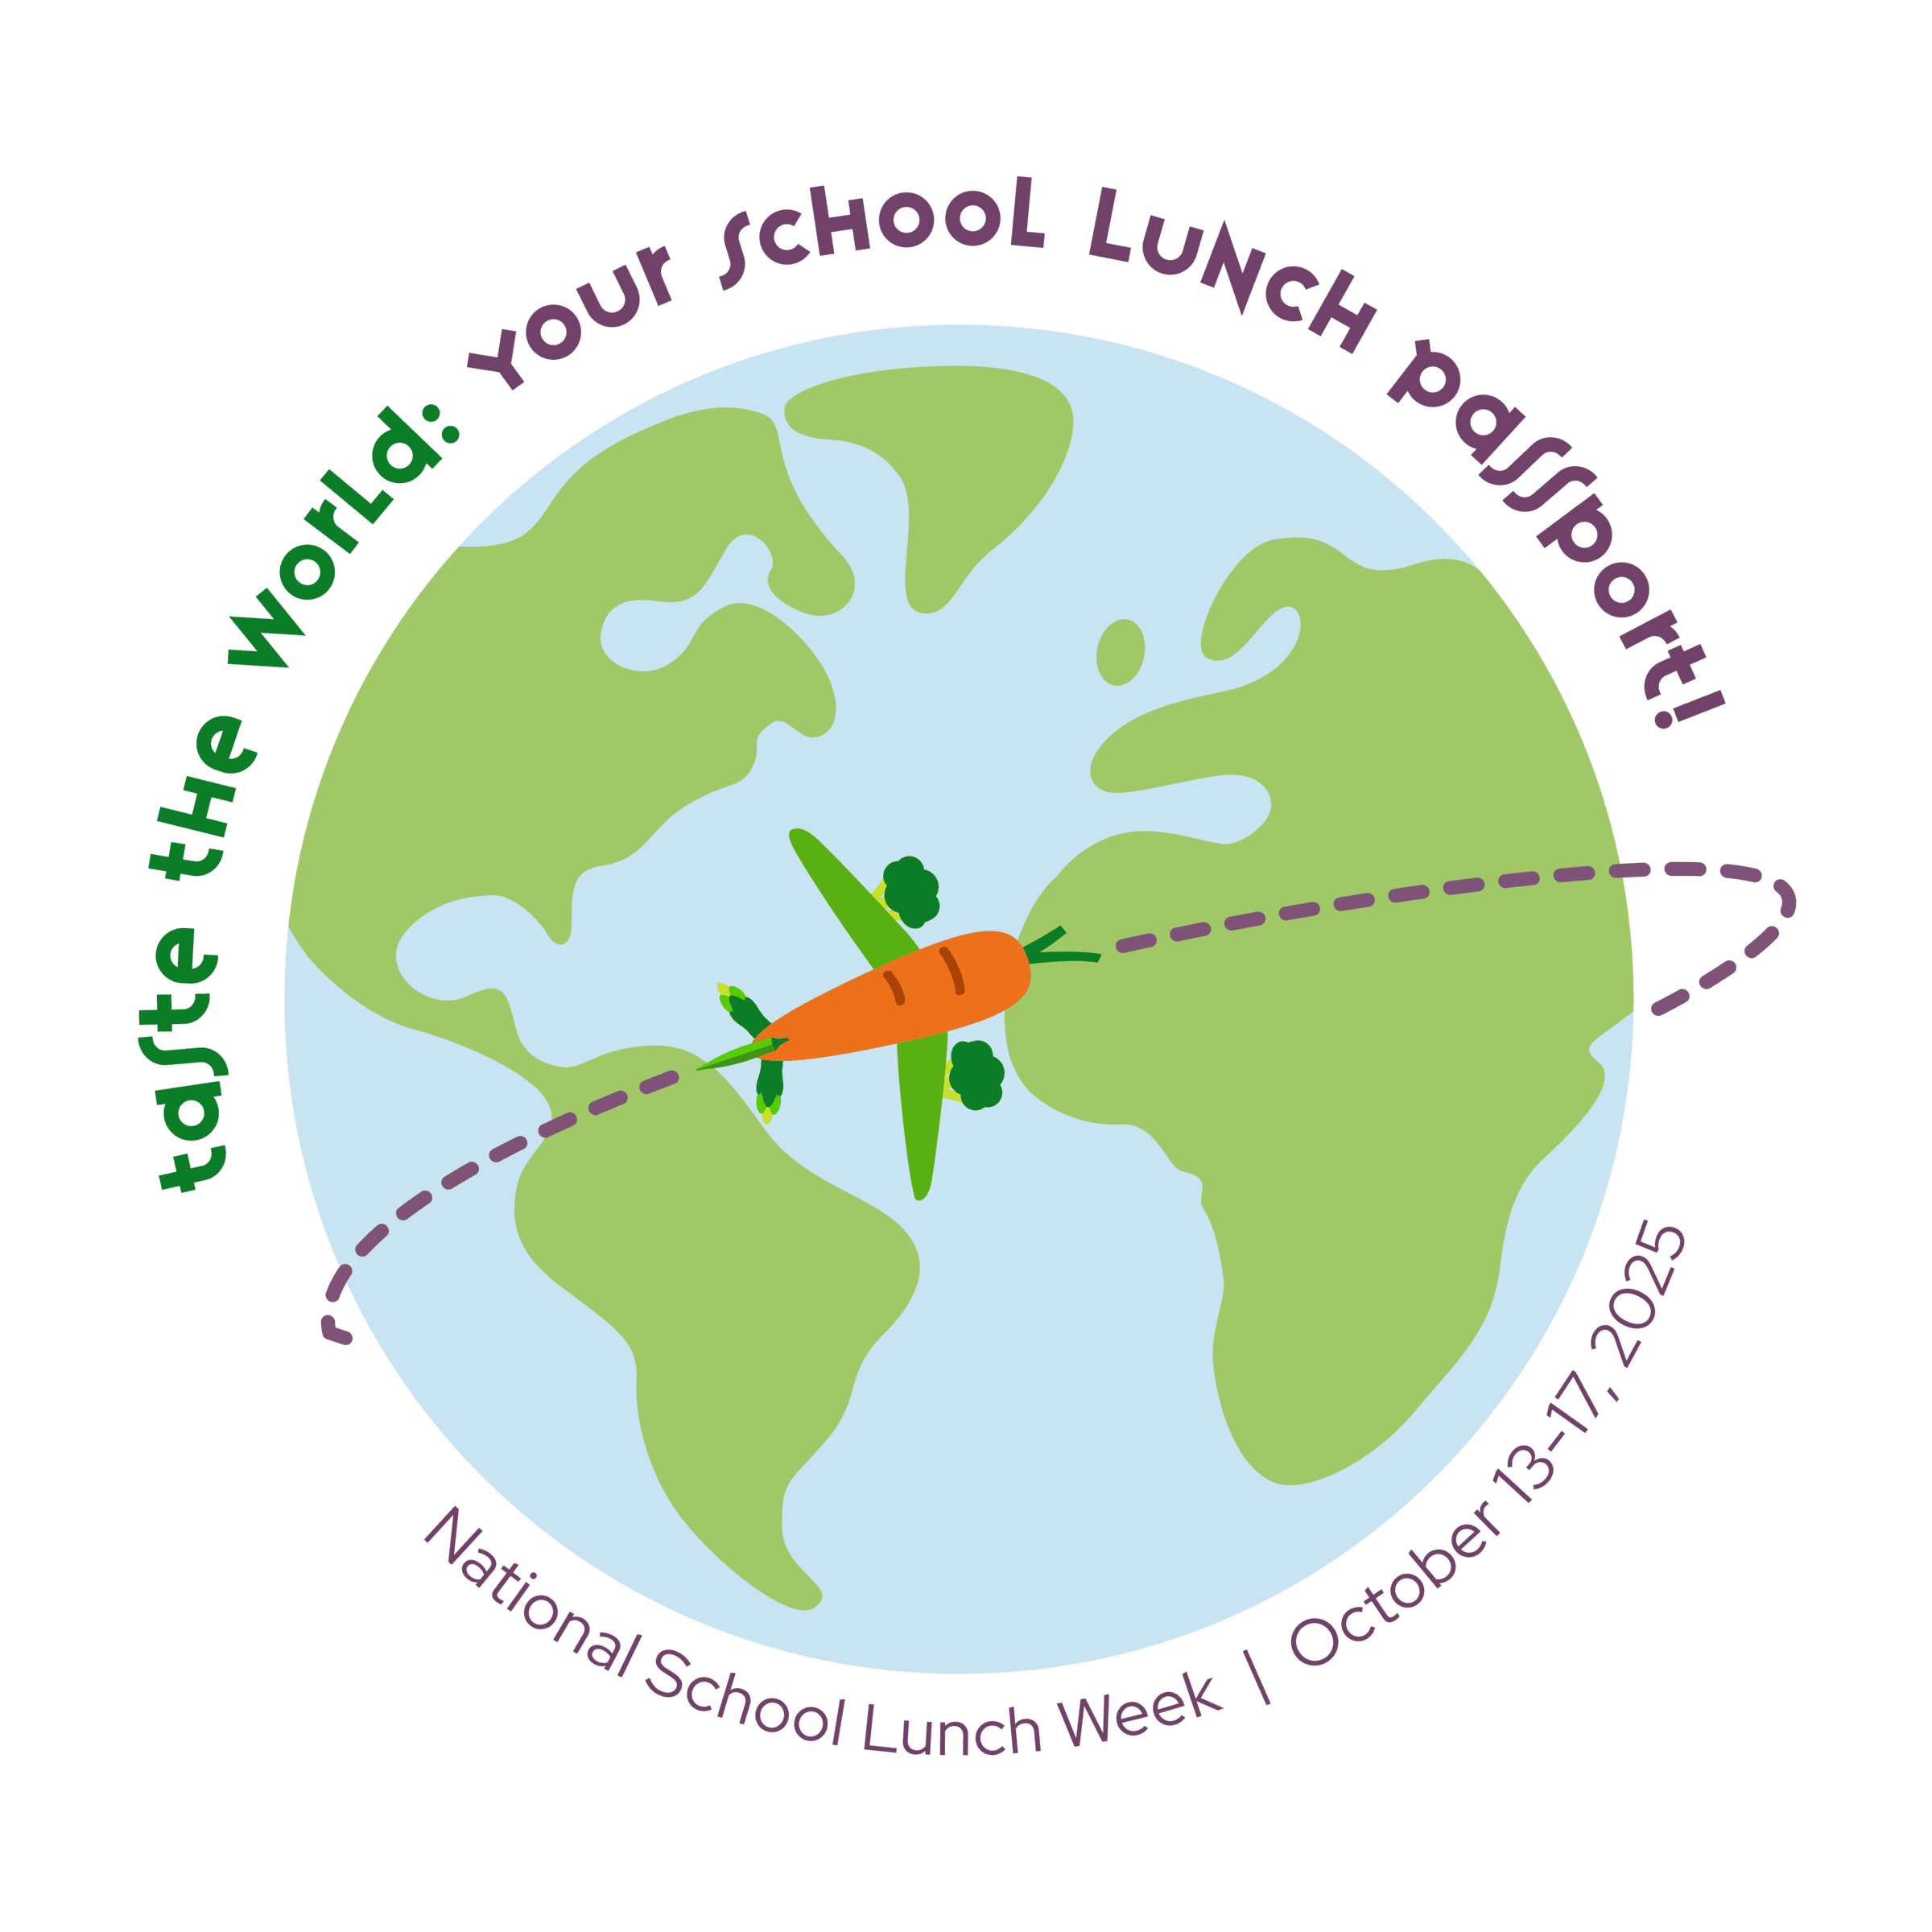
Fall Break

Boomin’ “Boo” Wings & Rings
Veggie Sticks
Ranch Dip
Roll
Fruit/Fruit Juice/Milk
Halloween Cookie

Water made available daily
Cheeseburger
Baked French Fries
Lettuce/Tomato
Frozen Fruit/Fruit Juice
Milk

Hot Wings
Cinnamon Fries
Veggie Sticks
Ranch Dip
Toast/Graham Bears
Fruit/Fruit Juice/Milk

Pepperoni Pizza Pocket
Marinara Sauce
Broccoli w/ Cheese Sauce
Fruit/Frozen Juice Cup/Fruit Juice
Milk

Hamburger Steak
Mashed Potatoes
Blackeye Peas
Cornbread
Fruit/Fruit Juice
Milk

Chicken Sandwich w/ Cheese
Tossed Salad/Crackers
Whole Kernel Corn
Fresh Fruit/Fruit Juice
Milk

Chili Cheese Dog
Tater Tots
Baked Beans
Frozen Fruit/Fruit Juice/Milk

Sumter County Schools, Lunch, 9-12
Beefy Nachos
Cheese Sauce
Jalapeno Peppers
Tossed Salad
Fruit/Fruit Juice
Milk

Fall Break

Chicken Nuggets
Waffle Fries
Veggie Sticks
Ranch Dip
Roll
Fruit/Fruit Juice/Milk

Chicken Tenders
Mashed Potatoes
Gravy
Steamed Carrots
Roll
Frozen Fruit/Fruit Juice/Milk

Beefaroni
Green Beans
Corn on the Cobb
Fruit/Fruit Juice
Cookie/Breadstick
Milk

Fall Break

Corndog
Spiral Fries
Baked Beans
Frozen Fruit/Fruit Juice
Milk

General Tso’s Chicken
or Sweet Chili Chicken
Fried Rice or White Rice
Mixed Vegetables/Egg Roll
Fruit/Fruit Juice
Milk

Oven Roasted Chicken
Baby Bakers
Turnip Greens
Cornbread
Fruit/Fruit Juice
Vanilla Pudding/Milk

Spaghetti w/ Meatballs
Tossed Salad
Fruit/Fruit Juice
Garlic Knot
Milk

Fall Break
Pizza
Tossed Salad w/ Cheese
Crackers
Crinkle Cut French Fries
Fruit/Fruit Juice
Milk

Professional Development
Hot Turkey and Cheese Sub
Lettuce/Tomato/Doritos
Veggie Sticks
Ranch Dip
Fresh Fruit/Fruit Juice
Milk

Taco Salad
Salsa/Sour Cream/Olives
Jalapeno Peppers
Whole Kernel Corn
Fresh Fruit/Fruit Juice/Milk
Cheez-it Crackers

