September
2022
Early Childhood Family Education
Welcome  Early Childhood Family Education Classes are for families with children birth to age 5. We will be meeting in the gym at the Kelliher Old School once a month. We are planning to have one other parent/child activity each month for families to attend.  Please register for ECFE through Community Education. | 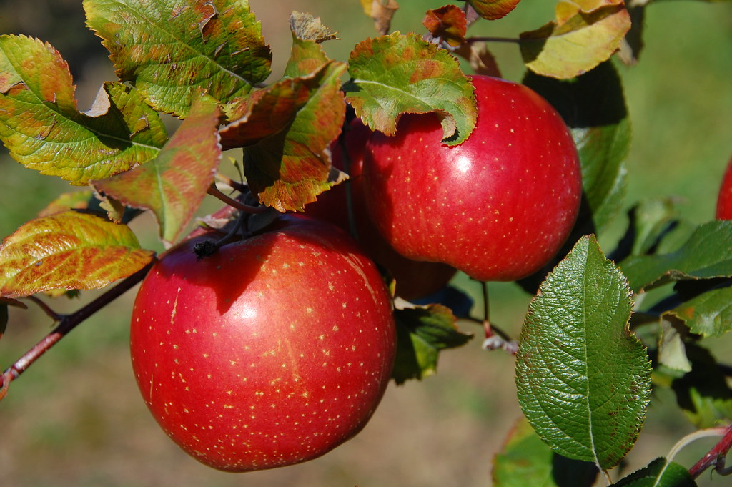
Sunday | Monday | Tuesday | Wednesday | Thursday | Friday | Saturday
 |  |  |  | 1 | 2 | 3
4 | 5 | 6 | 7 | 8 | 9 | 10
Preschool & PreK Open House
9-11am & 5-7pm
11 | 12 | 13 | 14 | 15 | 16 | 17
18 | 19 | 20 | 21 | 22 | 23 | 24
25 | 26 | 27 | 28 | 29 | 30
 | ECFE Open House 4-6pm
Contact Rachael Neft at rneft@kelliher.k12.mn.us of find Early Childhood Family Education on Facebook
Or message (218) 556-0244 or you can email Caitlin Johnson at cjohnson@kelliher.k12.mn.us

