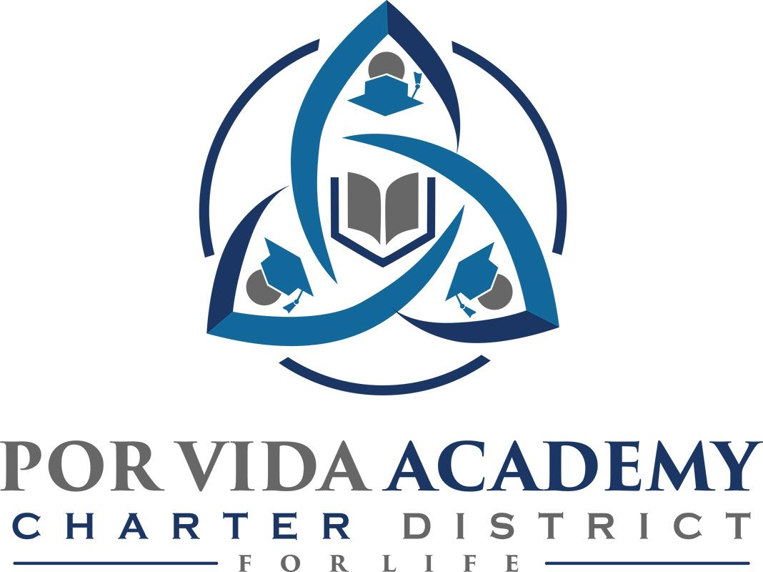

Tuesday, September 8, 2020 at 12:30pm 1135 Mission Road, SA TX 78210

Agenda of Regular Called Board Meeting

- Call to Order and Establishment of Quorum
  - Roll Call & Recording of Board Members Present - Declaration of Quorum Present
  - Recording of the Executive Director/Superintendent and Staff Members Present.

- Closed Session: None

- Pledge of Allegiance

- Salute to the Texas Flag- “Honor the Texas Flag; I pledge allegiance to thee, Texas, one state under God, one and indivisible.”

- Public Testimony

- Approval of Minutes: August 27

- Superintendent Items:

  - Campus Reports
  - Dr. Davidson Report
  - 2020-2021 Allotment & Certification
  - Request to extend the 2020-2021 school year beyond the first 4 weeks
  - Approval of Employee Handbook
  - Prioritized Focus Areas – share the two areas we are focusing on in TIP
  - EMAT TEKS Certification

- Financials
  - None

- Board Items: None

- Adjournment

