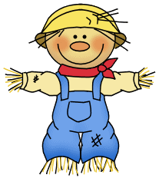October

October 16-20, 2023

**Weekly focus:**

**Theme**– farm animals

**Letters**- Kk

**Sight words**- in, is, it

**Math**- count to 50 by ones, write recognize and work with numbers 0-10, addition to 5, name 2d and 3d shapes, sort objects, positional words

**Reading/ language-** ask and answer questions about what is read, identify characters in a story, identify parts of a book, produce rhyming words, beginning sounds, identify letters and sounds of the alphabet

**Writing**- names correctly, letters of the week and previously learned letters

(Tt, Bb, Ff, Nn, Mm, Ii, Uu, Cc, Oo, Aa, Gg, Pp, Jj, Dd, Ss, Ee, Rr, Ll, Hh)

**Important dates:**

* **October 18th- field trip money due**
* October 23rd- book fair day
* October 24th- farm day
* October 24th- book fair parent night 4:30-7:00
* October 31st- bring $1 to wear a costume
* November 1st- Cedar Farm field trip
* November 20th-24th- Thanksgiving break

**\*sign and return all papers with report cards**

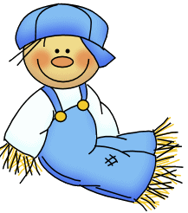

**Reminders:**

*Shoe boxes for soldiers items can be sent in until 10/17

*Million cans recycling contest- send in your aluminum cans

*2 inch binder due by 10/16 if you want your child to have a memory book

*ice cream order forms and money are due Thursday- kiddos will get ice cream on Friday for snack if they purchased

*practice sight words and letters/ letter sounds, and writing letters at home

**Special dress up days:**

10/18- wear orange for bullying prevention

10/23-10/27- red ribbon week (more info coming soon)

10/24- dress like a farmer

10/31- bring $1 to wear costume

